**Top tips for note-making (7 pages)**

Creating good quality notes on a topic can really ‘cement’ your learning. Transferring what you learn in class or through further reading and research into your **own words**, with your **own examples**, helps you to identify what you know and where there might be gaps in your understanding. Here are sometips for creating useful notes:

**Select one topic at a time:** Each module (or subject) that you take will cover a number of topics. Aim to create a really good set of notes for each of these topics. When you have decided which topic you are going to work on, gather all of the materials that you have related to this topic together. This is likely to include lecture notes/slides, your own notes taken in lectures and tutorials, readings, assignments, exam papers, and so on.

**Scan your materials** methodically, taking note of the **key words, key theorists** and **key concepts**. This is a good opportunity for you to review your general understanding of a particular topic. You may need to gather a few more materials, such as key readings, before moving onto the next step.

**Rewrite and arrange** your notes in a way that brings everything together in a coherent and concise manner. It is particularly useful to pay attention to **assignments** or **exam questions** on the topic you are studying when doing this. Remember, you are trying to create a set of notes that will help you to demonstrate your understanding of a topic when the time comes for you to do so.

**Review your notes** on a regular basis, addressing gaps, adding new information or knowledge, and evaluating your progress. This slow-and-steady activity will greatly reduce anxiety around exam time.

Notes don’t have to be paper-based: you can create **electronic notes** on your laptop or college PC. Check out note-making software such as Microsoft OneNote (which you have free access to as an NUI Galway student) or EverNote. Some students also like to create **audio notes** that can be listened back to in the gym or when travelling, for example.

Be very careful about **copying and pasting** material that you find online – you run the risk of **plagiarism** (intentional or otherwise) when you do this. If you feel that you must copy and paste, consider highlighting any text that you have copied word-for-word and make sure to include the relevant bibliographic (referencing) information, so that you have this to hand if and when you should need it.

**One-page summaries** of a topic can be very helpful for revision purposes. Use any of the techniques below to distil a topic down to a single page. You could write or draw on the file dividers in your folders, for example.

Note-making strategies will vary from person to person and sometimes from module to module. Try experimenting with some of these techniques to see what works best for you.

Basic **linear note-making or outlining** takes a form such as this:

* First item
  + - * Sub item
* Second item
  + - * Sub item
      * Sub-sub item
      * Sub-sub item
* Third item
  + - * Sub item

… and so on. You can use different colours to add interest to these list-type notes if you like.

With **nuclear note-making**, ideas, examples, or concepts are listed around a central theme:

Some students find this more visually appealing and memorable than a linear approach. Again, you can use colour to add interest if you like.

**Mind or concept maps** are diagrams in which ideas, concepts, facts, theories, and so on are also arranged around a central key word or concept. Colour, font size, lines or arrows, images or other techniques can be used to denote the importance of various concepts and their relationships to the central topic and to each other (see example overleaf). These type of notes are sometimes known as **pattern notes**. There are lots of mind-mapping applications available, such as Mind Genius, Coggle, or FreeMind.

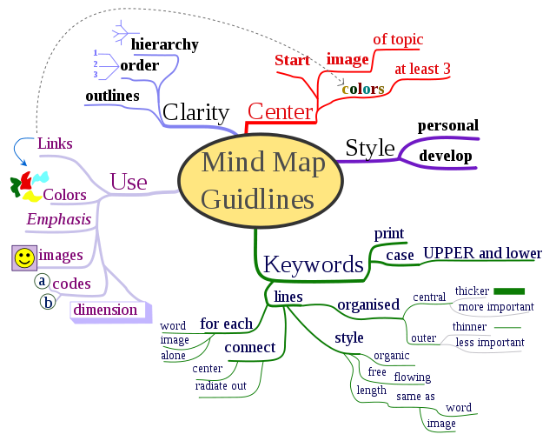

Source: <http://en.wikipedia.org/wiki/File:MindMapGuidlines.svg>

A very well-known note-making technique is the Cornell method. Check out the All Aboard online tutorial on **Learning Tools** (available at <http://www.allaboardhe.ie/learningtools/>) for a video demonstration of this method.

A variation of this is **question/answer notes**, where you divide a page into two columns. On the left-hand side, write a question (or questions) relating to the topic at hand. On the right-hand side, write brief answers. This can be a good method for science or law students, for example, where you may want to note how particular experiments or legal cases relate to a topic. You can also adapt this method as a way to record or review the different experiments or cases that you have studied (see example overleaf).

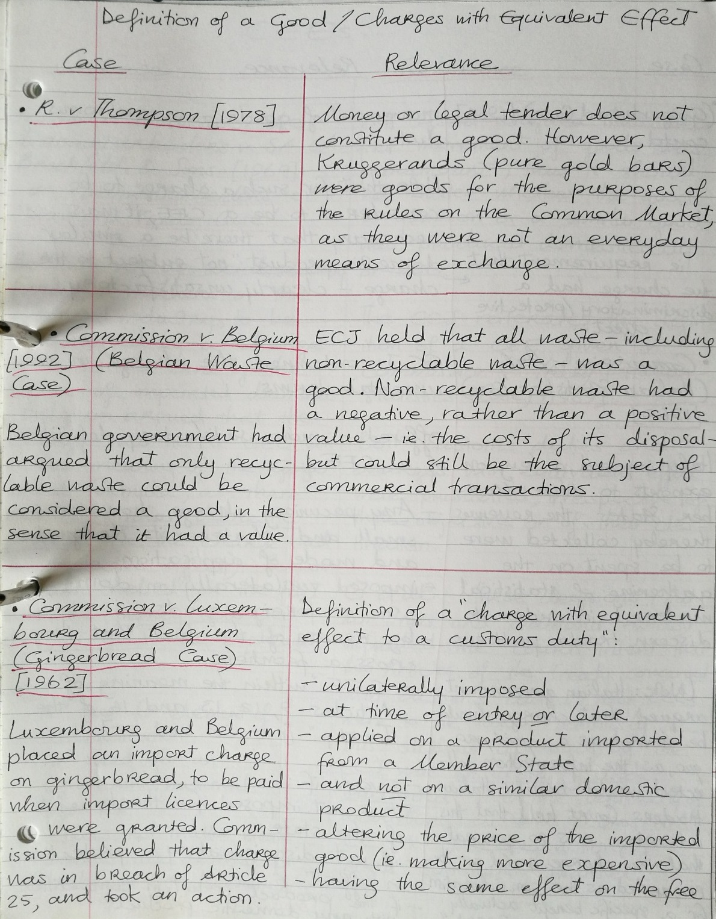

**Time-lines** can be useful for students of subjects such as history, geography, archaeology, science, philosophy, classics, sociology and politics, and many more. A visual map of dates and events, using a simple line drawn across a page, can help you to see and remember how things evolved over time far more effectively than a written list can.

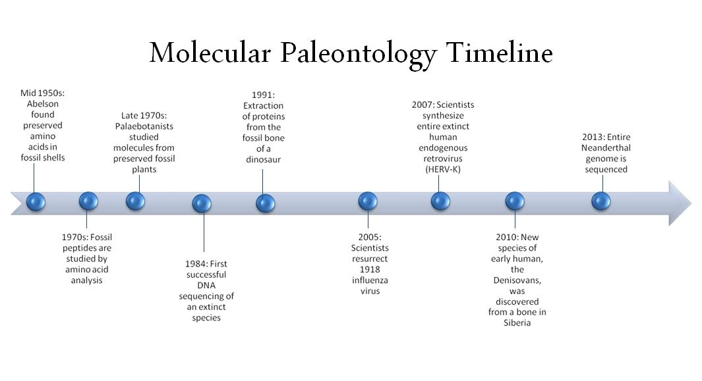

Source: <https://upload.wikimedia.org/wikipedia/en/5/5c/Molecular_Paleontology_Timeline.jpg>

**Fish-bone diagrams** can be helpful for visually summarising cause-and-effect scenarios. For example, if you’re studying the causes of the First World War, you could create something like this:

Alliances Nationalism/imperialism Militarism/arms race

**World War I**

Morrocan Bosnia Eastern Assassination of Archduke

crises question Franz Ferdinand

**Formula sheets** can be useful if you are taking any modules that require you to memorise a lot of formulas, for example in some maths, science, or business modules (do check whether the formulas will be provided with your exam paper – sometimes this is done and sometimes not). An example of a formula sheet for Economics is provided below:

* *Midpoint method:* (Q2 – Q1) / [(Q2 + Q1)/2]

(P2 – P1) / [(P2 + P1)/2]

* *Marginal product of labour:* ∆TP/∆L, where TP = total product or quantity of output and L =

number of workers

* *GDP:* Y = C + I + G + NX, where Y = total expenditure on the economy’s output of goods and services, C = consumption, I = investment, G = government purchases and NX = net exports, or exports minus imports
* *Nominal GDP:* (P x Q) + … + (P x Q), where P = current price and Q = current quantity

_ _ _

* *Real GDP:* (P x Q) + … + (P x Q), where P = price in the base period and Q = current quantity
* *National saving, S*: Y – C – G = I, where I = investment
* *Money multiplier, M*: 1/r, where r = reserve ratio, where r is expressed as a fraction or a decimal

… and so on. Finally, remember that note-making is a very different activity to note-taking in lectures or tutorials. The former requires more time and effort, but your results should make it worth your while.

**Supported by the NUI Galway Student Project Fund**