**University Skills Passport (USP) - Skills in Curriculum Setup Form**

Thank you for engaging with the USP - University Skills Passport. This form will determine the eligibility of your activity for inclusion on the USP - University Skills Passport. You are required to fill out one form for each badge that you would like to award. Typically, one module would be associated with one badge. It will capture the basic data required to set up your activity on our central student record system and to set up the credentials that you choose to award your students on completion of your activity (Digital Badge / University Skills Passport Transcript).

Should you wish to change the setup outside of the annual review process please email [USP@universityofgalway.ie](mailto:designingfutures@universityofgalway.ie).

1. **Module code**

|  |
| --- |
| MG3117 |

1. **Title:**

#### (Note: This title will appear on the credential awarded and on the University Skills Passport transcript)

|  |
| --- |
| Intercultural Encounters MG3117 |

1. **Module Owner contact Details:**

|  |
| --- |
| **Name:** |
| **Email:** [XXXXX@universityofgalway.ie](mailto:XXXXX@universityofgalway.ie) |
| **Phone:** |

1. **Hosting Department**

Please specify the disciplines(s) linked to this module on Akari

|  |
| --- |
| School of Business |

1. “**Contact Us” Email address**

(Email Correspondence from students enquiring about your award will be directed to this address)

|  |
| --- |
| **“Contact us” Email:** [**X**XXX**@universityofgalway.ie**](mailto:XXXX@universityofgalway.ie) |

1. **Description of Activity**

Please provide a brief description of your module. This description will be recorded on the metadata associated with the digital badge. Th**is should explain to a student and an external partner what the badge is about and what a student has completed in order to achieve the badge (i.e., badge criteria: Attendance, Written reflection, presentation etc,)**

**Recommended text length: 150 words**

|  |
| --- |
| Students learn concepts relating to global citizenship, diversity and inclusiveness that fosters cultural awareness, critical thinking, and empathy. To achieve this, disciplinary and cultural boundary crossing, knowledge sharing and co-production, as well as intercultural understanding and collaboration occurs between students.  Organized into teams, students partake in a service-learning action by connecting and working directly with voluntary groups, engaging with local stakeholders and experts from Galway. The experiential approach encourages students to reflect on and share their experiences to enable greater understanding.    To earn this badge the student must:   * As part of ongoing and final assessments reflect on their activities as a team and in conjunction with partners. * Work together to create a final presentation and participate in an action that directly benefits the community. * Commit to at least 4 meetings (including online, over the phone, and in person) with a community partner and at least 5 meetings (including online, over the phone, and in person) with their teams. |

1. **Criteria to earn this Digital Badge**

Please list a brief formal description of how the student earns this badge. This description will be recorded on the metadata associated with the digital badge. **This should explain what a student has completed in order to achieve the badge (i.e., badge criteria: Attendance, Written reflection, presentation etc,)**

|  |
| --- |
| **To earn this badge the student must**: |

1. **Target Cohort**

|  |  |
| --- | --- |
| Undergraduate | Yes |
| Postgraduate | No |
| All | No |

1. **Duration of the Activity**:

Duration that the activity typically spans (e.g., X weeks, Semester 1, Semester 2, yearlong)

|  |
| --- |
| **Semester 1** |

1. **Time Commitment in Hours (Min)**

What is the usual time commitment associated with this badge? If a range of hours is likely, please indicate what the minimum time commitment is?

|  |
| --- |
| **10+, in that throughout the semester students commit to at least 4 meetings (including online, over the phone, and in person) with a community partner and at least 5 meetings (including online, over the phone, and in person) with their teams. They must meet the minimum requirement of engagement hours.** |

1. **Verification**

Describe the validation process used to verify that this activity has been satisfactorily completed by the student? (Attendance log, Formal assessment, other)

|  |
| --- |
| As part of ongoing and final assessments, students must reflect on their activities as a team and in conjunction with partners, and work together to create a final presentation, as well as having partook in an action that directly benefits the community. |

1. **Current Activity Visual Identity**

Please include an image of your activity's logo / existing digital badge (If Relevant). Please attach high quality image of png / svg file to email if available

|  |
| --- |
| If you would like to deviate from the standard design please contact us at [USP@universityofgalway.ie](mailto:USP@universityofgalway.ie) |

1. **Skills and Dispositions**

* Please select **up to 5** skills and/or dispositions in the Designing Futures Framework that the student developed upon completion of this module.
* For each skill stated please identify at least one specific example of how the student developed this skill/disposition. The example should clearly outline what the student did in this context to develop the skill highlighted. (Reference Sample completed setup form available here)
* The example should be short and concise, 1 – 2 sentences long and phrased in the past tense.
* Please find the Skills Framework and associated examples available for your reference [here.](https://www.universityofgalway.ie/designingfutures/aboutdesigningfutures/frameworkforstudentdevelopment/frameworkforstudentdevelopment/)

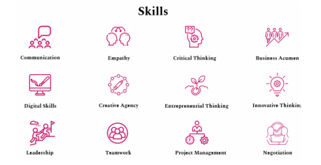

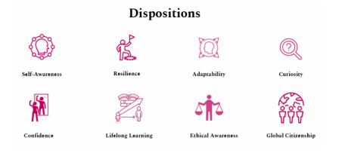

|  |  |
| --- | --- |
| **Skill / Disposition** | **Skills /Dispositions Description: give specific examples of how this skill/disposition was acquired by undertaking this module:** |
| 1. Global Citizenship | Developed an understanding of the core concepts of global citizenship, diversity, and inclusion. Completed the requisite online discussion board posts, that showed engagement with, as well as knowledge and understanding of the material. |
| 2, Ethical Awareness | Actively and respectfully engaged and negotiated with different perspectives to develop an ethically designed service-learning project. Developed a project plan and executed this project which provided a comprehensive solution for the specific challenge engaged with. |
| 3.Communication | Collaborated effectively within a diverse team to give a group presentation related to the service-learning project. Adapted the presentation language to suit the target community partner and delivered the message clearly and concisely. |
| 4. Teamwork | Worked with peers from different disciplines and cultural experiences to design and deliver a presentation on a complex service-learning issue related to a specific global challenge that also had a local impact. Navigated and resolved interpersonal conflict within the group. Dealt constructively with internal and external feedback. |

**Section 12 B**

**OPTIONAL NOT REQUIRED: Domain Specific competencies / Technical Competencies**

If you would like to highlight domain specific competencies / technical competencies that are outside of the skills framework, please list them here.

* You should list the name of the competency and a short description (Max 1 line) only if required.
* The text should be short and concise and phrased in the past tense.
* Note: If you choose to list competencies below you should only capture 4 skills in the skills section above

|  |
| --- |
| **Domain Specific Competency / Technical Competency list** |
| 1.  2.  3.  4.  5. |