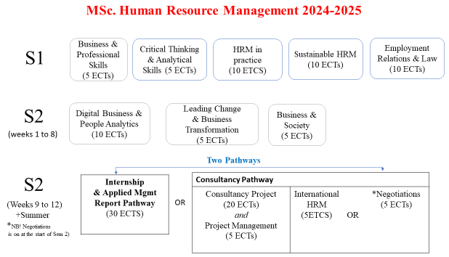

Module Descriptors

|  |  |
| --- | --- |
| **HRM in Practice (10 ECTS)**  This module provides students with an in-depth knowledge of Human Resource Management (HRM) and its core theories and practices within the organisation. The module has been designed to recognise the value that HR practitioners add in the pursuit  of organisational competitive advantage and organisational sustainability and as such, in this module, students will develop knowledge of key HRM processes and practices (for example, in recruitment and selection of staff, performance and reward management, training and development and also in the complexity surrounding contemporary challenges and trends, including new and emerging leadership paradigms, the potential and application of e-HR and sustainable HRM). | **Employment Relations and Law (10 ECTS)**  This module provides students with a comprehensive understanding of employment relations perspectives and debates, both national and international, from a theoretical and behavioural competency perspective. It does so with a critical perspective on the legal aspects of employment relations policy and practice. Through the module, learners will be able to assess the impact of employment law on employment relations and organisational practice and gain insights into the creation and implementation of effective employment relations procedures and policies. The module requires students to reflect critically on theory and practice from an ethical and professional standpoint and provides opportunities for applied learning and continuous professional development. |

|  |  |
| --- | --- |
| **Leading Change & Business Transformation (5 ECTS)**  Focusing on an organisational level and on large-scale business  transformation, this module addresses the role of leadership in driving change and achieving sustainable business transformation. | **Sustainable HRM (10 ECTS)**  This module explores the role of HRM in making work systems sustainable, as well as the role of organisational leaders in contributing to corporate sustainability and to overall societal sustainable development. The module uses a cross disciplinary approach through  including research and insights from other  disciplines such as; strategic HRM, green HRM, organisational behaviour, corporate sustainability, corporate social responsibility,  and emerging leadership perspectives. |
| **Digital, People & Business Analytics (10 ECTS)**  This module provides a grounding in the basic principles of people analytics and as People Analytics is not confined to the HR department, this module aims to develop the awareness, skills and knowledge required to understand people analytics as a mental framework, linking human resource decisions to business outcomes and organisational performance. | **Business & Society (5 ECTS)**  The module provides a comprehensive overview of the intersection between business and society, including the challenges facing organisations as they pursue global business activities. It places business ethics in a richer contextual setting, focusing on the challenges that businesses must now confront, and exploring how these issues can be met by a rethinking of business models, goals and strategies. |
| **Business and Professional Development Skills (5 ECTS)**  This module focuses on the development of skills that are pivotal to successful management practice and to effective leadership, including: thinking and decision-making skills, the management of financial information and budgets, team working and interpersonal skills.  This module prepares students for formal programmes of study with the inclusion of key postgraduate focus on critical reflection on theory and practice from an ethical and professional standpoint. | **Critical Thinking & Analytical Skills (5ECTS)**  This module focuses on the evaluation of evidence and helps students critical thinking competencies. It provides students with an understanding of the limitations of research methods and of the biases that methods and /or researchers introduce. Students will be guided in strengthening their academic writing skills to effectively communicate, not only business recommendations, but also how these recommendations were determined |
| **Project Management (5 ECTS)**  This module covers project management methods and techniques for successful project delivery. It delves into the planning, budgeting, quality, leadership | **Negotiations (5 ECTS)**  This module explores how two or more parties with competing interests discuss and manage issues so as to attain an agreement, settle a matter of mutual |

|  |  |
| --- | --- |
| and risk management of projects in  different organisational settings. | concern, or resolve a conflict. Negotiation is a valuable leadership and management skill, which is employed in a wide range of business contexts, such as contracts, deal-making, employment discussions, team building, and disputes. Negotiations  occur in commercial, non-profit and governmental organisations. |
| **International HRM (5 ECTS)**  This module encourages students to critically develop their knowledge and expertise across a range of specialist themes in the complex field of IHRM. | |