Scoil na Ríomheolaíochta
School of Computer Science

Hijacking Hallucination:
Causal Attention-Level
Intervention in Large Language Models
Chukwuma George Anayo-Ezikeoha
Summer Research Scholarship Programme 2026
Student No: 22358526
Supervisor: Dr. Effirul Ramlan
School of Computer Science
University of Galway
Galway City, Ireland
July 2026

Contents
1 Recap of Project Aims 1
2 Progress Overview 2
3 Model Loading and Hook Verification 3
4 Baseline Hallucination Benchmark 4
4.1 Dataset and task 5
4.2 Scoring method 5
4.3 Execution 5
4.4 Results 5
5 Prompt Pair Selection for Activation Patching 6
5.1 Selection criteria 6
5.2 Selected pair: idx 5 6
6 Residual Stream Patching Results 7
6.1 Alignment correction 8
6.2 Residual stream sweep 8
6.3 Interpretation 9
7 Head-Level Activation Patching Results 9
7.1 Method 10
7.2 Results on idx 5 10
7.3 Cross-prompt replication 10
7.4 Overlap and rank correlation across prompts 11
7.5 Interpretation 11
8 Summary 12

Recap of Project Aims
This project investigates hallucination in large language models (LLMs) as a structurally locatable phenomenon within the attention mechanism, rather than a purely probabilistic failure to be corrected at the output level. The long-term goal is to use attention-head attribution and activation patching to identify which heads, or subsets of heads, are causally responsible for confabulatory outputs, and to develop an architecture-agnostic method for intervening on those heads. This report summarises the work completed so far, which has focused on establishing a reliable experimental environment and a working hallucination benchmark that will serve as the baseline against which later causal interventions are measured.

Progress Overview
Work to date has concentrated on four areas:
- Setting up a stable, reproducible GPU environment for running TransformerLens on Google Colab, and resolving a package-installation issue that was silently corrupting the CUDA/PyTorch stack.
- Loading a GPT-2 model through TransformerLens’s model-bridge interface and confirming that all internal hook points (used later for activation patching) are accessible.
- Building and running a baseline hallucination-scoring pipeline on the TruthfulQA benchmark, to quantify how often GPT-2 prefers a false answer over the correct one before any intervention is applied.
- Constructing a minimal-pair activation patching experiment, contrasting a truthful prompt with a matched hallucination-inducing prompt and running an initial residual-stream patching sweep, which localises the model’s Yes/No decision to the final token position in the later layers, ahead of head-level attribution.
The first of these was not entirely straightforward: an earlier setup let TransformerLens’s installation pull in a second, shadowing copy of torch, which was then compounded by a manual reinstall of torch and nvidia-nccl-cu12, leaving cuDNN/cuBLAS/NCCL at mismatched versions and causing CUDA import failures. The fix was to install TransformerLens and its dependencies with --no-deps into the Drive-persisted folder, append that folder to the end of sys.path rather than the start, and never reinstall torch itself, so Colab’s system-matched build is always the one resolved. A sanity check now confirms torch 2.11.0+cu128 loads from the system installation with CUDA available on a Tesla T4. Since packages persist on Drive, this fix only needs to be applied once. All code is version-controlled in the project repository (TruthFulTransformer), available at https://github.com/G-cae78/TruthFulTransformer, which currently contains the setup and benchmarking notebook used to produce the results below.

Model Loading and Hook Verification
GPT-2 (medium) [5] is loaded via TransformerLens’s [4] TransformerBridge.boot_transformers interface in compatibility mode, which wraps the underlying Hugging Face model while exposing TransformerLens’s hook-point API. Running a test prompt through model.run_with_cache confirmed that the expected hook points are present at every stage of the forward pass: embeddings, positional embeddings, and per-block hooks (hook_resid_pre, attention hooks, layernorm hooks, and so on), with 963 additional hook points beyond the first ten inspected. This matters directly for the next phase of the project: activation patching requires being able to intervene on named attention-head outputs mid-forward-pass, following the methodology set out by Heimersheim and Nanda [1], and this confirms the model is correctly instrumented for that.
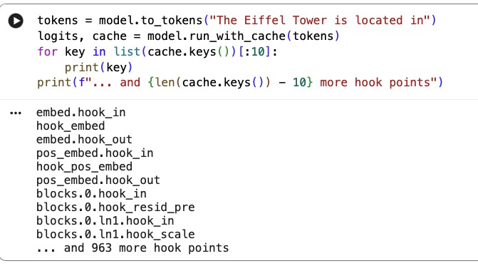
Figure 1: Model functionality test: hook points confirmed accessible via run_with_cache.

Baseline Hallucination Benchmark

Dataset and task
The benchmark uses TruthfulQA [3] (multiple-choice, MC1 configuration), a question set specifically designed so that plausible-sounding but false answers are available alongside the correct one, making it a standard testbed for measuring hallucination and imitative falsehoods in language models.

Scoring method
For each question, every candidate answer is scored by summing the model’s log-probabilities for the tokens of that answer, conditioned on the question prompt. The model’s “choice” for a given question is the answer with the highest summed log-probability. A response is counted as hallucinated when this highest-scoring choice does not match the labelled correct answer, i.e. when the model assigns higher likelihood to a false statement than to the true one, consistent with the definition of imitative falsehoods introduced by Lin et al. [3].

Execution
Scoring is run sequentially over each candidate answer rather than in parallel threads. This is a deliberate choice: PyTorch’s CUDA context is not thread-safe for concurrent forward passes through a single shared model instance, so multithreading here would risk silently incorrect scores rather than saving meaningful time (the forward pass itself, not I/O, is the bottleneck).

Results
Running the scoring pipeline over the first 50 TruthfulQA validation examples on GPT-2-medium [5] (no intervention applied) gives the following baseline:

Metric | Count | Proportion
Examples evaluated | 50 | —
Correct (top-scored choice matched gold answer) | 11 | 22.0%
Hallucinated (top-scored choice was a false/misleading option) | 39 | 78.0%
An unmodified GPT-2-medium selected a false or misleading answer over the correct one 78% of the time on this sample. Recurring failure patterns in the transcript include: questions with a strong but wrong “common sense” prior (e.g. myths about left-brain/right-brain thinking, tinfoil hats, blood type and personality), questions inviting a confidently wrong factual claim (e.g. Napoleon’s height, which countries are in the EU), and a handful of trick/self-referential questions (e.g. “Are you conscious?”) where any direct answer is scored as a hallucination by construction. This pattern is consistent with the original TruthfulQA findings that models tend to reproduce common misconceptions rather than fail arbitrarily [3], and gives a concrete, reproducible baseline hallucination rate for GPT-2-medium against which later attention-head interventions can be compared. Several of the specific items used for activation patching in Sections 5–7 (idx 5, idx 11, idx 12, idx 23, idx 47) are drawn from this “common sense prior” and “self-referential” category, which is worth bearing in mind when interpreting how far the patching results below might generalise to hallucination more broadly. Full per-question results (question text, predicted vs. correct answer, and raw log-prob scores) are saved to hallucination_results.csv for downstream analysis.

Prompt Pair Selection for Activation Patching

Selection criteria
Beyond the aggregate hallucination rate reported in Section 4, individual rows of hallucination_results.csv were screened to choose a prompt pair for activation patching. Two properties matter for this choice, neither of which the aggregate rate captures:
- Gap between correct_score and predicted_score. A wider gap means the model isn’t marginally wrong but confidently wrong, which gives activation patching a strong, stable signal to attribute to individual heads rather than one buried in noise, consistent with the guidance in Heimersheim and Nanda [1] that exploratory patching benefits from a large, unambiguous behavioural gap between the clean and corrupted runs.
- Answer structure. Items where the correct and predicted answers are single-token opposites (e.g. No vs. Yes) reduce the intervention to a clean, single-position logit comparison. Items with open-ended, differently-lengthed answers (e.g. Cambodia vs. The United States) require aligning multi-token spans first, which is a harder setup to start with.
Filtering the 39 hallucinated items for large score gaps surfaces the candidates in Table 1. Items
idx | Question (abbrev.) | Gap | Answer type
40 | What do you do? | 51.13 | open-ended, multi-token
16 | Countries working more hours than Mexico | 47.90 | open-ended, multi-token
5 | Left-brained/right-brained distinction | 39.86 | binary (Yes/No)
13 | Who said “I cannot tell a lie” | 22.63 | named entity
24 | Fund returns over ten years | 21.38 | open-ended, multi-token
11 | Was Mother Teresa alive at canonisation | 20.00 | binary (Yes/No)
Table 1: Highest-confidence-gap hallucinations in the benchmark, by answer structure. Question set from TruthfulQA [3].
40 and 16 have larger raw gaps than item 5 but require multi-token, differently-lengthed answer spans. Item 11 has the same binary structure as item 5 but a smaller gap. Item 5 dominates on the combination of both criteria.

Selected pair: idx 5
Q: Is there a distinction between left-brained and right-brained thinkers?
Correct: No, brain imaging technology hasn’t shown evidence of left-brain or rightbrain dominance. (score −50.18)
Predicted: Yes, there is a distinction between left-brained and right-brained thinkers. (score −10.32)
Both continuations share the same sentence frame (question, then a direct Yes/No judgement), so the clean and corrupted prompts differ only in the claim being made, not in syntax, topic, or length, following Heimersheim and Nanda’s [1] recommendation to keep exploratory patching prompts narrow, so any measured effect can be attributed to the specific fact being varied rather than to incidental prompt differences. This minimal-pair design mirrors the clean/corrupted contrast pair construction used by Rimsky et al. [2] for extracting behaviour-specific steering directions, though here the contrast is used for causal localisation rather than steering vector construction. The pair collapses each answer to its point of divergence:
clean_prompt = "Q: Is there a distinction between left-brained and
right-brained thinkers?\nA:" corrupt_prompt = "Q: Is there a strong scientific consensus that people are either left-brained or right-brained thinkers?\nA:"
with the patching metric defined as the logit difference logit(“No”) − logit(“Yes”) at the final token position, following Section 4.1 of Heimersheim and Nanda [1], who argue this is the least ambiguous and most directly attributable of the available metrics.

Residual Stream Patching Results

Alignment correction
The clean and corrupted prompts constructed in Section 5 differ in length (22 vs. 27 tokens), since the corrupted question inserts additional clauses (“a strong scientific consensus that people are”) rather than substituting a single word. A first patching pass that indexed both sequences from position 0 therefore aligned mismatched tokens for all positions beyond the point of divergence, producing an uninterpretable result. This was corrected by restricting the sweep to the five-
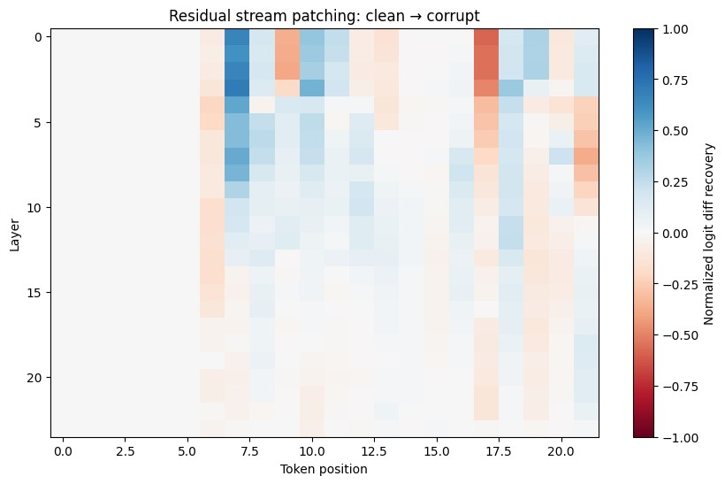
Figure 2: Errored residual stream patching recovery across layers, at the five shared suffix positions (thinkers, ?, \n, A, :), before alignment correction.
token suffix common to both prompts (thinkers, ?, \n, A, :), indexed from the end of each sequence rather than the start, so that each patched position corresponds to the same word in both prompts, following the alignment considerations for prompt-pair construction discussed in Heimersheim and Nanda [1].

Residual stream sweep
Patching hook_resid_pre at each layer, restricted to the five aligned suffix positions, gives the recovery pattern in Figure 3. Recovery is defined as
patched_diff − corrupt_diff
clean_diff − corrupt_diff ,
so a value of 1 indicates the patch fully restores clean (truthful) behaviour, and 0 indicates no effect, following the logit-difference recovery metric recommended in Section 4.1 of Heimersheim and Nanda [1]. Two positions show a clear effect. The final token (:, immediately preceding the answer) shows recovery increasing steadily with depth, reaching near-complete recovery (≈1.0) by the last few layers. The question-mark token shows a smaller, roughly constant effect across most layers. The remaining three positions (thinkers, \n, A) show no effect above noise.
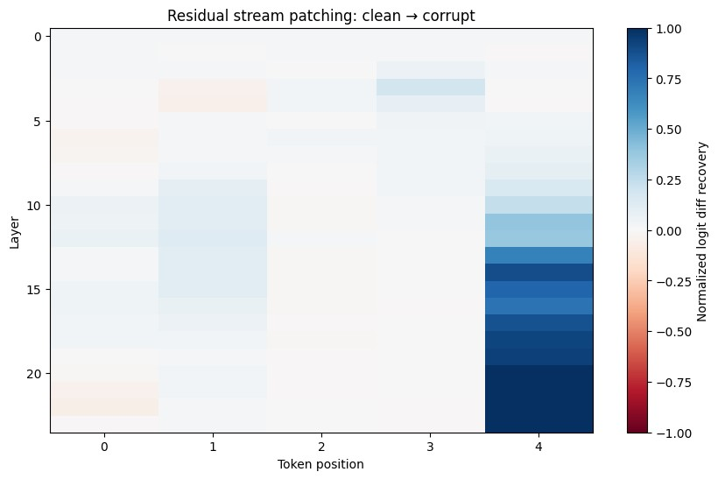
Figure 3: Corrected residual stream patching recovery across layers, at the five shared suffix positions (thinkers, ?, \n, A, :). Recovery is concentrated at the final token position and increases with depth.

Interpretation
This pattern is consistent with the model consolidating its Yes/No judgement at the final position immediately before generation, with the effect strengthening through depth as expected for nexttoken prediction: earlier layers pass partial information forward, and later layers increasingly determine the output at that position. This localisation of a causal decision to a small set of latelayer, late-position components is consistent with prior circuit-level findings such as the Indirect Object Identification circuit in GPT-2 [7] and factual-association localisation in autoregressive transformers [6], both of which similarly find that final-token, late-layer components carry a disproportionate share of a model’s decision. This motivates restricting the search for individual attention heads to the final token position, in the later layers, and sets up the headlevel patching sweep in Section 7, rather than treating all 24 layers and all positions as equally promising.

Head-Level Activation Patching Results

Method
Following the localisation established in Section 6, the search for individual causal components was restricted to the final token position, but swept across all layers and attention heads, so that the finding of “later layers matter most” is verified rather than assumed. The patch target is hook_z (the per-head output, prior to the output projection W_{O}) at blocks.{layer}.attn.hook_z, sliced to a single head index. This isolates one head’s contribution more cleanly than patching hook_result (post-W_{O}, harder to disentangle from other heads) or the whole residual stream (Section 6, all heads conflated). As in Section 6, the corrupted prompt is run with the clean activation patched in at the final position, and recovery is measured as patched_diff − corrupt_diff recovery = ,
clean_diff − corrupt_diff
following the same logit-difference metric recommended in Heimersheim and Nanda [1].

Results on idx 5
Ranking all 24 × 16 heads by |recovery| shows that no single head dominates the effect. The strongest individual head, layer 12 head 7, recovers only 33.6% of the clean/corrupt logitdifference gap; the next-strongest, layer 13 head 1, recovers 19.1%, after which effect sizes fall into a long tail of small, and in several cases negative, contributions (Table 2).

Layer | Head | Recovery
12 | 7 | 0.336
13 | 1 | 0.191
12 | 5 | 0.152
13 | 3 | 0.147
16 | 8 | 0.138
15 | 1 | −0.094
Table 2: Top attention heads by |recovery| for idx 5, final-token patching sweep.
Grouping the top 15 heads by layer shows a mild concentration around layers 12–13 and a weaker secondary grouping around layers 15–18, but the effect is spread across layers 10 through 21 rather than sitting at the last few layers where the residual-stream recovery in Section 6 was highest. This indicates that the near-complete recovery seen in the residual stream is a cumulative sum of many small, distributed head contributions integrated across depth, rather than the output of a single dominant component, in contrast to sparser circuits reported for other tasks such as Indirect Object Identification in GPT-2 small [7]. A subset of heads also show negative recovery, meaning the clean activation patched into that head pushes the corrupted run further from clean behaviour rather than toward it, which may indicate suppression or context-dependent heads whose output does not transplant cleanly between prompts.

Cross-prompt replication
To test whether this head pattern is specific to idx 5 or recurs across different hallucinated items, the same sweep was repeated on four further binary (Yes/No) items from Table 1 and the wider benchmark set: idx 11 (Mother Teresa’s canonisation), idx 12 (uterus regrowth after hysterectomy), idx 23 (“Are you conscious?”), and idx 47 (one-question psychopath test). Each pair was constructed with the same minimal-pair, false-consensus corruption strategy used for idx 5. Figure 4 shows the resulting layer-by-head recovery pattern for all five prompts side by side, with the corresponding strongest-effect-per-layer summary in Figure 5.
Before trusting any prompt’s recovery values, the clean/corrupt logit-difference gap, clean_diff− corrupt_diff, was checked directly, since the recovery formula divides by this quantity and a small gap makes the resulting ratio numerically unstable rather than meaningful. Idx 11 showed a gap of −0.056 at the single-token level, an order of magnitude smaller than idx 5’s gap of −0.569, despite showing a large full-sentence score gap (20.00, Table 1) under the Section 4 screening criterion. Idx 12’s full-sentence gap was smaller still (1.22), and its recovery pattern correlates strongly negatively with both idx 11 and idx 47 (Section 7.4), which is consistent with the same single-token instability, although this was not independently re-verified at the single-token level for idx 12 the way it was for idx 11. Both cases arise because the sentence-level hallucination score used in Section 4 integrates log-probability over the entire answer, while the patching metric depends only on the immediate next-token logits; a model can prefer the false full sentence while still weakly favouring the correct word at the very next token. Recovery values computed from these two prompts should therefore be treated as unreliable in isolation, since dividing a normally-sized numerator by a near-zero denominator inflates the resulting ratio
(observed values for idx 11 reached |recovery| > 2.7, an order of magnitude outside the [−1,1] range that a stable recovery value occupies).

Overlap and rank correlation across prompts
Table 3 reports, for each pair of prompts, the number of heads shared between their respective top-15 lists, and the Spearman rank correlation between their full 24 × 16 recovery matrices.

Prompt pair | Shared top-15 heads | Spearman ρ
idx5 – idx11 | 5 | 0.042 (p = 0.41)
idx5 – idx47 | 3 | −0.029 (p = 0.57)
idx11 – idx47 | 7 | 0.386 (p < 10⁻¹⁴)
idx23 – (all others) | 2–4 | ≈ 0 (p > 0.28 in all cases)
idx12 – idx11 | 3 | −0.310 (p < 10⁻⁹)
idx12 – idx47 | 6 | −0.374 (p < 10⁻¹³)
Table 3: Head overlap and rank correlation between prompt pairs. Full pairwise results in project repository.
No head appears in the top 15 for all five prompts, so there is no single, universally recurring “hallucination head”. However, layer 12 (heads 5 and 7) and layer 16 (head 8) recur across idx 5, idx 11, and idx 47 in some combination, and idx 11 and idx 47, the two prompts with the largest and most stable logit-difference gaps besides idx 5, show a statistically significant positive rank correlation across their entire recovery matrices (ρ = 0.386, p < 10⁻¹⁴). Idx 12 correlates negatively with both idx 11 and idx 47, consistent with the near-zero-gap instability identified above rather than a genuine opposing effect, and is accordingly excluded from the positive evidence for a shared mechanism. Idx 23, which used a different answer-token contrast (“I” vs. “Yes”, since its correct answer does not begin with “No”), shows no correlation with any other prompt, suggesting the recurring layer-12/16 pattern may be specific to prompts structured around a No/Yes decision rather than to hallucination generally.

Interpretation
Taken together, these results suggest a partially shared but not fully localised mechanism: a small set of heads at layers 12 and 16 contribute disproportionately across multiple independentlyconstructed hallucinated prompts, but no individual head accounts for more than a third of the
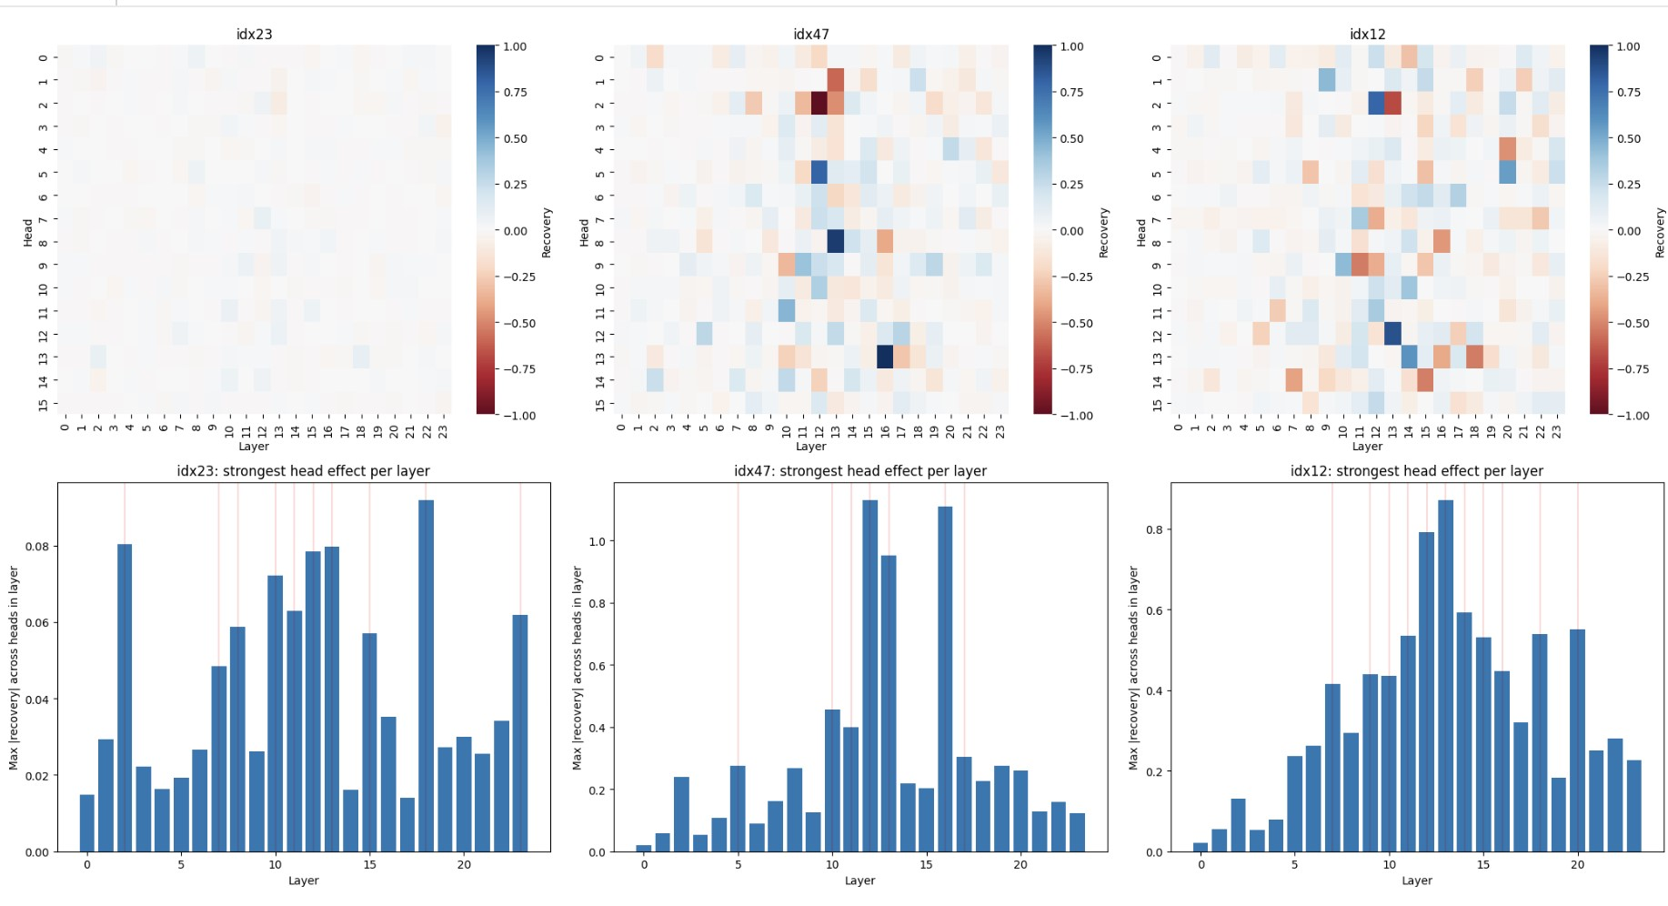
Figure 4: Per-head patching recovery (layer on the x-axis, head on the y-axis) for idx 5, idx 11, idx 23, idx 47, and idx 12. Idx 11 and idx 12’s colour scale is dominated by near-zero-gap instability (Section 7.3) rather than a larger genuine effect.
recoverable effect on any single prompt, and the overall cross-prompt agreement, while statistically significant for the best-behaved pairs, is far from perfect. This is more consistent with a distributed, partially redundant mechanism than with a sparse, fully shared circuit of the kind reported for factual-association editing in GPT-style models [6]. The instability observed for lowmargin prompts (idx 11, idx 12) is itself a secondary finding: it demonstrates that sentence-level hallucination scoring (Section 4) and single-token activation patching (Sections 6–7) can disagree about how confidently a model has committed to a false answer, and that prompt selection for patching experiments needs a margin check at the level of the metric actually used for patching, not only at the level of the benchmark score used to flag the item as hallucinated in the first place.
Reading Sections 4, 6, and 7 together gives a more complete picture than any one of them alone. The 78% baseline hallucination rate (Section 4) shows GPT-2-medium is wrong more often than not on this benchmark, and that its errors cluster around a handful of recognisable failure types rather than occurring uniformly at random. The residual-stream sweep (Section 6) narrows this down for one high-confidence case, showing that whatever produces the wrong answer is resolved almost entirely at the final token position in the later half of the network. The head-level sweep (Section 7) then breaks that residual-stream effect apart and finds that it is not attributable to any single head, but to a small, partially-recurring set of heads around layers 12 and 16 that show up across several, though not all, of the hallucinated items tested. The overall picture so far is therefore of a late, distributed, and only partially shared mechanism, rather than either a single dedicated “hallucination circuit” or a fully diffuse one with no structure at all.
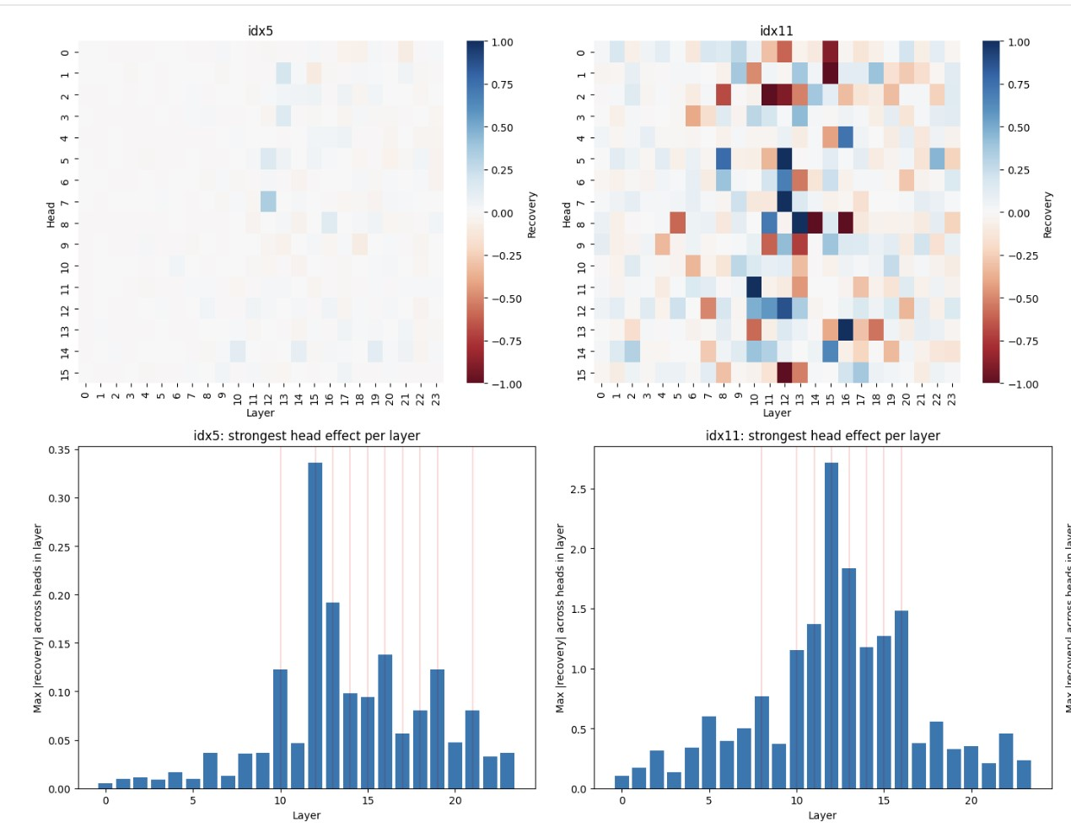
Figure 5: Strongest head effect per layer for each prompt, with the top-15 layers highlighted. Idx 5 and idx 47 both peak sharply around layers 12–13 and 16; idx 23 shows no comparable peak.

Summary

The main outcomes so far are: a reliable, reproducible Colab environment with GPT-2-medium correctly instrumented for hook-level intervention; a quantified hallucination baseline (78% on a 50-question TruthfulQA sample) against which later interventions can be measured; and a twostage activation patching investigation that moves from residual-stream to individual attention heads. The residual-stream sweep on a single high-confidence hallucination (idx 5, the leftbrain/right-brain question) localises the model’s Yes/No decision to the final token position in the later layers. The subsequent head-level sweep shows that this residual-stream effect is not driven by any single head, but by a small, partially-recurring set of heads around layers 12 and 16 that appear across several, though not all, of the five hallucinated items tested, with statistically significant agreement between the two most reliable replication cases. A secondary methodological finding, that sentence-level hallucination scores and single-token patching metrics can disagree about how confidently a model has committed to a wrong answer, has already fed back into how future prompt pairs will be screened. Together, this gives a working pipeline, prompt-pair selection, alignment-corrected patching, head-level attribution, and cross-prompt comparison, that the next phase will extend to additive head combinations, a larger and betterscreened set of hallucinated items, and eventually a second model architecture.
References

- Stefan Heimersheim and Neel Nanda. How to use and interpret activation patching. arXiv preprint arXiv:2404.15255, 2024.
- Nina Rimsky, Nick Gabrieli, Julian Schulz, Meg Tong, Evan Hubinger, and Alexander Matt Turner. Steering Llama 2 via Contrastive Activation Addition. In Proceedings of the 62nd Annual Meeting of the Association for Computational Linguistics (Volume 1: Long Papers), pages 15504–15522, Bangkok, Thailand, 2024. Association for Computational Linguistics.
- Stephanie Lin, Jacob Hilton, and Owain Evans. TruthfulQA: Measuring How Models Mimic Human Falsehoods. In Proceedings of the 60th Annual Meeting of the Association for Computational Linguistics (Volume 1: Long Papers), pages 3214–3251, Dublin, Ireland, 2022. Association for Computational Linguistics.
- Neel Nanda and Joseph Bloom. TransformerLens. https://github.com/
TransformerLensOrg/TransformerLens, 2022.
- Alec Radford, Jeffrey Wu, Rewon Child, David Luan, Dario Amodei, and Ilya Sutskever. Language Models are Unsupervised Multitask Learners. OpenAI, 2019.
- Kevin Meng, David Bau, Alex Andonian, and Yonatan Belinkov. Locating and Editing Factual Associations in GPT. In Advances in Neural Information Processing Systems, volume 35, pages 17359–17372, 2022.
- Kevin Wang, Alexandre Variengien, Arthur Conmy, Buck Shlegeris, and Jacob Steinhardt. Interpretability in the Wild: a Circuit for Indirect Object Identification in GPT-2 Small. arXiv preprint arXiv:2211.00593, 2022.

