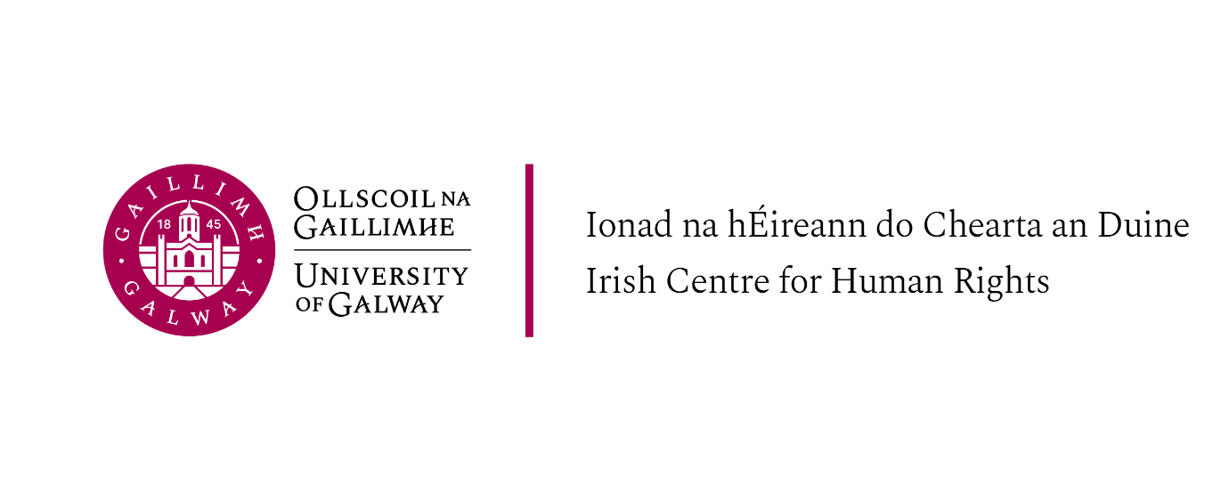
LLM Introductory Week, Schedule of Events, 9-12 September 2024

Please note that attendance at the introductory sessions is required for all students on the LLM programmes offered at the Irish Centre for Human Rights (LLM in International Human Rights Law; LLM in International Migration and Refugee Law and Policy; LLM in Peace Operations, Humanitarian Law and Conflict and LLM in International Criminal Law)

Monday 9th September

Ground Floor, Aula Maxima, The Quadrangle, University of Galway

13.30 Tea and Coffee and light lunch

14.00 Welcome and introduction to the staff and LLM programmes at the Irish Centre for Human Rights
Professor Siobhán Mullally, Director, Irish Centre for Human Rights
ICHR academic and professional services staff and Programme Directors

14.30 Introduction to LLM modules, Podcast and General Q&A
All Teaching Staff

16.00 Academic Integrity, Legal Research and LLM Dissertation information session (Professor Siobhán Mullally and graduates)

17:00 Welcome reception – Moffetts restaurant, Orbsen building

Tuesday 10th September

Ground Floor, Aula Maxima, The Quadrangle, University of Galway

9.15 – 10.00 Global Legal Action Network (GLAN) LLM placement opportunities – Dr Gearóid O’Cuinn, Executive Director of GLAN
Information about GLAN is at: https://www.glanlaw.org/

10.00 - 11.30 Professor Roja Fazaeli, Established Professor of Law and Islamic Studies, Irish Centre for Human Rights ‘Gender, Agency and Islam

11.30 - 12.00 Tea/Coffee Break

12.00 - 13.30 Guest lecture: Priya Gopalan, UN Working Group on Arbitrary Detention and International Criminal lawyer

13.30 - 14.30 Break

14.30 – 15.30 Careers in international law

15.30 - 15.45 Tea/Coffee Break

15.45 - 17.00 Guest lecture: Professor Ray Murphy – ‘Is International Humanitarian Law still relevant?’

Wednesday 11th September

Ground Floor, Aula Maxima, The Quadrangle, Main Campus, University of Galway

9.30 - 11.00 Professor Jeremie Gilbert, University of Roehampton, ‘The Rights of Nature’

11.00 - 11.30 Tea / Coffee break

11.45 - 13.00 Fengsuo Zhou (Executive Director of Human Rights in China, co- founder of Humanitarian China.) and Bill Shipsey (Director Art for Human Rights and Lawyer)

13.00 - 14.15 Break

14.15 - 15.45 Rania Muhareb, Irish Centre for Human Rights ‘Apartheid, International Law, and Palestine' with Ramez al Hayek and Hasan Abu Omar (PhD researchers, Irish Centre for Human Rights)

16.30 – 18.00 Inaugural Lecture: Professor Shane Darcy, ‘Ireland and the world – appealing to international law in times of conflict’

18.00 Wine reception

Thursday 12th September

10.00 - 11.00 Library training online - teams invite to follow

12.30 LLM in International Criminal Law (Programme students only)
Professor Shane Darcy, Programme Director
Location: Seminar Room – Irish Centre for Human Rights

14.00 LLM in International Migration and Refugee Law and Policy (Programme students only)
Dr. Ciara Smyth, Programme Director
Location: Seminar Room – Irish Centre for Human Rights

15.00 LLM in Human Rights Law Introductory Talk (Programme students only) Professor Siobhan Mullally, Programme Director
Location: Seminar Room – Irish Centre for Human Rights

16.00 LLM in Peace Operations, Humanitarian Law and Conflict (Programme students only)
Prof. Ray Murphy, Programme Director
Location: Seminar Room – Irish Centre for Human Rights

