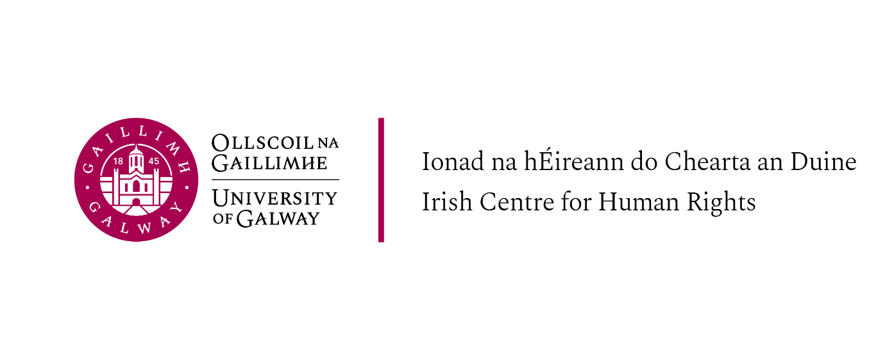
LLM Introductory Week, Schedule of Events, 4-7 September 2023

Please note that attendance at the introductory sessions is required for all students on the LLM programmes offered at the Irish Centre for Human Rights (LLM in International Human Rights Law; LLM in International Migration and Refugee Law and Policy; LLM in Peace Operations, Humanitarian Law and Conflict and LLM in International Criminal Law)

Monday 4th September

Ground Floor, Aula Maxima, NUI Galway

13.30 Tea and Coffee and light lunch

14.00 Welcome and introduction to the staff and LLM programmes at the Irish Centre for Human Rights
Professor Siobhán Mullally, Director, Irish Centre for Human Rights
ICHR academic and professional services staff and Programme Directors

14.30 Introduction to LLM modules and General Q&A
All Teaching Staff

16.00 Academic Integrity, Legal Research and LLM Dissertation information session (Professor Siobhán Mullally and graduates)

17:00 Welcome reception – Moffetts restaurant

Tuesday 5th September

Ground Floor, Aula Maxima, The Quadrangle, Main Campus, NUI Galway

9.15am – 10.15 am Global Legal Action Network (GLAN) LLM placement opportunities – Dr Gearóid O’Cuinn, Executive Director of GLAN
Information about GLAN is at: https://www.glanlaw.org/

11.30 – 12.30pm LLM in Peace Operations, Humanitarian Law and Conflict (LLM Peace Operations students only) Professor Ray Murphy, Programme Director

13.30-14.30 Guest lecture Dr Sandra Duffy, Bristol University, Co-Director of Centre for Health Law and Society (all LLM students)
‘Gender Identities, Human Rights and Law’

14.30- 14.00 – Tea / Coffee break and light snacks

15.00 – 16.30 Guest lecture and discussion: (all students)
BILQIS: Building Conceptual and Methodological Expertise for the Study of Gender, Agency and Authority in Islam
Professor Roja Fazaeli, Established Professor of Law and Islamic Studies, Irish Centre for Human Rights

Wednesday 6th September

Location: Hardiman Building – THB G011

10.00 Tea /Coffee and pastries

10.15 Film Screening and Talk: Right Now I Want to Scream: Police and Army Killings in Rio – the Brazil Haiti Connection (all LLM students)
Professor Siobhan Wills, Director, Transitional Justice Institute, University of Ulster

12.30 LLM in International Criminal Law (Programme students only)
Professor Shane Darcy, Programme Director
Location: Seminar Room – Irish Centre for Human Rights

14.30 LLM in International Migration and Refugee Law and Policy (Programme students only)
Dr. Ciara Smyth, Programme Director
Location: Seminar Room – Irish Centre for Human Rights

15.30- Tea / Coffee and snacks (Irish Centre for Human Rights ‘PC suite / kitchen area)

16.00 LLM in Human Rights Law Introductory Talk (Programme students only) (Irish Centre for Human Rights Seminar Room)
Professor Siobhan Mullally, Programme Director

Thursday 7th September

10.00 – 11.00 Library training – online (all LLM students)

Link for Library training below:

Microsoft Teams meeting
Join on your computer, mobile app or room device
Click here to join the meeting
Meeting ID: 382 794 476 141
Passcode: A9AAf8
Download Teams | Join on the web
Learn More | Meeting options

