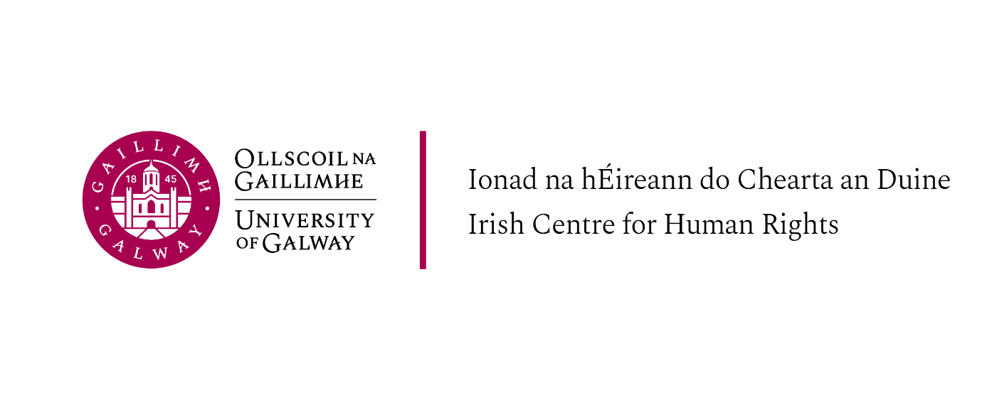
LLM Introductory Week, Schedule of Events, 8-11 September 2025

Please note that attendance at the introductory sessions is required for all students on the LLM programmes offered at the Irish Centre for Human Rights, they are as follows:
LLM in International Human Rights Law
LLM in International Migration and Refugee Law and Policy
LLM in Peace Operations, Humanitarian Law and Conflict
LLM in International Criminal Law
LLM in Gender and Human Rights: Law and Policy
LLM in Transitional Justice, Human Rights and Conflict

Monday 8th September

Ground Floor, Aula Maxima, The Quadrangle, University of Galway

11.00 Welcome from Prof Martin Hogg, Head of School of Law
Student supports overview: Using Canvas: Dr Sergei Medvedev Student Support Officer: Ms AnnMarie Gilchrist
Race Equality and Intercultural Skills: Dr Tanja Kovacic Academic Integrity Adviser: Ms Anna-Louise Hinds Career Development Centre: Ms Aisling Conroy

14.30 Welcome and introduction to the Irish Centre for Human Rights
Professor Siobhán Mullally, Director, Irish Centre for Human Rights
ICHR academic and professional services staff and Programme Directors

15.00 Introduction to staff and to LLM modules, the Human Rights Podcast, Mooting and Q&A
All Teaching Staff

16.15 Academic Integrity, Legal Research and LLM Dissertation information session (Professor Siobhán Mullally and graduates)

17:00 Welcome reception – Moffetts restaurant, Orbsen building

Tuesday 9th September

Ground Floor, Aula Maxima, The Quadrangle, University of Galway

10.00 - 11.15 Lecture and Discussion - Dr Mais Qandeel ‘ Palestine and International Law’

11.15 -11.30 Break

11.30 - 12.45 Lecture and Discussion - Dr Sophie Capicchiano-Young ‘Refugee Law in the Americas’

12.45 - 14.00 Break

14.30 – 15.30 Lecture and Discussion - Professor Roja Fazaeli ‘Gender, Islam and Human Rights’

15.30 - 15.45 Break

15.45 - 17.00 Professor Ray Murphy - Book launch, Dr Cian Moran (Irish Defence Forces) The Evolution of Humanitarian-Intervention in International Law: From the Ottoman Empire to the Russia-Ukraine War (Brill 2024)

Wednesday 10th September

Ground Floor, Aula Maxima, The Quadrangle, Main Campus, University of Galway

9.15 LLM in International Migration and Refugee Law and Policy (Programme meeting - Programme students only)
Professor Siobhán Mullally Programme Director
(Location – Aula Maxima)

10.00 am LLM in Human Rights Law (Programme meeting - Programme students only) (Location – Aula Maxima)
Professor Siobhan Mullally, Programme Director

11.00 - 12.15 Lecture and Discussion: Professor Ray Murphy ‘Is Humanitarian Law Still Relevant?’

Break

2.00 - 3.15pm Lecture and Discussion ‘Palestine, Apartheid and International Law’

3.15 - 4.30 Panel Discussion – Mobilising for Justice: Palestine, Human Rights and Accountability

Thursday 11th September

12.30 LLM in International Criminal Law (Programme students only)
Professor Shane Darcy, Programme Director
Location: Seminar Room – Irish Centre for Human Rights

13:30 Library training online – teams invite link to follow

15.00 LLM in Peace Operations, Humanitarian Law and Conflict (Programme students only)
Prof. Ray Murphy, Programme Director
Location: Seminar Room – Irish Centre for Human Rights

15.30 LLM in Gender and Human Rights: Law and Policy (Programme students only)
Prof. Roja Fazaeli, Programme Director
Location: Seminar Room – Irish Centre for Human Rights

16:00 LLM in Transitional Justice, Human Rights and Conflict (Programme students only)
Dr. Anita Ferrara Programme Director
Location: Seminar Room – Irish Centre for Human Rights

