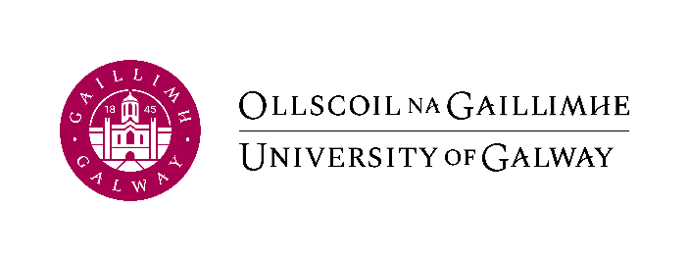
University of Galway, International Office, Distillery Road, Galway H91

Email: Federalaid@universityofgalway.ie

FEDERAL AID LOAN APPLICATION 2026-27
For internal use only

SECTION 1 – APPLICANT DETAILS

PERSONAL DETAILS  Student Name (Please PRINT): ________________________________  Date of Birth (DD/MM/YYYY): __________________  Student ID: ______________________________________  (Write ‘pending’ if you do not have it yet)  Social Security No: ___________________________ |  |  | Student Phone:_____________________________  Student Email:______________________________  (the one you check regularly)  Address:__________________________________  _________________________________________  _________________________________________
PROGRAM DETAILS  - Undergraduate / Postgraduate (Please circle as appropriate)  - Program of Study:___________________________________________________  - Study Period (Please circle): 9 months 12 months  - Will you be based in the US for any period during your program of study?  YES / NO  - If ‘YES’ please give details:  ______________________________________________________________________ | - Length of Program in years:_______  - Upcoming Year of Study :_________  (e.g. 1st / 2nd / 3rd...)  - Anticipated Program Completion Date: (mm/yyyy)________________  - Mode of Study (Please tick):  Full-Time  Part-time  Less Than Half-Time
  (For example, a student who adheres to our standard terms beginning in September and finishing in April/May would be considered to be doing a ‘9-month’ study period. A Masters student who is writing a thesis over the summer would be considered to have a ’12-month’ study period)

SECTION 2 – CONFIRMATION OF LOAN AMOUNT

Please confirm below how much you would like to borrow in USD

Your eligible loan amount is up to the maximum of your ‘Cost of Attendance’ (as per Section 2) but remember, you will have to pay these loans back so it is in your best interest to spend frugally and borrow as little as possible

Student Name:_____________________________________________

Student ID:______________________

I would like to borrow the following amount in Federal Aid. I understand that these funds may be comprised of Subsidized Direct Loans, Unsubsidized Direct Loans, and Direct PLUS Loans:

US Dollars (Max = ‘Total COA in USD’ as per Section 2): $________________

Student Signature:________________________ Date:___________________

Note: All loans are subject to eligibility. Your official eligible loan amount may be lower than your ‘Total COA’ once your SAI (‘Student Aid Index’) and other sources of funding have been taken into account.

Once your application has been processed, you will receive an email with your official ‘Cost of Attendance’, and an ‘Award Letter’ detailing your official eligible loan amounts.

APPLICATION CHECKLIST

**Please note, incomplete applications will be rejected**

Do you require PLUS Loans?
YES / NO
If yes: please ensure that you send all required documents for this along with your application

The following items must be attached to this email application:
Academic qualifications (i.e. diploma or transcripts)
A copy of your acceptance letter from University of Galway (for students entering 1st year)
Signed Master Promissory Note (MPN) for Direct Loan
Confirmation of Entrance Counselling
For PLUS loans:
Successful credit check confirmation
Signed PLUS loan Master Promissory Note (MPN)
Confirmation of PLUS loan Entrance Counselling
Supporting documentation for any ‘Additional funds’ as per Section 2
Applications should be sent by email to federalaid@universityofgalway.ie by August 1st
2026
If you have questions regarding this application, please email federalaid@universityofgalway.ie

