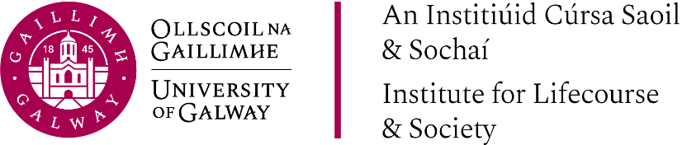

What next for Irish Public Policy Development?
Strengthening the use of Data and Evidence.

‘Strengthening Public Policy Development: Recent Progress and Next Steps.’
John McKeon, Secretary General, Dept of Social Protection.

‘The challenges and opportunities of research evidence for policy development.’
Dr Colm O'Reardon, Secretary General, DFHERIS.

