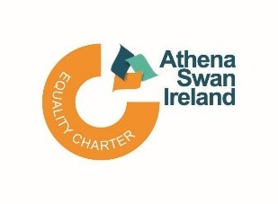

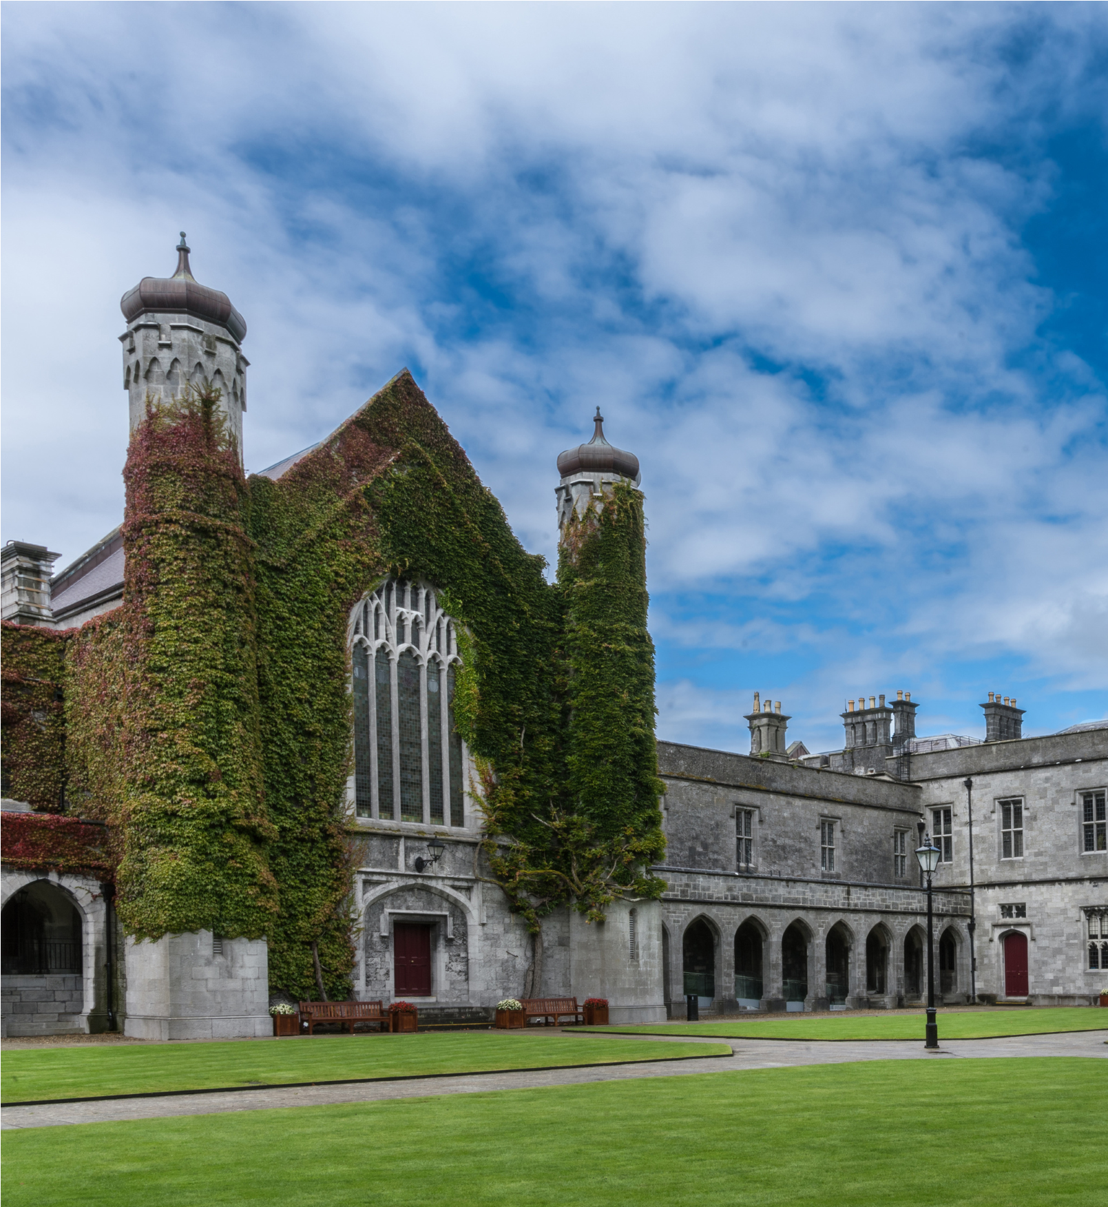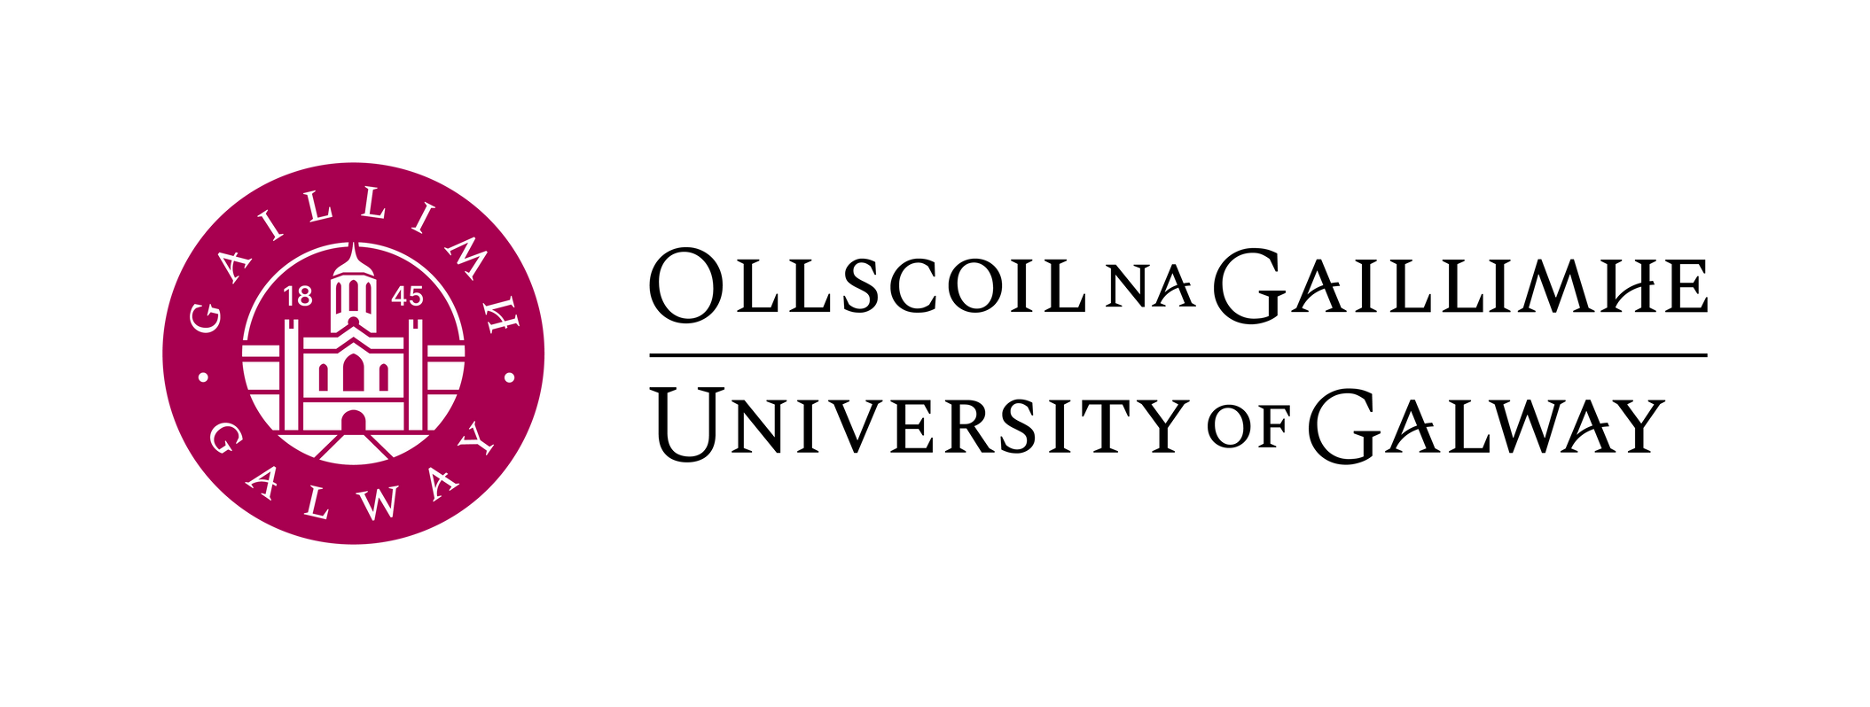

**‘Established Professor of [Insert Post Title]’.**

**‘Duration of Post’, ‘FTE’**

**Ref #:**

**TABLE OF CONTENTS**

Job Advertisement x

Background (if applicable) x

Job Description x

Eligibility Requirements x

Competency Framework for Professorship Role at University of Galway x

Profile of Our University X- X

**Established Professor [Insert Post Title]**

[Please complete table below]

|  |  |
| --- | --- |
| College | Insert details |
| School |  |
| Post Title & Subject Area |  |
| Post Duration |  |
| Level |  |
| Reports to |  |

**JOB ADVERTISEMENT**

[Insert details of the post here, keep text to a minimum for the advertisement]

Applications are invited for an appointment as [insert post title] at University of Galway.

For informal enquiries, please contact [insert contact name, title, and name of School], Email [insert University of Galway email address] +353 (0)91 49xxxx

Additional information on the School/Discipline/College (delete as appropriate) is available at: [insert weblink]

Information on the University's Strategic Plan is available at: [Strategy - University of Galway](http://www.nuigalway.ie/strategy2025/)

**Salary: €xxxxx to €xxxxx p.a (applicable to new entrants effective from January, 2011)**

This appointment will be made on the insert relevant scale in line with current Government pay policy and in accordance with the terms and conditions of the University’s Remuneration policy.[QA321-Updated-PP-Remuneration.pdf (universityofgalway.ie)](https://www.universityofgalway.ie/media/financialaccounting/financialaccountingoffice/QA321-Updated-PP-Remuneration.pdf)

**Closing date for receipt of applications is 17:00 (Irish Time) on xxxxxxxxxx. It will not be possible to consider applications received after the closing date.**

**Garda vetting may apply.**

**Appointments will be conditional on work authorisation validation.**

**Further details are available at** [**www.dbei.ie**](http://www.dbei.ie)

**For more information and Application Form please see website:**

[Jobs - University of Galway](http://www.universityofgalway.ie/about-us/jobs/) **Applications should be submitted online.**

**Please see further information on how to apply here:** [E-Recruit - University of Galway](https://www.universityofgalway.ie/human-resources/recruitment-and-selection/applicant-information/e-recruit/) and [Guidelines for On-line Applications (universityofgalway.ie)](https://www.universityofgalway.ie/media/humanresources/universityofgalway-user-guide-academic-external)

Please note that appointment to posts advertised will be dependent upon University approval, together with the terms of the Employment Control Framework for the higher education sector.

At the University of Galway, we celebrate diversity and believe that every candidate can bring unique perspectives, talents and approaches to our University community.  We actively encourage applications from all backgrounds regardless of race, religion, ethnicity, gender, family status, civil status, membership of the Traveller community, sexual orientation, disability or age.

We value flexibility and recognise that a work-life balance is essential.  We offer flexible working arrangements, including hybrid options, to accommodate the diverse needs of our staff.   Our commitment to inclusivity extends beyond recruitment as we foster a friendly and supportive work environment, where all work styles are valued and respected.  Join us in shaping a workplace that thrives on diversity, creativity and collaboration.

University of Galway is an equal opportunities employer.

**BACKGROUND IF APPLICABLE**

[Insert background detail of post here if applicable]

**JOB DESCRIPTION**

**Principal Duties and Responsibilities**

The post-holder duties will include, but not be limited to, the following:

**Teaching**

To give instruction and supervision, as directed by the Head of School, to students of the University in courses and programmes organised by the School or to which the School contributes to another School or College. Such duties to include curriculum and course design, preparation and delivery of lectures, tutorials, project supervision and general examination and other assessment responsibilities. The post-holder is also required to be available to students for academic counselling and advice. In some disciplines, academic activities may also include laboratory, workshop or clinical instruction, supervision of fieldwork, site visits and other off-campus activities.

**Research**

To engage in research and other creative and innovative activity as appropriate to the discipline. The post-holder is required to disseminate their research in academic publications, other outlets as appropriate and to participate in postgraduate supervision. The post-holder is encouraged to engage in initiatives to seek research funding, as appropriate. The post-holder is also encouraged to promote and engage in the development of collaborative research.

**Contribution and Scholarly Activity**

To participate in academic administration at School, College and University levels as part of their contribution to the University. To engage with the wider community regionally, nationally and internationally from a civic, economic, social and cultural perspective as a contribution to the life of the University. In representing the University externally, the post-holder is expected to maintain the highest professional standards, thereby enhancing the reputation of the University. The post-holder is expected to engage in scholarly activity such as, but not limited to, refereeing of journals, membership of discipline related advisory bodies and peer review panels and work associated with external examinership.

The post-holder shall carry out these duties under the direction of the Head of the School or of an authorised senior member of the staff of the School.

The post-holder shall be a member of College/Colleges in accordance with University Statutes.

The post-holder will have the capacity and willingness to act as Head of School.

The post holder may be asked to serve as Head of Discipline, and/or assume other positions of responsibility within the School, for an agreed term upon or during the period of appointment)

Hours of work are those prescribed under the Public Service Agreement in respect of Academic Staff.

**ELIGIBILITY REQUIREMENTS**

**Person Specification**

Applications will be judged solely against the criteria set out below. Applicants should ensure that their application clearly demonstrates that their skills and experience meet these criteria.

**The successful candidate will demonstrate the Eligibility requirements below:**

[Insert Eligibility requirements here, subdivide into Essential and Desirable]

**Essential Requirements:**

* Text and bullet point format.

**Desirable Requirements:**

* Text and bullet point format.

The appointment will be made to the School [insert School name], but will be associated with the discipline of [insert name of Discipline].

**Competency Framework for Professorship Role at University of Galway**

|  |  |  |
| --- | --- | --- |
| **Academic Excellence** | **Leadership Excellence** | **Organisational Excellence** |
| **Excellence in Research**  *The Professor is a leader in his / her field and contributes to the direction and development of his / her discipline and body of knowledge through planning and leading research of outstanding quality. S/he leads others to make the most effective contribution to their discipline and encourages cross discipline research collaboration.* | **Personal Effectiveness**  *The Professor is passionate and enthusiastic about the discipline/school and is committed to making his / her best personal contribution through employing excellent planning and organising, communication and decision making skills in order to achieve ambitious goals for their discipline/school and to meet the changing demands of the Professorship role.* | **Thinking Strategically**  *The Professor is responsible for developing and implementing a strategic approach to the development of the discipline/school. S/he is aware of the wider environment, has the ability to think strategically and to devise and implement changes in line with their strategy.* |
| **Excellence in Teaching**  *The Professor oversees the development of, and participates in, delivering teaching programmes which engage and inspire students at all levels and ensures a strong focus on quality teaching and on the continuous review and development of teaching skills and methodologies in the discipline.* | **Leading and Managing Others**  *The Professor is responsible for the delivery of the work programme by getting the best out of others. S/he ensures that good administrative procedures are in place, that work is organised fairly, that there is a highly engaged work environment, and that time is given generously to developing staff.* | **Collegiate and Community Contribution**  *The Professor values and works to instil a collegiate approach not only within his / her discipline / school and the University, but across the wider external community. S/he actively seeks to build effectively functioning teams and networks. S/he is approachable, collaborative, and values the contribution of others.* |

Ollscoil na Gaillimhe

University of Galway

**PROFILE OF THE UNIVERSITY**

**The University at a Glance:**

**The University Management Team**

The University Management Team (UMT) is responsible for the executive day-to-day management of the University. UMT is led by the President who is the Head and Chief Officer of the University. Our current Interim University President, Professor Peter McHugh, was appointed in 2024. You can read more about him at: [www.universityofgalway.ie/president](http://www.universityofgalway.ie/president)

Acting under the President, the members of the University Management Team (UMT) each have specific leadership responsibilities for delivery of the University’s objectives in education, research and management of the organisation. You can see the full UMT membership in the organisational chart above.

Find out more about the University’s Governance and Management structures at: [www.universityofgalway.ie/governance/the-kube-the-governance-hubhttp://www.universityofgalway.ie/governance/the-kube-the-governance-hub](http://www.universityofgalway.ie/governance/the-kube-the-governance-hub)

**Colleges and Schools**

The University has four Colleges:

* + College of Arts, Social Sciences & Celtic Studies
  + College of Business, Public Policy & Law
  + College of Medicine, Nursing & Health Sciences
  + College of Science & Engineering

Each of the Colleges is led by an Executive Dean. Within each College, decisions are taken by College Boards, chaired by the Executive Dean, and including the Heads of each School in the College.

For more information on Colleges, Schools and Disciplines, visit:

[www.universityofgalway.ie/colleges-and-schools](http://www.universityofgalway.ie/colleges-and-schools)

|  |  |
| --- | --- |
| **College** | **Schools** |
| College of Arts, Social Sciences &  Celtic Studies              College of Business, Public Policy  & Law      College of Medicine, Nursing &  Health Sciences      College of Science & Engineering | School of Political Science & Sociology  School of Psychology  School of Education  School of Geography, Archaeology & Irish Studies  School of English & Creative Arts  School of History & Philosophy  School of Languages, Literatures, & Cultures    J.E. Cairnes School of Business & Economics  School of Law  Shannon College of Hotel Management    School of Health Sciences  School of Medicine  School of Nursing & Midwifery    School of Biological & Chemical Sciences  School of Computer Science  School of Engineering  School of Mathematical & Statistical Sciences  School of Natural Sciences |

**Strategic Plan 2020-2025**

In January 2020, following widespread consultation, the University published *Shared Vision, Shaped by Values,* the University’s strategic plan for the period 2020-2025. It is structured around four core values debated and defined by the University community: Respect, Openness, Sustainability and Excellence. Over 50 Flagship Actions for implementing the strategy are articulated under each value. A further section entitled ‘Building for the Future’ articulated the University’s plans for campus development in the years ahead.

* + **Strategic Plan:** You can read the strategic plan at: [www.universityofgalway.ie/strategy2025](http://www.universityofgalway.ie/strategy2025)
  + **Halfway Progress Report:** In December 2022, the University published a halfway report on our progress towards strategy implementation. You can read the report (internal access only) at:

[https://nuigalwayie.sharepoint.com/sites/UniversityStrategy-HalfwayReport.](https://nuigalwayie.sharepoint.com/sites/UniversityStrategy-HalfwayReport) Or request a copy from the Director of Human Resources.

We are currently at the final stages of developing our next Strategic Plan 2025-2030, building on our core values, and with a renewed focus on our **core mission of teaching, learning, research and innovation that are both excellent and impactful**. The incoming Dean will play an important role in achieving our strategic priorities for research and innovation, delivering landmark initiatives, and developing our research functions, systems and infrastructure to enable success in the years ahead.

**Academic Programmes**

The University provides teaching through four Colleges and 18 Schools up to PhD level, for primary and postgraduate Degrees and for a wide variety of Diplomas, Certificates and, more recently, Micro-credentials. 68 separate programmes of study are offered for undergraduate students, with over 190 taught programmes at postgraduate level and over 90 structured postgraduate research programmes. The University also provides a programme of Adult Learning and Professional Development and conducts a number of Summer Schools.

The University has displayed considerable dynamism in the development of programmes to meet the evolving needs of society. Supported by funding from the Human Capital Initiative, our *Designing Futures* programme is transforming how our students learn and develop skills, through success coaching, transdisciplinary modules and our IdeasLab and Empathy Lab programmes. The University is also playing a key role in the delivery of the HCI Multicampus *Micro-credentials* project, which aims to develop a series of micro-credentials across the IUA Universities, and which will provide upskilling and reskilling opportunities to those in employment and those seeking to enhance their employability. Meanwhile, through our membership of the *ENLIGHT network* of European universities, we are developing greater opportunities for student mobility and cross-border collaboration on academic programmes and research.

**Student Body**

The total student body, including part-time learners, comprises over 20,000 students, over 25% of whom are studying at postgraduate level.

Over 18% of our students were from outside the island of Ireland, coming to study in Galway from over 122 different countries worldwide. Through the Global Galway project, we are seeking to grow our international diversity further through a greater focus on international recruitment, mobility and partnerships.

**Research**

University of Galway is a globally focused research-intensive university. We recognise that research areas are neither standalone nor static. The problems of the world are not solved from just one perspective. With our knowledge of global challenges, national policy and regional needs our research areas enable an interdisciplinarity approach and impact.

Our research community achieved over €110m in EU research funding during the 2014-2020 programme period. We are now firmly focused on the 2021-2027 programme cycle, with ambitions to achieve in excess of €150m of EU research funding, including Horizon Europe. In 2023, the University had a record €82m annual spend in research, across a breadth of research areas. Engaging with our partners locally, nationally and worldwide, our current university strategy (Strategic Plan 2020-2025) invites ambition in research that underpins the following areas:

* + Enhancing policy and society
  + Enriching creativity and culture
  + Improving health and wellbeing
  + Realising potential through data and enabling technologies
  + Sustaining our planet and people

These areas are aligned to the work of our Research Institutes, including:

* + Data Science Institute
  + Ryan Institute for advancing sustainability and innovation
  + Institute for Lifecourse and Society
  + Institute for Creativity
  + Institute for Clinical Trials
  + Institute for Health Discovery and Innovation (launched in October 2024).

For more information on our research institutes, centres and units, visit:

[www.universityofgalway.ie/our-research/listings/research-centres-institutes-and-units.html](http://www.universityofgalway.ie/our-research/listings/research-centres-institutes-and-units.html)

**Staff**

The University employs approximately 2,500 staff, including full-time and part-time, which includes approximately 1,000 academic staff.

Human Resource issues are managed within the Human Resources Office, under the direction of the Director of Human Resources. In 2023, a new Hybrid Working Policy was launched to facilitate more flexible working arrangements in a post-Covid environment.

**Finances**

The University is its own financial authority and has an annual income of over €350m, including contract research income of over €70m. The sources of income are Student Fees (approx. 40%), State Grants and Pension funding (approx. 30%), Research Income (20%) and Miscellaneous (10%).

**The University and the Irish language**

The University’s commitment to the Irish language was first set out in the University College Galway Act 1929 and this was reiterated in the University College Galway (Amendment) Act 2006, which states that one of the principle aims of the university is “the provision of education ... through the medium of the Irish language”.

The University’s Strategy 2020-2025 goes even further and commits to developing and implementing an ambitious and future-focused strategy for the Irish language, in partnership with national stakeholders and Gaeltacht communities, based on our values of respect and sustainability. In 2021, the University published its first Irish Language Strategy and appointed its first Irish Language Officer.

Irish language programmes are delivered primarily through the Discipline of Irish and through Acadamh na hOllscolaíochta Gaeilge, our Irish language academy, which has three centres located in the Gaeltacht.

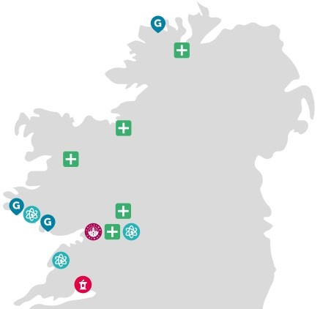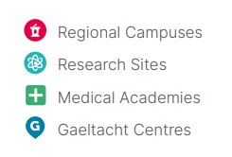

**Our Region**

Our regional footprint includes five Medical Academies, three Gaeltacht centres, off-campus research sites in Connemara and the Burren, and a satellite campus in Shannon College, Co. Clare.

**Our Campus**

The main University Campus, with an area of some 105 hectares in the heart of the city of

Galway, is attractively situated on the west bank of the River Corrib, and stretches from Nuns' Island in the south to the Sports Grounds in Dangan to the north. Other teaching and research facilities are located outside the city in An Cheathrú Rua, Carna and Mace Head in Connemara, in Shannon, Carron and Finnevara in Co. Clare, and in Gaoth Dobhair in Co. Donegal. The University’s medical students and researchers benefit from on-the-ground Medical Academies located in hospitals throughout the region from Portiuncula University Hospital in Co. Galway to Letterkenny University Hospital in Co. Donegal.

**Building for the Future:** The University is in the process of finalising its masterplan for the years ahead, which will include the Nuns’ Island creative and innovation district in Galway city centre. Recent years have seen some significant additions to campus, including:

* Clinical Simulation Facility: completed in 2022
* Dunlin Village on-campus student accommodation (674 beds): completed in 2022

The following construction projects have been commenced or approved in recent years:

* Learning Commons (new Library): construction commenced in 2024
* Water Sports Centre: planning permission approved in 2023
* New Law School: design for planning in progress
* New Pharmacy School: funded to planning stage
* New Medical School: funded to planning stage

**Sustainability**

Sustainability is one of the University’s core values and we are recognised as a leader in the transition to a sustainable future. We are committed to the SDGs at an institutional level on multiple levels:

* As a signatory to the SDG Accord, we have committed ‘to align all major efforts with the SDG targets and indicators, including through our education, research, leadership, operational and engagement activities’ and to ‘share our learning’.
* Our Climate Action and Sustainability Policy formalises our commitment ‘to lead the transition to a sustainable future by embedding the SDGs into all our major efforts’.
* Our Sustainability Strategy 2021-2025, which is mapped to the SDGs, sets out our vision across the campus and beyond.

In the past three years we have been ranked First in Ireland and Top 50 worldwide in the Times Higher Education Impact Rankings for our progress on the SDGs. In 2023, we established a new Sustainability Office to lead the implementation of our Sustainability Strategy and to embed sustainability across our curriculum and operations.

Through the work of the University’s Sustainability Office, the Community and University Sustainability Partnership, colleagues in Buildings and Estates and other university operations, and our Student Societies, we have advanced understanding and action on the urgent need for sustainability, using a Learn – Live – Lead model. Since 2006, we have achieved over 50% reduction in energy usage, exceeding our targets. In 2021, we established our carbon footprint, and we are actively working towards achieving carbon neutrality by 2050.