Statutory Examination of Pressure and Lifting Equipment – Process Summary (V. 8 - August 2026)

Context:
The University is obliged to carryout out the statutory examination of defined lifting and pressure equipment to ensure compliance with the:-
- Safety, Health and Welfare at Work (General Application) Regulations 2007 Chapter 2 Part 2: use of Work Equipment
- Safety, Health and Welfare at Work (General Application) (Amendment) Regulations 2012 – Pressure Systems

HSBEIL Engineering are appointed to provide this statutory examination service on. The Contract is arranged via the University Insurance Brokers. The cost of this annual service is paid centrally.

University of Galway Units/Sites:
Units with any relevant equipment are responsible for its safe installation, use, maintenance and disposal. This includes ensuring that the necessary statutory examinations are carried out and that the report actions set out in such a statutory examination report are complied with.

For the purposes of these examinations the relevant Units are set up as sites on the HSB online (Connect) system. The sites are intended to correspond with the Units responsible for the equipment. The current site list and contacts are as below:-

Site | Address 1 | Site contact name
22 | University Road | Sean Farrell
13 | Buildings & Estates | Tony Nevin
14 | Ryan Institute Carna and on Campus | Oilibhéar Ó Niadh (Carna)  Kieran O’Halloran (Campus
15 | School of Engineering | Martin Burke
16 | School of Biological & Chemical Sciences: Microbiology | Martina Wernecke
17 | School of Natural Sciences: Physics | Stuart Harries
18 | Nuns Island | Tony Nevin
19 | School of Biological & Chemical Sciences: Chemistry | Marion Vignoles
20 | School of Biological & Chemical Sciences: Biochemistry | Martina Wernecke
21 | School of Natural Sciences: Zoology | Storm McDonald (2nd contacts: Darius Nowak, Aedín McAleer)
23 | BMS & Orbsen | William Brennan
24 | Shannon College of Hotel Management | Imelda O’Connell
25 | School of Medicine (Lambe Inst and Human Biology Bld) | Mark Webber
 | Campus Living (Goldcrest) | Thomas Higgins

Head of Unit Responsibilities/Site Contact acting on their behalf:
Each Head of Unit/Site is responsible to ensure that there is a current contact in place at all times. To change the contact details, please email kevin.scully@hsbeil.com or alice.daly@universityofgalway.ie for University staff specifically to be set-up, where required by the Head of Unit.
Each Head of Unit/Site is responsible to ensure that there is a current contact in place at all times. To change the contact details, please email kevin.scully@hsbeil.com or alice.daly@universityofgalway.ie for University staff specifically to be set-up, where required by the Head of Unit.

For each site there is a list of equipment that is being examined by HSB Engineers.
On receipt of the report the site contact must review the report and follow-up on the actions required in the report. If there are any queries on this, such as resource implications this needs to be referred directly to their Supervisor/Head of Unit.
Where a report identifies that there is an immediate need to take equipment out of service. HSB Engineering email the University of Galway Safety Office directly. The Health and Safety Authority are automatically notified.

If there is any further equipment to be examined the Site Contact should email kevin.scully@hsbeil.com

Similarly if any Unit has not had relevant lifting or pressure equipment statutorily examined previously they should contact kevin.scully@hsbeil.com to arrange this as a matter of priority.

Equipment Maintenance
Units are responsible to ensure the safe maintenance of their equipment in accordance with statutory provisions such as the Safety, Health and Welfare at Work (General Application) Regulations 2007 and the manufacturer’s and supplier’s specifications. The Unit/Principal Investigator owning the equipment is responsible for establishing an equipment maintenance contract where required and meeting the cost of maintenance. Units with equipment maintenance contracts in place should confirm this in the first instance to kevin.scully@hsbeil.com so that the statutory examination and servicing of the equipment can be co-ordinated to facilitate thorough examinations.

University of Galway Equipment Tagging
HSBEIL Engineering provide a tagging service to confirm the statutory examinations of defined lifting and pressure equipment. These tags will provide a quick reference visual aid to allow the owner/user to determine if that item of equipment is within the defined statutory compliance period, or if the statutory compliance period has elapsed.

Tags are as follows –

Cable tie type Tag: Miscellaneous Lifting Equipment - for example Loose Lifting Equipment, Harness, Lanyards etc. The Tags may vary in colour

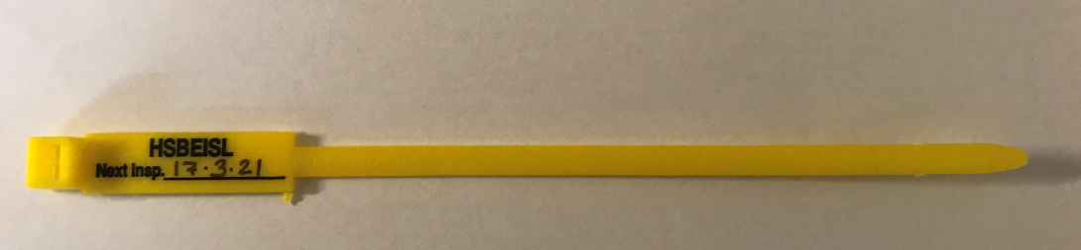

These tags will be closed around the item and will display the Next Inspection Date:
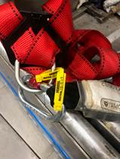
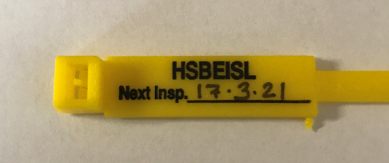

Fixed Sticker type Tag: Fixed Pressure and Lifting Equipment – for example Passenger/Goods Lifts, Fork Lift Trucks, Hot Water Boilers, Autoclaves etc.,

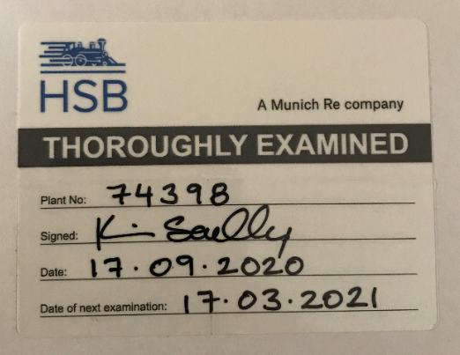

These tags will be fixed to the item and will display the Plant Serial Number, the signature of the person that has completed the examination, the date the examination was completed and the date of the next examination.

Statutory Examination Reports/Queries:
On completion of an examination the site contact will be subsequently provided with a copy via HSB Connect.
Each site contact can self- administer their use of the site and all site contacts have been provided with training in using HSB Connect.
For University queries on using HSB Connect or to arrange further training please contact john.golden@universityofgalway.ie

The HSB Connect Support Team can be contacted by email @ HBBconnect@hsbeil.com or phone 0044 161 817 2115.

Equipment Disposal:
When pressure or lifting equipment is no longer in service or requires to be disposed of, the Unit Head/Unit site contact must inform HSB Engineering directly kevin.scully@hsbeil.com and attach signage to state that the equipment is no longer in service and can no longer be used. If it is for disposal, they must ensure that the equipment is safely and effectively disposed of.

