Specialist Risks |  |  |  |  |  | DO NOT TOUCH
Sharps | 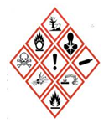Chemical Hazards | 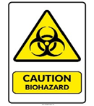Hazard Group 2 | 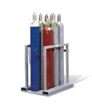Asphyxiant Gas |  |  | 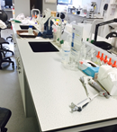Benches | 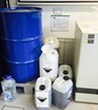Chemical Waste | Gas Cylinders | 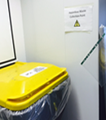Hazardous Waste Bins | 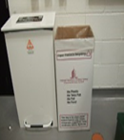Glass Waste
Contract Cleaners to ONLY clean |  |  |  |  |  | Contract Cleaners to ONLY empty these bins
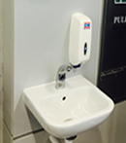  Hand Wash Basin | 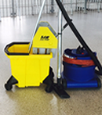  Floors | 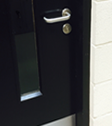  Doors |  |  |  | Bins | 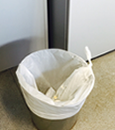Bins

This Contract Cleaners Operational Control Summary sets out the specialist risks, areas to be cleaned and wastes to be emptied in the above table. The remainder of the Safety Working Procedures (below) are in accordance with the Buildings & Estate’s Safety Management System for Cleaners work in Laboratories.

Safe Working Procedures
- No staff are to enter a laboratory without contacting the Lab Manager to ascertain if the work will expose them to hazards present in the laboratory.
  - Cleaning staff who have received training and who adhere to agreed University practices and procedures are exempted from this.
  - Signage to be update for additional hazards or to notify if the facility is out off limits.
- For any hazardous work, a detailed risk assessment must be undertaken.
- Staff must wear additional personal protective equipment where appropriate.
- If staff are unsure about any aspect of the work, they must contact Buildings and Estates \ Lab Manager.
In an emergency:
- Security staff (ext. 3333) may act as first responders to a chemical spillage but should not deal directly with the chemical. Contact the Lab Manager immediately during work hours. In the case of large spillages phone the Emergency Services – the Fire Brigade at 999/112 or 9-999/9-112 from an internal phone.
- When responding to a gas detector activation, contact Security staff (ext. 3333). Do not enter the lab until authorised to do so.

