Computer Display Screen Equipment (DSE) Self-Assessment checklist for hybrid working
The DSE Assessment process is only complete when a Full DSE Assessment has been arranged through your Unit Safety Coordinator and DSE Assessor - this DSE Self-Assessment is Part 1. The DSE Assessment process is a requisite for consideration for hybrid working and should NOT be completed if not part of a hybrid working application.
Section 1
Preliminaries
We need to first get some information about you and provide some introductory information.
1. Name of Employee (Surname, Forename)
2. To which Unit are you primarily affiliated?
Please take care identifying your correct Unit, e.g. College of Science and Engineering ONLY applies to a very small number of staff, select the correct School.
[There follows a list of 53 Units]
3. Choose the email address for your Safety Co-ordinator
A list of current Safety Co-ordinators is available here:
https://nuigalwayie.sharepoint.com/:x:/s/HealthandSafetyOffice/EX1wZGRqeyVKiVaREpYClZkBxQlZ84DK8a9oZgl0LtyTVw?e=ogijgB
It is very IMPORTANT that you select your correct Safety Co-ordinator, failure to do so will delay your Hybrid Working application
[There follows a list of 53 Safety Coordinator email addresses]
4. Date of this Self-Assessment:
5. Have you previously had your Computer Workstation at work assessed by a Unit DSE Assessor?
If Yes, use the same principles to self-assess your Home Computer Workstation. (If No, you should arrange a DSE assessment of your Campus Workstation as soon as possible)
Yes/No
6. Are you using a Laptop or a Desktop?
If you use a Laptop, you MUST use a separate keyboard or screen. It is not possible to assess display screen equipment where a laptop is used on its own. Please arrange the correct equipment then return and complete the self-assessment.
It is also not recommended to use a laptop alone for lengthy periods of time (irrespective of this DSE Assessment). Some laptop guidance is available here: http://www.nuigalway.ie/media/healthsafety/Laptop-Guidance.pdf
Desktop/Laptop with additional keyboard or screen/Laptop
If you answer ‘Laptop’ (alone), the Form terminates here.
Section 2
Workstation
7. Does your home workstation have adequate space for the necessary equipment including mouse, keyboard, laptop/PC, laptop stand, monitor and does it allow the employee to find a comfortable position?
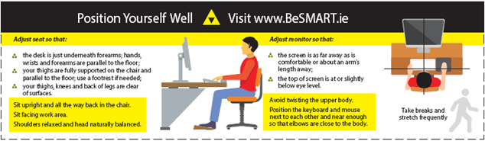
See Ergonomics Infographic for an overview on Working from Home https://ergonomics.org.uk/resource/working-from-home-infographic.html or the Health & Safety Authority’s Guidance on Remote Working https://www.hsa.ie/eng/topics/remote_working/ (currently being updated)
Yes/No
8. Is there a dedicated workspace that can be set up in the home that is safe, suitable and free from distractions?
If no, arrange this as far as possible
Yes/No
9. Is there enough knee clearance underneath the workstation?
If no, the employee should remove obstructions
Yes/No
10. Is there enough space to allow you to change position and vary movements?
If no, the employee should rearrange work area
Yes/No
11. Do you need a document holder to read documents?
If needed, the employee should request one
Yes/No
Section 3
Chair
12. Is your chair stable, adjustable in height, allows freedom of movement and provides lower back support?
Under the Hybrid Working Policy, the office chair is the responsibility of the employee. Your chair must follow the specific regulations https://www.hsa.ie/eng/publications_and_forms/publications/general_application_regulations/display_screen.pdf (see page 19)
Yes/No
13. Is the chair set up so that the forearms are level with the desk?
If no, the employee should adjust the height of their chair seat so forearms are now level with the desk
Yes/No
14. Are your feet flat on the floor when the chair is adjusted to the right height for typing? If your feet are above the floor you should use a footrest.
You can temporarily use a large book to raise your feet to right height. Otherwise footrests are available through Stationery Suppliers and similar
Yes/No
Section 4
Screen
15. Is the screen positioned to avoid glare and reflection?
Position at a right angle to the window and consider using blinds
Yes/No
16. Can your screen swivel and tilt easily?
If no, the employee should consult their computer user guide
Yes/No
17. Is the screen positioned so that the top of the screen is at eye level or slightly below to avoid sustained bending of your neck?
Raise the screen on a screen stand or lower to achieve the required position.
Yes/No
18. Is the image on the screen stable with no flickering?
Ensure the screen is clean and usable. Report to manager if it needs to be replaced.
Yes/No
Section 5
Communications
19. Are arrangements in place for staff consultation and for you to report issues e.g. workload, accidents, etc.
Under the Hybrid Working Policy the employee should check with their manager and review their hybrid working arrangement if necessary
Yes/No
Section 6
Keyboard/Mouse
20. Are the mouse and keyboard within easy reach with space available in front of the keyboard? Is your keyboard at an angle for more comfortable typing?
Position keyboard so that there is space to comfortably rest your hands between typing
Yes/No
21. Is the mouse or input device suitable? Ensure they are positioned close to you and use support for your wrist and/or forearm if needed.
Yes/No
Section 7
Lighting
22. Is the lighting available (natural, task lighting) suitable for the type of work being carried out and your vision?
If not suitable, organise additional room or desk lighting adjacent to your workstation.
Yes/No
Section 8
Health
23. Have you availed of an Eye Test if needed?
If not, use the below link to the Health & Safety website to apply.
http://www.nuigalway.ie/health-safety/lab-office-field-diving/officesafety/eyeeyesighttesting/
Yes/No
24. Has the employee been advised to report any musculoskeletal discomfort?
You should report any discomfort affecting your muscular and skeletal system that is associated with your computer work to your manager. Answer 'Yes' to this. (This IS the advice to report same).
Yes/No
25. Do you take adequate breaks/changes in activity from computer work?
The employee should vary work and take breaks/changes in activity to avoid prolonged sitting. Stand up/move at least every 30 minutes and avoid back-to-back video calls/online meetings.
Yes/No
Section 9
Heating & Ventilation
26. Is the room you’re working in warm enough and has it adequate ventilation?
Organise supplementary heating/open windows when cold or inadequate ventilation is an issue.
Yes/No
Section 10
Electricity
27. Have your household electrical supply and equipment e.g. sockets, lighting, RCD, heaters, that are not provided by the employer, been checked by you on a regular basis?
Check your RCD every 3 months, see Safe Electrics link (https://safeelectric.ie/help-advice/home-safety/ ). Contact a Registered Electrical Contractor for work on electrical systems.
Yes/No
28. Is the area around the workstation kept clear of trailing cables and trip hazards?
If not, eliminate any unnecessary cables and tidy away others safely from the access routes.
Yes/No
29. Is there an adequate number of sockets available?
Eliminate or relocate any unnecessary electrical equipment.
Yes/No
30. Check any portable electrical equipment provided by the employer regularly. Is unsafe equipment taken out of use (check for frayed wires, signs of burns or melting)?
Use this Electrical Equipment Safety Check (link below) to carry out a basic check of the electrical equipment. http://www.nuigalway.ie/media/healthsafety/f_7455_6693-NUIG-Electricity-Safety-A4-Leaflet-4.pdf
Yes/No
Section 11
Fire
31. Does the homeowner check firefighting and detection equipment regularly and is an emergency plan in place in case of fire (Fire detection and firefighting equipment is the responsibility of the homeowner).
Ensure that you have the basic fire safety measures in place to prevent, escape safely, detect and extinguish a fire in the home.
Yes/No
For Information only:
32. This is a suitable home computer set-up relevant to this checklist. Please insert an image of your setup. This will be useful for the DSE Assessor but this is NOT a required action for now but will be an essential part of the Full DSE Assessment.
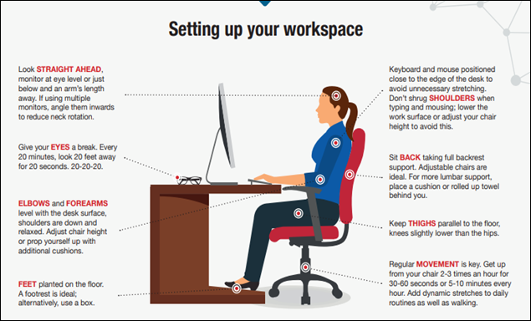

33. For further details see the above full infographic at Chartered Institute of Ergonomics & Human Factor's Working from Home Infographic (https://ergonomics.org.uk/resource/working-from-home-infographic.html ), further information at Health and Safety Authority Remote Working (https://www.hsa.ie/eng/topics/remote_working/ ) [the specific link to remote working is currently marked Page Under Review] and the more detailed University of Galway Office Display Screen Equipment (DSE) Assessment Form for DSE Assessment on Campus (http://www.nuigalway.ie/media/healthsafety/NUI-Galway-DSE-Assessment-Form.pdf )

