Application Form
Hardiman PhD Scholarships

The closing date for receipt of applications is 17:00 (Irish Time) Friday, 7th February 2025.
For information on the PhD Scholarships and the application process, please visit our website.
Applicant Details
Title Mr/Mrs/Miss/Ms/Other  (specify) | Last Name | First Name | Middle Name(s)
Date of birth (DD/MM/YY) | Please select (√) one of the following:  Female  Male  Non Binary  Other  Prefer not to say | Nationality (i.e. your passport-issuing country) | Place of Birth
Permanent Address |  | Address for correspondence (if different)
…………………………………………………………………  …………………………………………………………………  …………………………………………………………………  Postcode……………………………Country…………  Telephone Number …………………………………..  Mobile Number ………………… |  | …………………………………………………………………  …………………………………………………………………  …………………………………………………………………  …………………………………………………………………  Postcode……………………………Country …………  Telephone Number ……………………………..
E-mail Address ………………………………………………………………………………………………………….

- Current Study (if applicable)

Degree | Major Subject | Expected Completion Date | Institution Name | Student No.

- Education

Qualification | Major Subject | Completion Date | Grade | Institution Name | Student No.
- Please list any Academic Awards or Scholarships received.

- Please give details of your research experience.

5. Personal Research Statement: Please write a brief statement (max 1000 words), outlining your interest in and suitability for a scholarship and the selected research area(s).
Describe your research question, aims and objective, theoretical/conceptual framework, methodology, research plan and relationship of the project to existing research. Please also indicate your motivation for pursuing a PhD on this research topic, your reasons for choosing this supervisor and why you are particularly suited to this research programme.

- Please provide any other relevant information.

- Insert your CV here (maximum 2 pages).

- Proposed PhD Supervisor at University of Galway
Applicants must nominate one supervisor and forward the ‘University of Galway Supervisor Form’ to the proposed supervisor for completion.
- Have you contacted this supervisor to discuss your PhD research plans?
Yes ☐ No ☐
- We require a completed University of Galway Supervisor form.
- Download the University of Galway Supervisor form available on our website.
- Fill out Section A in the University of Galway Supervisor form and provide this to your proposed supervisor.
- The proposed supervisor should then complete Section B of the University of Galway Supervisor form and submit to hrscholar@universityofgalway.ie, to be received by 17:00 (Irish Time) Friday, 7th February 2025.
- Please provide the name and contact details for the proposed supervisor below.

- Supervisor Name: ___________________________________

- Email: _____________________________________________

Normally each supervisor may only be awarded one new Hardiman scholarship-funded PhD student each year.

- Academic References
We require two references that indicate your academic suitability and potential to undertake postgraduate research at University of Galway. References from any proposed supervisors will not be accepted.
- Please provide the names and contact details for each of your referees below.
- Please gain the consent of any proposed referee before nominating.
- Download the Academic Reference Form available on our website.
- Fill out Section A in two copies of the Academic Reference Form and provide these to your referees.
- Each of your referees should then complete Section B of the Academic Reference Form and submit to hrscholar@universityofgalway.ie, to be received by 17:00 (Irish Time) Friday, 7th February 2025.
Name | Address | Position | Contact Details
 |  |  | Email:
 |  |  | Telephone:
 |  |  | Email:
 |  |  | Telephone

- At least one Hardiman PhD Scholarship will be awarded to a candidate with a disability who meets the determining criterion. “The determining criterion in awarding a Hardiman PhD Scholarship shall be the quality of the applicant “
Do you wish to be considered for a Hardiman PhD Scholarship that will be awarded to a candidate with a disability who meets the determining criterion?
Yes ☐ No☐

10.1 Please visit the University of Galway Disability Support Service for information on disability support at our university. For further details on disability please visit AHEAD.ie.
10.2 Applicants, who have confirmed that they wish to be considered for this PhD Hardiman Scholarship, are required to provide verification of their disability, as part of the Hardiman PhD Scholarship application process, submitted by email to hrscholar@universityofgalway.ie, by 17:00 (Irish Time) Friday, 7th February 2025.
Information, on the type of professional report required for confirmation of diagnosis, from an appropriate consultant, can be found under the ‘1. What you need in order to apply of the Disability Support Service website.

Documentation which has been completed in a language other than English can be submitted, along with an English translation. This translation must be conducted by an individual/organisation that is completely independent of the applicant.
10.3 Please confirm your consent by ticking ‘Yes’ that the information you disclose regarding your disability is shared with relevant staff for the purpose of the Hardiman PhD scholarship.
Yes ☐ No☐
If you tick ‘No’ this means that you are not eligible to be considered for the Hardiman PhD scholarship to be awarded to a candidate with a disability.

11. How did you hear first about the Hardiman PhD Scholarships?

☐ University of Galway Staff ☐ University of Galway Website ☐ University of Galway Alumni network
☐Word of mouth ☐ www.jobs.ac.uk ☐ www.findaphd.com
☐ Social media ☐ Other - please provide details
Please note that it is your responsibility to ensure that the proposed supervisor submits the completed ‘University of Galway Supervisor Form’ and that Referees submit the completed ‘Academic Reference Forms’ to hrscholar@universityofgalway.ie by 17:00 (IRISH TIME) Friday, 7th February 2025.
Incomplete applications will not be assessed.

Declaration

I hereby declare that I have read and accept the Applicant requirements as set out in the Applicant’s Guide on the Hardiman website.
Please type your name in the box below to indicate that the information you have provided is true to the best of your knowledge. You may be asked to sign the form if selected to attend for interview.

Applicant’s Signature | Date

How to submit your Application Form
- Save the application form in PDF format, with your full name included in the filename. See example below:

- Email the application form as an attachment with your full name in the subject line to hrscholar@universityofgalway.ie by 17:00 (IRISH TIME) Friday, 7th February 2025. See example below:
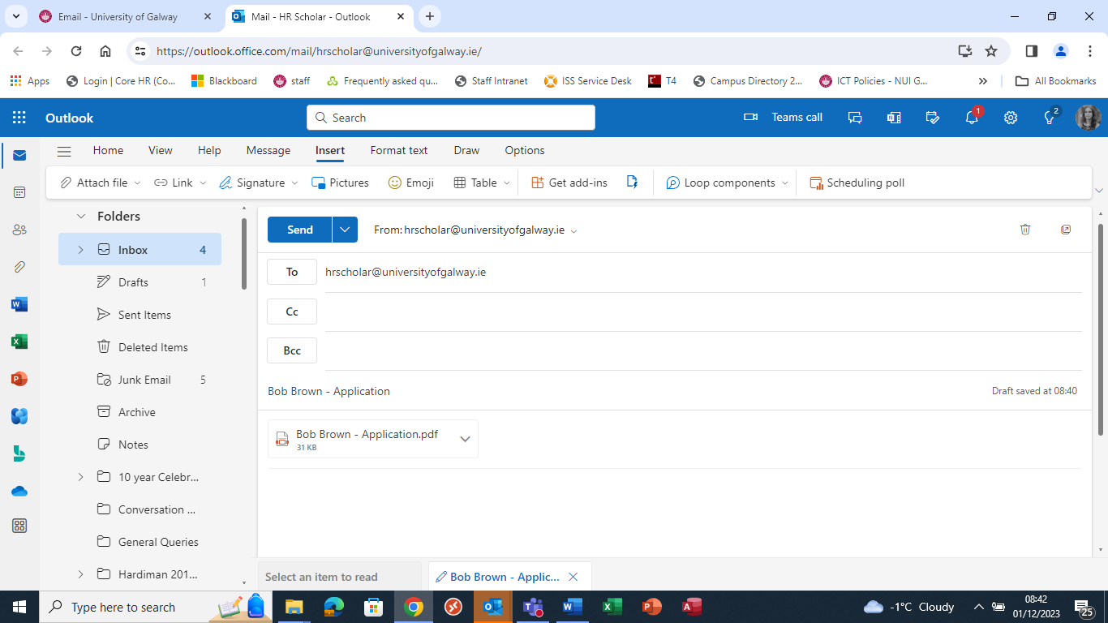
- IMPORTANT: The two completed Academic Reference Forms and Supervisor Form must also be received by hrscholar@universityofgalway.ie by 17:00 (IRISH TIME) Friday, 7th February 2025.

English Language Requirements

Entry Requirements - University of Galway
Language tests must be undertaken no more than two years prior to commencement of your programme at the University. The University of Galway TOEFL institution code is 8861.
Please note that you may be asked to provide transcripts of your academic record and qualifications in the English language should you progress to the later stages of the selection process.

