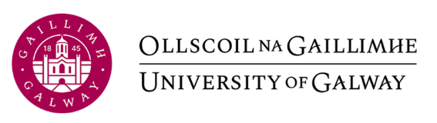

Appeal Application (Progression) GS 055

Student Details Student Name*
First Name

Last Name

Student ID Number*

Email *
@universityofgalway.ie

Phone Number*

Progression Decision Details
College:
Research degree programme:
Date of GRC recommendation:

Grounds for Appeal

A- If there is evidence of substantive irregularity in the conduct of the examination and / or the assessment process, or where a student presents evidence to support an assertion that the mark awarded was incorrect.

B - If there are extenuating circumstances that impacted on the student's exam or assessment performance of which the Examinations Board were not aware when making its decision; or, the Examination Board were aware of the circumstances, however, were not aware of the impact of those circumstances on the student's exam or assessment performance. If the extenuating circumstances had not been made known previously to the Dean of College, the appeal must include a support explanation for the non-disclosure. Where medical evidence is being relied upon, appropriate certification by an independent Medical Practitioner (excluding any Medical Practitioner who is a family relation) should be attached.

Statement of Appeal
Typed Statement of Appeal : A full description of what happened and why the appeal is being made.
Statement of Appeal

- Attach as one file any other appropriate, dated, documentation relating to the circumstances cited in your appeal e.g. expanded statement of appeal, medical evidence, correspondence, transcripts (this list is not exhaustive).
- Applicants are advised that the Board can request additional documentation at a later stage, if the Board consider it relevant.
- Important: Only one file can be attached to this form. If you have multiple documents or files, ensure that you combine them into a single file.
- A Zip file is not an acceptable format as it contains multiple files.

Student Declaration *

By ticking this box I declare that all of the information in this appeal application is my own and approved by me*

Please save this completed form and email, with relevant attachments to
govandacademicaffairs@universityofgalway.ie
Please include as subject of the e-mail: ‘Appeal a decision not to allow progression to the Standing Committee of Academic Council’

