SCHOOL OF BIOLOGICAL AND CHEMICAL SCIENCES

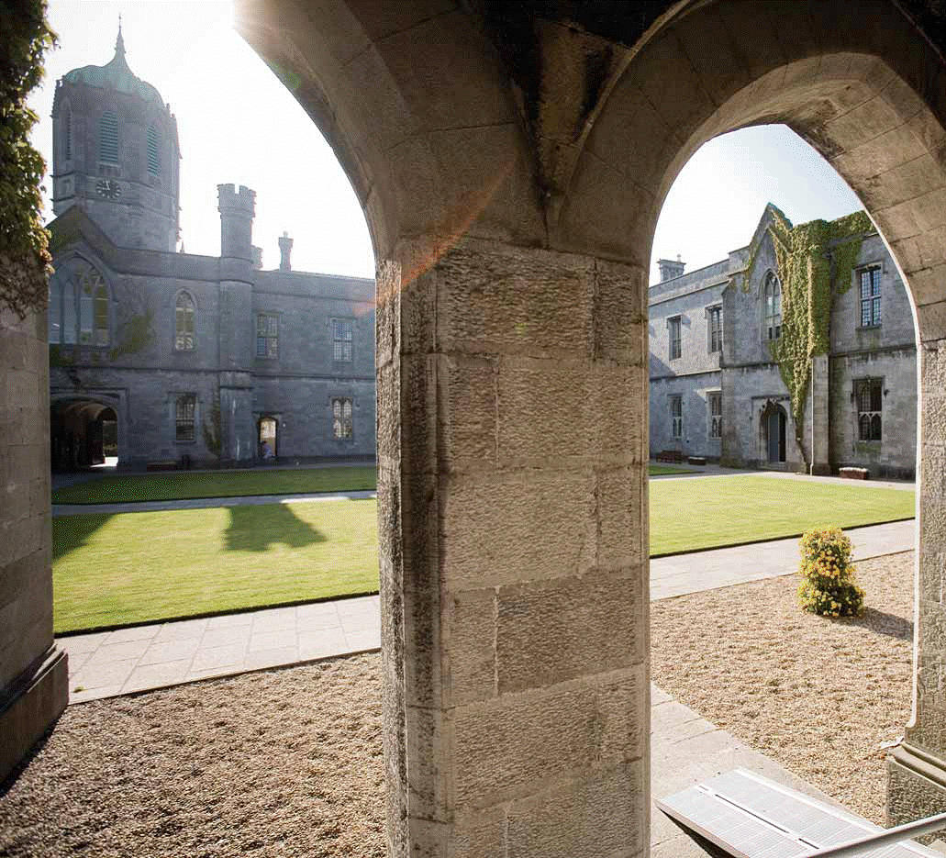

4th Year Medicinal Chemistry
Information Booklet
2023-2024

CONTENTS

SUMMARY OF COURSE STRUCTURE 3

SEMESTER I & II TIMETABLES* 4

CH448: SPECTROSCOPIC AND PHYSICAL METHODS AND APPLICATIONS 5
CH451: PRACTICAL SKILLS DEVELOPMENT 6

CH429: PHYSICAL CHEMISTRY 8

CH432: BIOPHYSICAL CHEMISTRY 9

CH438: BIOORGANIC CHEMISTRY 10

CH445: ADVANCED INORGANIC CHEMISTRY 11

CH446: BIOINORGANIC AND INORGANIC MEDICINAL CHEMISTRY 12

CH4113: ORGANIC CHEMISTRY 13

CH4114: CURRENT TOPICS IN MEDICINAL CHEMISTRY 14

CH4101: RESEARCH INVESTIGATION 15

SCHEDULE RESEARCH INVESTIGATION MODULE 16

RESEARCH JOURNAL TEMPLATE 17

GUIDELINES IN WRITING REPORTS 18

PROJECT ASSESSMENT FORM 23

PLAGIARISM 24

PERSONAL DATA 26

*subject to change
SUMMARY OF COURSE STRUCTURE 2023-2024

INDUCTION

A mandatory welcome/induction session will be held on Monday, 4th September from 9:30-10.30 in room 231.

Semester I
Examination
Research Investigation (CH4101, 20 ECT) continuous assessment
Spectroscopic and Physical Methods and
Applications (CH448, 5 ECT) continuous assessment (4 tests)
Practical Skills Development (CH451, 5 ECT) continuous assessment

Semester II

Mandatory Modules
Current Topics in Medicinal Chemistry (CH4114, 10 ECT) continuous assessment
Bioinorganic/Inorganic Medicinal Chemistry (CH446, 5 ECT) 2 h Exam paper + continuous assessment
Bioorganic Chemistry (CH438, 5 ECT) 2 h Exam paper + continuous assessment
Organic Chemistry (CH4113, 5 ECT) 2 h Exam paper + continuous assessment

Elective Modules (Pick Any 1)
Physical Chemistry (CH429, 5 ECT) 2 h Exam paper + continuous assessment
Biophysical Chemistry (CH432, 5 ECT) 2 h Exam paper + continuous assessment
Advanced Inorganic Chemistry (CH445, 5 ECT) 2 h Exam paper + continuous assessment

Notes on workload expected for each module

Workload for a 5 Credit Module 125 h

The workload includes the teaching contact with staff & autonomous learning.
Autonomous learning & working includes time spent working independently carrying out assignments, learning, revising, additional reading. Normally this is 4 times that of the contact time spent with staff. Thus the contact time with staff in each module above is 25 h and students would be expected to spend over 100 h working independently studying these modules.

Continuous assessment in Semester II

The continuous assessment will be in the form of in-class tests during the teaching semester that will be graded. The 2 CA will contribute 20% of the overall grade for each module. Note that CH4114 is 100% CA.
SEMESTER I AND II TIMETABLES
SEMESTER I
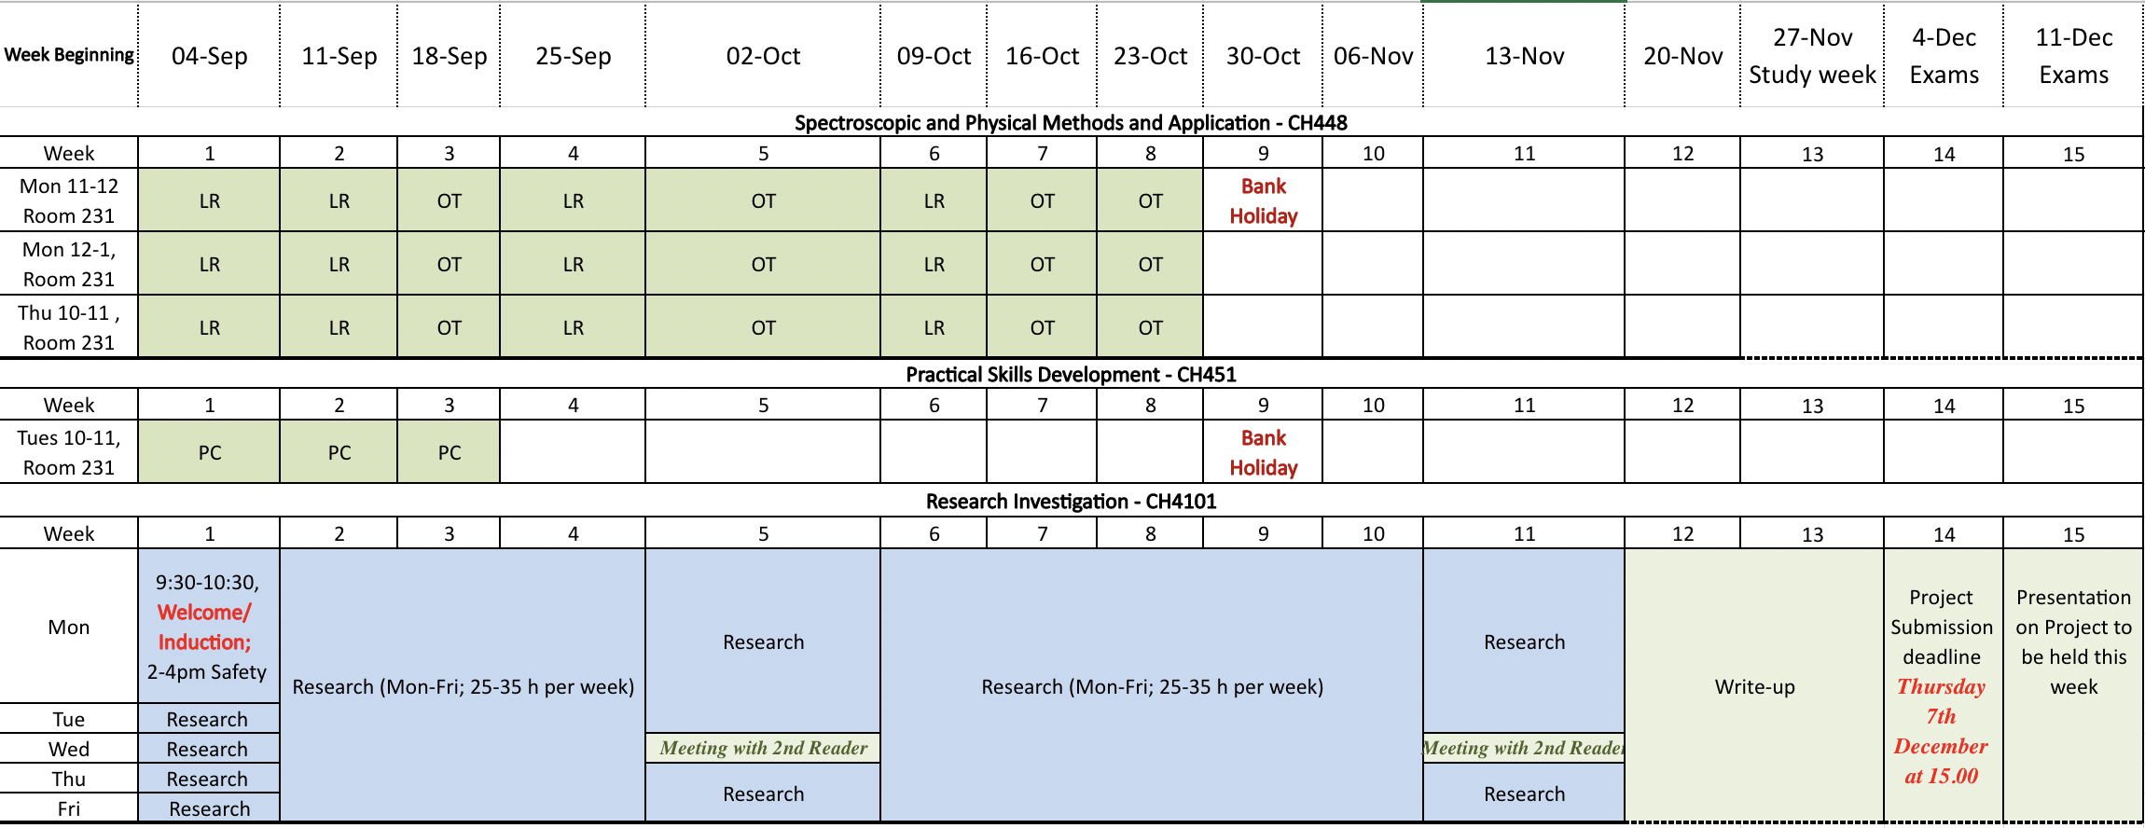
SEMESTER II
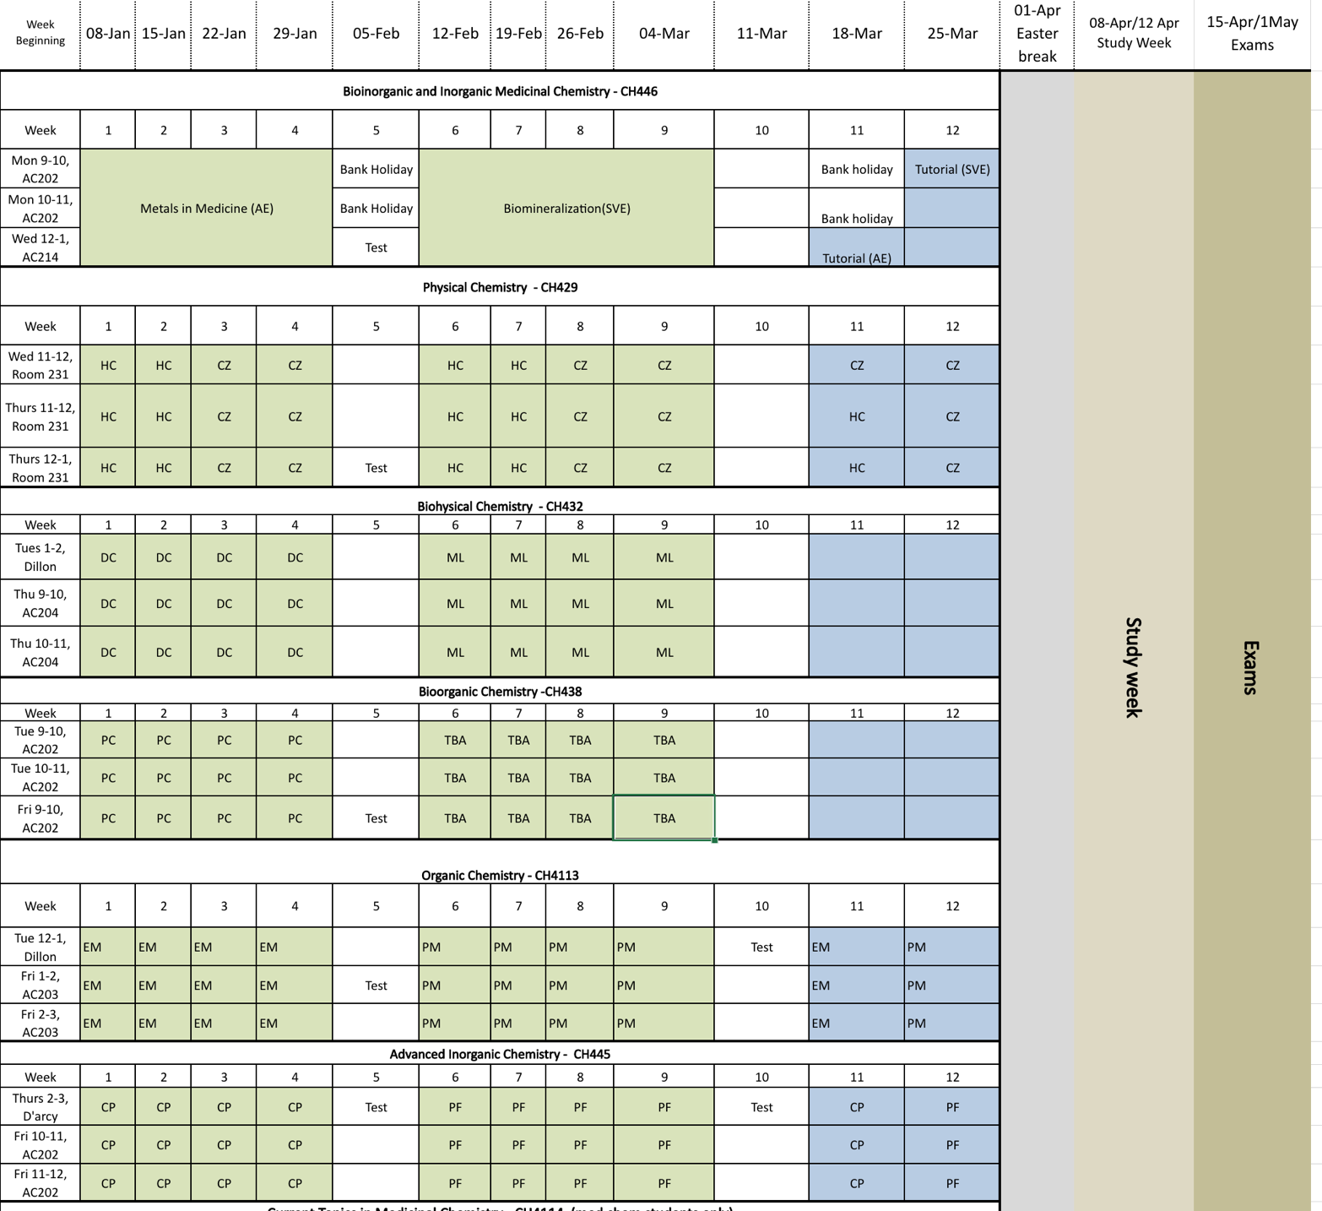

CH448: SPECTROSCOPIC AND PHYSICAL METHODS AND APPLICATIONS (SEMESTER I)

Staff: Prof. Olivier Thomas (coordinator), Dr Luca Ronconi

The main objectives of this module are to provide the necessary background in analytical chemistry to perform the 4th year project in the best conditions. No final exam will be organised and the assessment will be performed through two tests in each of the following parts

1. NMR and mass spectrometry for organic molecules (12 h)
2. Analytical techniques for inorganic molecules (12 h)

Course Topics: | Learning Outcomes
PART 1: Organic molecules (12 h including 2 h of test)
1D NMR experiments including ¹H, ¹³C DEPT  Other nuclei | Understand the basics of 1D NMR experiments. How to perform an experiment. How to interpret data of a 1D NMR experiment. Number of qC, CH, CH₂ and CH₃. Applications to other nuclei such as F and P.
2D NMR experiments to establish the planar structures of organic molecules | Be able to use COSY experiments to build Spin Coupled Systems. Be able to use HSQC/HMQC experiments to complete the SCS. Link the different SCS and heteroatoms using HMBC spectra.
Coupling constant values interpretation for cyclic compounds and couble bonds  Spatial coupling such as ROESY and NOESY experiments to gain insights into the 3D structures of (bio)organic molecules | Be able to use nOe and coupling constant values to propose relative configurations of organic molecules.
Mosher method | Use Mosher method to assess the absolute configuration of organic molecules
Mass spectrometry low and high resolution | Use data from low and mass spectrometry to obtain information such as the molecular formula of organic molecules. Use of chemcalc
Structure elucidation of organic molecules | Understand how to elucidate the 2D and then 3D structures of organic molecules using NMR and MS data.
PART 2: Inorganic molecules (12 h including 2 h of test)
Electronic spectra of metal complexes (microstates, spectroscopic terms, Russell-Saunders coupling, spin-orbit coupling, Racah parameters, Tanabe-Tsugano diagrams); | Understand and use of the electronic transitions of metal complexes
IR spectroscopy of transition metal complexes (focusing on metal–other atoms vibrations in the far IR region); | Understand the data obtained for IR spectra of inorganic molecules
Solution NMR spectroscopy of transition metal complexes (focusing on the direct detection of NMR-active nuclei other than 1H, 13C, 15N and 31P); | Use of spectroscopic techniques to derive the structure and to understand the properties of transition metal complexes.

CH451: PRACTICAL SKILLS DEVELOPMENT (SEMESTER I)

Staff: Prof. Peter Crowley (coordinator), Dr Eddie Myers

The purpose of this 5 credit module is for you to become familiar with key aspects of research and to prepare you for CH4101. You will complete CH451 within the first 3 weeks of semester I. The module has six components (Table 1) including a mini-report that you submit to your project supervisor before 4 pm on Friday 22 September 2023.

Table 1. CH451 module components
# | Component* | Task
1 | Induction  (<1 page) | Learn about your host laboratory. What is the main aim of the laboratory and what are your roles both in research and in contribution to the laboratory.
2 | Health & Safety  (>2 pages) | Health and safety is paramount to research. Attend the H&S briefing, prepare your project risk assessment (PRA) and a standard operating procedure (SOP) – see details below.
3 | Summary and literature search  (2 pages) | Use Scopus to find relevant literature. Demonstrate the funnel approach, from identifying the broad topic to distinguishing specific papers. Write a short summary including project aim (one sentence); project objectives (three bullet points); how your project will contribute to state of the art (one paragraph); methods / approach you will use to address the project (one paragraph); a self-made graphic that captures the essence of your project; a project timeline and at least 6 references.
4 | Practical skills  (1 page) | Identify a technique that is central to your project. Get training in that technique and document the main steps required. Include representative data, that you obtained and explain the uses/limitations of the technique.
5 | Experiment design  (<1 page) | Scientific research is about (dis)proving hypotheses. When correctly performed, experiments can be used to test a hypothesis. A properly designed experiment includes controls. Describe an example of good experiment design for your project.
6 | Mini-report | Document your completion of components 1 – 5 with PRA, SOP and other supporting documentation appended.
*Indicative page count in the mini-report.

Health and Safety
Health and safety is essential when designing and performing experiments, and handling, analysing, storing or disposing of chemicals. You should strive to be aware of all possible ways your work could adversely affect you, your colleagues and the environment. Take steps to prevent or mitigate that impact.

You will be assessed on the following:

- Participation in the Health and Safety Briefing at 2-4 pm, Monday 4th September 2023 (venue TBA)

- Preparation of a project risk assessment by using the template provided and in consultation with your supervisor. The completed form is signed by you and your supervisor and sent to the Health and Safety Officer (Dr. Myers) before experiments begin.

- Preparation of a standard operating procedure (SOP) for the use of a chemical or the performance of a technique that is relevant to your project. This SOP will be added to the School’s health and safety documentation, which will be available to other researchers.

- Identification and documentation of the health and safety risks of each experiment before the experiment is performed. This documentation will be made available to your second assessor during scheduled meetings or be presented to the School’s Health and Safety Officer upon request during lab audits.

General Health and Safety Rules
- Never work alone
- Laboratory work is within core hours, 9 am – 6 pm.
- Protective clothing, safety glasses and coat, must be worn in the laboratory
- No food or drink is permitted in the laboratory
- Headphones/earbuds are not permitted in the laboratory

Failure to adhere to the general rules will lead to disciplinary action. Repeated and/or blatant disregard for health and safety will result in dismissal from the research laboratory.

CH429: PHYSICAL CHEMISTRY (SEMESTER II)

Staff: Prof. Henry Curran (coordinator), Dr Chongwen Zhou
- Chemical Kinetics
- Statistical Thermodynamics
- Quantum Mechanics

1. Chemical Kinetics

Students will be able to:
- Derive the rate law for a first and second order reaction and from that determine the half-life for a reaction and the rate of reaction.
- Determine the kinetics for an elementary reaction.
- Explain the kinetics associated with flow reactors, jet-stirred reactors and shock tubes.
- Understand how the rate constant of a reaction varies with temperature and derive the frequency A-factor and activation energy of a reaction given the rate constant and different temperatures.
- Appreciate and understand the dependence of kinetics on thermodynamics of reactants and products.
- Understand Photochemical Kinetics and its application to real world problems.
- Understand Photolytic activation and flash photolysis
- Understand fast reactions and how these can be studied
- Theories of reaction rates
- Understand and apply Simple Collision Theory

2. Statistical Thermodynamics

- Know that the Boltzmann distribution that gives the number of molecules in each state of a system at any temperature is given by the equation:
- The partition function is defined as: 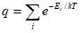and is an indication of the number of thermally accessible states at the temperature of interest.
- The molecular partition function is the product of the contribution from translation, rotation, vibration, electronic and spin distributions: q = q^{T} q^{R} q^{V} q^{E} q^{S}
- The translational partition function is: q^{T} = (2πmkT)^{3/2}V/h³
- The vibrational partition function is: q^{V} = 1/(1–e^{–hω/kT})
- The rotational partition function is: q^{R} = kT/σhB, where σ = 1 for an unsymmetrical linear rotor and σ = 2 for a symmetrical linear rotor.
- The electronic partition function is: q^{E} = 1 for closed-shell molecules with high-energy excited states.
- The internal energy is: U = U(0) + E, with E = (NkT²/q) × slope of q plotted against T.
- The Boltzmann formula for the entropy is S = k ln W, where W is the number of different ways in which the molecules of a system can be arranged while keeping the same total energy.
- The standard molar Gibbs energy is

3. Quantum Mechanics
Students will gain an appreciation of
- fundamentals of quantum mechanics - quantization, uncertainty principle, the Schrodinger equation and its application to particle in a box and the rigid rotator
- the hydrogen(ic) atom – solutions of the Schrodinger equation, spectrum of the hydrogen atom
- application of quantum mechanics to multielectron atoms
- application of quantum mechanics to molecular structure
- electronic structure calculations – Hartree-Fock, post-HF methods, semi-empirical calculations, and density functional theory

CH432: BIOPHYSICAL CHEMISTRY (SEMESTER II)

Staff: Dr David Cheung (coordinator), Dr Mihai Lomora

- Molecular Driving Forces
- Analysis of Biomaterials

1. Molecular Driving Forces (12 hours, DC)

This block of lectures will explore how the behaviour of chemical and biological systems can be understood from simple physical principles. It will cover the following topics:
- Entropy and free energy
- Interfaces, wetting, and capillarity
- Phase transitions and phase separation
- Co-operativity
- Adsorption, binding, and catalysis

2. Analysis of Biomaterials (12 hours, ML)

The course outline and learning outcomes that will be assessed from this topic will comprise of:
- General overview of biomaterials: main types (polymers, metal/metal oxides, ceramics, composites) and specific characteristics, key bulk & surface properties
- State-of-the-art characterization techniques generally used for the physical and chemical analysis of biomaterials. The general operation principles, sample preparation, and instrumental technical details accompanied by real-world examples of analysed biomaterials will be covered for the following techniques:
Stopped Flow Spectroscopy, Electronic and Vibrational Circular Dichroism (eCD, vCD), Polarimetry, Ramachandran plots, Fluorescence Microscopy, Confocal Microscopy, Fluorescence Lifetime / Imaging: Fluorescence Correlation Spectroscopy (FCS), Fluorescence Cross-correlation Spectroscopy (FCCS), Fluorescence Lifetime Correlation Spectroscopy (FLCS), Fluorescence Lifetime Imaging Microscopy (FLIM), Förster Resonance Energy Transfer (FRET), Super Resolution Microscopy: Stimulated Emission Depletion Microscopy (STED), Electron Microscopy: Transmission Electron Microscopy (TEM), Scanning Electron Microscopy (SEM), Environmental SEM (ESEM), Scanning Probe Microscopy (SPM): Scanning transmission microscopy (STM), Atomic Force Microscopy (AFM), Contact Angle, Dynamic / Static Light Scattering (DLS, SLS), and Nanoparticle Tracking Analysis (NTA)

CH438: BIOORGANIC CHEMISTRY (SEMESTER II)

Tutors: Prof. Peter Crowley (coordinator), TBA.

Sections:
- Supramolecular Protein Chemistry – Prof. Crowley
- TBA

1. Supramolecular Protein Chemistry (12 h)

Learning outcomes:
- Protein interactions and molecular recognition
- Macrocycles, calixarenes, cucurbiturils, cyclodextrins
- Supramolecular ligands for protein recognition and assembly
- The chemistry of the cationic residues Arg and Lys
- Methods to study protein interactions (e.g. X-ray, NMR, ITC)

2. TBA

CH445: ADVANCED INORGANIC CHEMISTRY (SEMESTER II)

Staff: Dr Pau Farras (coordinator), Dr Constantina Papatriantafyllopoulou

1. Energy and respiration in biological systems (Dr Pau Farras)
2. Molecular Magnetism (Dr Constantina Papatriantafyllopoulou)
3. Porous Materials (Dr Constantina Papatriantafyllopoulou)

This module will look over contemporary chemistry, with examples of inorganic chemistry which aim to solve some of the current societal challenges. The content of this module has direct relationship with the Sustainable Development Goals (SDG):
- SDG2: No Hunger
- SDG6: Clean Water and Sanitation
- SDG7: Affordable and Clean energy
- SDG11: Sustainable Cities and Communities
- SDG13: Climate Action

1. Energy and respiration in biological systems (11 lectures + 2 tutorials, PF)

The students will be introduced to the synergy between natural and artificial systems for the design of novel metal-based devices to tackle the issues related to renewable energies.

The learning outcomes that will be assessed will include:

• Correlation between basic electron transfer theories with real biological systems such as proteins.
• Photosynthesis and mechanisms of energy transfer.
• Oxygen metabolism and fuel cells.
• Nitrogen fixation and the future of fertilisers.

2. Molecular Magnetism (6 lectures + 1 tutorial, CP)

The learning outcomes that will be assessed are:

- The student being able to understand basic concepts and definitions in molecular magnetism (magnetization, magnetic susceptibility, spin), and recognize the different types of magnetic behaviour.
- The student being able to predict all the possible spin states for a metal compound.
- The student being able to describe and understand the mechanisms of magnetic interactions.
- The student being able to understand the single molecule magnetism behaviour and its potential use in technological applications (information storage devices, quantum computing).

3. Porous Materials (6 lectures + 1 tutorial, CP)

This lecture series will deal with the synthesis, properties and applications of porous materials. Specifically, the following topics will be covered:

- classification of porous materials;
- general features of main categories of porous materials, including zeolites, activated carbon, carbon nanotubes, mesoporous silica, mesoporous alumina, etc;
- metal-organic frameworks: synthesis, properties and applications (drug delivery, gas storage/separation, catalysis, sensing, etc)

Continuous assessment in module CH445

The continuous assessment will be in the form of in-class tests during the teaching semester that will be graded. There will be tests in the week of February 6th and in the week of March 13th. The continuous assessment will contribute 20 % of the overall grade for the module.
In addition, for part 1 Energy and Respiration, group presentations will be done on the week of March 6th and will account for 5% of the overall grade for the module.
CH446: BIOINORGANIC AND INORGANIC MEDICINAL CHEMISTRY (SEMESTER II)
Staff: Dr Andrea Erxleben (coordinator), Dr Stanislas Von Euw

Topics

1. Metals in Medicine (Dr Andrea Erxleben)
2. Biomineralisation (Dr Stanislas Von Euw)

1. Metals in Medicine [12 lectures + 2 tutorials]

The learning outcomes that will be assessed will include:

- The student being able to describe the relevance of various metals in medicine. Metals covered will include: Pt, Ru, Ga, Au, Gd and various radioactive metals (e.g. Tc).
- The student being able to describe and understand the chemistry of antitumour active platinum compounds with regard to the synthesis of cis- and transplatin, coordination chemistry of Pt, trans-effect, mechanism and kinetics of ligand substitution, solution behaviour of cisplatin, reaction of cisplatin with DNA, nucleobases and amino acids, structure-activity relationships for Pt drugs, Pt NMR.
- The student being able to understand and explain aspects of the coordination chemistry of Ru, Ga, and Au relevant to the biological behaviour of these metals
- The student being able to understand and explain the function of photosensitizers in photodynamic tumour therapy.
- The student being able to understand and explain the study of covalent and non-covalent interactions between metal complexes and DNA.
- The student being able to understand and describe the generation and selection criteria of therapeutic and diagnostic radionuclides, the synthesis of radiopharmaceuticals and the function of radiosensitizers.
- The student being able to understand and explain the choice of metals and ligands suitable for MRI contrast agents.

2. Biomineralisation [12 lectures + 2 tutorials]

The students will be introduced to the mechanisms of biomineralization. A particular emphasis will be given to calcified tissues (bone, mollusc shells) since their hierarchically-organized structures provide design principles for the fabrication of advanced materials.

The learning outcomes that will be assessed will include:
- The student being familiar with the concepts of biomineralization.
- The student being familiar with a number of materials characterization techniques used to investigate the growth of inorganic crystals in synthetic and biological systems.
- The student being able to describe and identify the different pathways to crystallization associated with non-classical crystal growth.
- The student being able to explain the different bio-inspired mineralization processes.
CH4113: ORGANIC CHEMISTRY (SEMESTER II)

Staff: Dr Eddie Myers (coordinator), Prof. Paul Murphy

1. Pericyclic and Radical Reactions (12 h)
2. Selectivity in Organic Synthesis (12 h)

1. Pericyclic and Radical Reactions (12 h)

Students will be assessed on the following learning outcomes:

- The ability to classify a pericyclic reaction as either a cycloaddition, an electrocyclic reaction, a sigmatropic rearrangement or a group-transfer reaction.
- The ability to predict the sense of a pericyclic reaction (suprafacial/antarafacial and disrotatory/conrotatory) under a certain set of reaction conditions (thermal/photochemical) based on the Woodward–Hoffman Rules.
- The ability to draw a set of π-based molecular orbitals for any conjugated molecule, to assign electrons to these orbitals, to identify the HOMO and LUMO orbitals and to use the resulting information to predict the sense of a pericyclic reaction under thermal or photochemical conditions.
- To understand the concept of stereospecificity pertaining to pericyclic reactions and to be able to predict the diastereoselectivity of a pericyclic reaction.
- The ability to use structural features to predict the relative rate and regioselectivity of pericyclic reactions.
- The ability to draw radical reaction mechanisms by using single-headed (fishhook) arrows.
- To understand and distinguish radical stability and reactivity.
- To understand the major types of reactions and processes involving radicals, such as fragmentation of weak bonds to form radicals, atom abstraction reactions, the addition of radicals to alkenes, and radical-radical combination and disproportionation.
- To understand radical chain processes and their use in the formation of rings and polymers
- To understand electron paramagnetic resonance as an analytical method for the study of radicals
- To have an appreciation for the role of radical reactions in biology and chemical biology.

2. Selectivity in Organic Chemistry (12 h)

The learning outcomes that will be assessed will include evaluation of student’s knowledge and understanding of important reactions in organic synthesis and factors which influence those such as for those mentioned below:

- Chemoselective reactions of carbonyl compounds with various reducing reagents.
- Chemoselective reactions of alcohols and alkenes with oxidising agents
- Stereoselective olefination (alkene forming reactions)
- Enantioselective oxidation and reduction
- Stereoselective substitution reactions (basis in SN1, SN2 reactions)
- Regioselective reactions with carbohydrates/cyclic epoxides
- Bioorthogonal reactions

CH4114: CURRENT TOPICS IN MEDICINAL CHEMISTRY (SEMESTER II)

Staff: Dr. Eddie Myers (coordinator), Dr. Luca Ronconi, TBA (new lecturer)

In this module, you will expand your knowledge of the biological targets and small-molecule and biopharmaceutical modulators associated with anticancer, antibacterial, antiviral and neurological therapy. In addition, you will gain an in-depth understanding of cutting-edge synthetic methods, analytical techniques and biological assays that are used in the medicinal chemistry departments of pharmaceutical companies. Course content will not be conveyed in the usual passive manner, that is, through traditional lectures. Instead, you will curate your own content through exploration of the medicinal chemistry literature as guided through a variety of individual and group assignments, which will also develop your skills in scientific writing, oral communication, problem solving and critical analysis.

This 10-credit module will be assessed continuously throughout the 12-week period of Semester 2 and is divided into 4 components:

1. Mini Perspective (40%) – All academic staff: Weeks 1-11

In November/December, you will choose a medicinal chemistry mini-perspective topic from a listing provided by the module coordinator and you will be assigned a supervisor, who will be able to provide guidance on the writing task and provide feedback on drafts. The mini perspective will be based on the Journal of Medicinal Chemistry mini perspective series (32 page, double-spaced, Times New Roman, font size 12) where a narrow topic is critically analysed (non-exhaustive) and supported with suitable figures/schemes and approximately 70 references. In Semester 2, there will be deadlines for the submission of an introduction/outline, an advanced draft, and the final manuscript. Your assigned supervisor will provide timely feedback on the introduction/outline and an advanced draft. An information session will be organised in early January.

2. Antiviral Therapy (20%) – Dr. Myers: Weeks 1-4
In this section of the module, each student will be assigned a recent (2023) primary research article from Journal of Medicinal Chemistry on a topic in antiviral therapy. The article will be used as platform for directing your own learning. You will be asked to study the article carefully and generate a detailed set of notes containing definitions, diagrams, and addition information that you have sought from the chemical literature/books/online articles and videos to help you understand the article background/analytical techniques/data/graphs. You will also be asked to write a 16-sentence abstract on the article. Upon submission of your set of notes/abstract (end of Week 3), your understanding of the article will be assessed through a 20-minute one-to-one oral examination in Week 4.
3. Metal-based Anticancer Therapy (20%) – Dr. Ronconi: Weeks 5-7
This lecture/workshop series will focus on the design and development of metal-based drugs as targeted anticancer chemotherapeutics. An initial 2-hour lecture will give students an overview of the basic principles of targeted anticancer chemotherapy with a focus on selected biomolecules/pathways acknowledged as hallmarks of cancer (i.e. G-quadruplexes, glucose metabolism, proteasome, vitamin B12 metabolism, thioredoxin reductase). Students will also gain an appreciation of areas of unmet clinical needs, novel drug targets and current trends in metallodrug discovery. The remaining workshops (two 2-hour sessions) will build upon the knowledge acquired in the introductory lecture and will be student-led. Students will work in pairs and the workshop coursework will allow them to demonstrate their competence in the learning outcomes through the delivery of a short presentation on case-study based on lecture material, independent literature search and problem solving.
4. Antibacterial Therapy (20%) – New Lecturer: Weeks 8-10
Details on this section of the module will become available in December 2022, when a new lecturer in pharmaceutical chemistry will be hired. In the past, this section of the module was assessed through an in-class examination, but the new lecturer will make a decision on what form of assessment would be appropriate.

CH4101: RESEARCH INVESTIGATION

All students will undertake a research investigation. Information on the research project topics are given in this booklet. Students will submit their preferences by 12 noon on Friday 15th July 2022 and assignments will then be based on 3rd year Chemistry grades.

Learning outcomes from this module are provided below:

Students will manage their own learning.
Students will apply the basic knowledge gained earlier in the programme in order to consolidate and extend their knowledge and understanding of chemistry.
Students will become integrated into a scientific research team and develop teamwork skills.
Students will also develop skills such as finding data or information from the literature, to organise and summarise this and to present the outcomes of their investigations, placing it in context.

More specifically students will:
- Establish or become aware of the state of the art in assigned topics
- Critically analyse data or facts obtained from library and/or laboratory work
- Use the facts or data obtained by this independent investigation to challenge current teaching and/or myths/hyperbole and/or to provide new insights and/or advance a topic in Chemistry
- Demonstrate a greater understanding and knowledge within Chemistry as a result of their independent investigation
- Demonstrate competence in recording, reporting & presenting the outcomes of their independent investigative work
- Participate in the research team activities
- Be able to carry out and report their research in an ethical manner

SCHEDULE FOR RESEARCH INVESTIGATION MODULE

- The laboratories will be open for the research from Monday 4th September 2023 until Friday 17th November 2023.

For health and safety reasons, undergraduates are restricted in the laboratory between 9am-6pm on Monday-Friday and should never work alone.

Chemistry students are expected to work ~25h per week generating data on their project in this period.

- Students will keep a lab notebook to document their experiments, observations, and provide a preliminary interpretation of the results, as well as include information about the experiments risk assessment. An electronic copy of the lab notebook will be submitted to your supervisor no later than Thursday 7th December 2023 by 15.00.

- Students are strongly encouraged to keep a research journal. This will be beneficial for research planning and goals achievement. It will provide evidence about the project/student’s progress in a timely manner and can act as a self-assessment tool. An electronic copy of the research journal template can be downloaded from Canvas. Copies of the research journal will be submitted to supervisor no later than Thursday 7th December 2023 by 15.00.

- Students are assigned a second reader of their project reports. Students should meet their second reader twice during the project to discuss their progress. Meetings will be held on 4th October and 15th November 2023. Students will confirm the time and venue of the meeting with their second reader. PowerPoint slides will be submitted to the second reader at least 3 days in advance of each meeting.
Meeting 1 agenda: a brief literature review, project aim and preliminary results.
Meeting 2 agenda: research update and dissertation outline.

- Students are assigned a third reader of their project reports. The role of the third reader will be to assess the quality of the report according to the marking scheme on page 25.

- Upload electronic copy of the project thesis is required no later than Thursday 7th December 2023 by 15.00– Marks will be deducted for late submission.

- Oral and poster presentations on projects will take place in the week of 11th December 2023. The oral presentations will be assessed by the academic staff attending. The poster presentations will not be graded. Students will have the opportunity to share their efforts and results with their fellow students and academic staff. It will be a part of a celebratory research day marking the completion of the research projects.

- Students can revise the project report taking on board the comments raised by the 1st and 2nd reader and the academic staff attending the project presentation. An electronic copy of the revised report is required to be uploaded no later than one week after the date of presentation.

FEEDBACK ON REPORTS

Students should arrange an appointment with their supervisors to obtain feedback on a draft of the write-up of the research report. Please provide a timely draft to your supervisor in advance of this meeting (at least one week in advance) and please confirm the time and date of this meeting with your project supervisor in advance.

RESEARCH JOURNAL TEMPLATE

WEEK 1 (4/9/2023)

Goal(s)/associated tasks:

Completed tasks:

Reflective entry:

An electronic copy of the template can be downloaded from Canvas

GUIDELINES FOR STUDENTS IN WRITING A SYNTHESIS PROJECT REPORT

1. Title of Project

2. Summary or Abstract
A concise summary (up to 350 words) of what has been achieved. This should be explicit and reference should be made to work/experiments carried out and the results. Highlights from the research should specifically be included. A graphic is recommended to support this abstract.

3. Introduction
Approximately 4-8 pages (A4, typed, one and a half or double line spacing, margins approx 1”, font such as Times and font size 12). Structure diagrams or schemes can be drawn with ChemDraw available for all students. The introduction should include background to the project, explaining the reasons for undertaking the work and include a project plan. In the case of synthetic projects for example, this could show a scheme. References must be included and usually are numbered in sequence as they are found in text with a superscript and the full reference listed at the end of the report.¹⁻³ Compounds should be numbered (in bold) as they appear in schemes. The final section of the introduction should outline the aims of the project. The final sentence or paragraph should summarise what has been achieved.

4. Results and Discussion

Students are advised to give a concise presentation of results presented first followed by a discussion of their significance (novelty of method?, novel mechanism?). Please also provide any relevant figures or schemes or tables that are needed to efficiently and clearly present your results.

In synthetic projects, there is no need to provide mechanisms for all reactions (although you will be expected to be able to discuss these during the oral assessment). Please only discuss a mechanism if an unexpected product is obtained or if this is central to the project objective.

When relevant there can be a description of the key characterisation data that supports a structural assignment, a brief description of how the reactions were carried out and yields can be given etc.

Example from a synthesis report: “The bromide derivative (10) was obtained (65%) after treatment of penta-O-acetyl-α-D-glucopyranose with hydrogen bromide in acetic acid. The ¹H-NMR spectrum of 10 had signals at δ 6.30 (1H, d, J 4.0 Hz, H-1), 4.80-3.50 (6H, ms, H-2–6) and 2.00-2.10 (12H, 4 x s, CH₃C=O), which were in excellent agreement with literature data.⁴” Tables can be used and diagrams/reaction schemes should be included and numbered etc. (Scheme 1, Fig. 1, Table 1).

Compounds should be numbered in order of appearance in schemes etc. If NMR is not relevant, then give X-ray or other spectroscopic data or analytical data to support your assignments.

5. Conclusions
Please include a conclusions section, summarizing briefly the main findings of the project.

6. Experimental
Description of experiments should be given in detail sufficient to enable experimental workers to repeat them.

For synthesis projects include full characterisation, yields, m.pt., R_{f}, NMR data, IR data, [α]_{D}, microanalysis (for new compound), mass data and their assignments should be included). If a compound is not new, please include a citation to where it has been characterized previously and include some characterization data (e.g. ¹H-NMR, IR, LRMS and alpha-D) and state that the data is in good agreement with that described previously. You may include a general experimental section if this is relevant.

Typical experimental procedure (for a synthesis project) for a new compound and assignment of analytical data:

N-(2,3,4,6-Tetra-O-acetyl-(β-D-glucopyranosyl)-5-ethylthiophene-2-carboxamide 9 The reaction of 5-ethylthiophene-2-carboxylic acid (0.23 g, 1.44 mmol) as described for 3-bromothiophene-2-carboxylic acid gave a mixture of anomers (0.64 g, 91 % yield, α:β, 1:16). The residue was recrystallised from EtOAc and cyclohexane to afford β-anomer 9 as a colourless crystalline solid (0.42 g, 51%) and as an adduct with EtOAc (1:1); mp 64-66 °C; [α]_{D} +12 (c 8.0, CDCl₃); ¹H NMR (300 MHz, CDCl₃) δ 7.33 (1H, d, J 3.9 Hz, aromatic H), 6.84 (1H, d, J_{NH,H1} 9.3 Hz, NH), 6.77 (1H, dd, J 3.9 Hz, J 0.9 Hz, aromatic H), 5.37 (2H, 2 x overlapping t, J 9.3 Hz, H-1,3), 5.10 (1H, t, J 9.3, H-4), 5.03 (1H, t, J 9.3 Hz, H-2), 4.34 (1H, dd, J_{6a,6b} -12.5 Hz, J_{6a,5} 4.2 Hz, H-6a), 4.09 (1H, dd, J_{6b,6a} -12.5 Hz, J_{6b,5} 2.1 Hz, H-6b), 3.88 (1H, ddd, J_{5,4} 9.9 Hz, J_{5,6a} 4.2 Hz, J_{5,6b} 2.1 Hz, H-5), 2.86 (2H, q, J 7.5 Hz, CH₂CH₃), 2.08, 2.04 (2s), 2.03 (each 3H, each s, each CH₃), 1.32 (3H, t, J 7.5 Hz, CH₂CH₃); ¹³C NMR (75 MHz, CDCl₃): δ 171.5, 170.7, 169.9, 169.6 (each ester C=O), 161.8 (amide C=O), 154.9, 134.3 (each aromatic C), 129.5, 124.6 (each aromatic CH), 78.9, 73.6, 72.6, 70.7, 68.3 (each CH), 61.7, 23.8 (each CH₂), 20.6, 20.7, 15.7 (each CH₃); ESI-LRMS m/z 486 [M+H]⁺, 324, 271, 169; ESI-HRMS (m/z) calcd for C₂₁H₂₈NO₁₀S 486.1434, found m/z 486.1448 [M+H]⁺. Anal Calcd for C₂₅H₃₅NO₁₂S (EtOAc adduct): C, 52.35; H, 6.15; N, 2.44; S, 5.59. Found: C, 52.22; H, 6.09; N, 2.49; S, 5.92.

Include the name of the compound, if possible. Many compounds can be named by checking for related compounds in SciFinder and using names provided in SciFinder abstracts as guidelines. Chemdraw can also be helpful in naming. Please consult your supervisor for advice on preparation of the experimental section. This can vary significantly between research areas.

Note: You can use Reaxys (www.reaxys.com) or SciFinder to search for compounds to determine whether they are new or known. If a compound is known then a citation should be provide. If analytical data is in agreement with data reported previously then this should be stated. Do include melting points and alpha D data if relevant and do state the literature data for these, if relevant.

7. References (Please use a standard style such as the one (RSC) outlined below).
1. I. Fleming, Frontier Orbitals and Organic Chemical Reactions, Wiley, Chichester, 1976, p. 55.
2. A. J. L. Beckwith and K. U. Ungold, in Rearrangements in Ground and Excited States, ed. P. de Mayo, Academic Press, New York, 1980, vol. 1, p. 161.
3. P. D. Cunningham, N. W. A. Geraghty, P. J. McArdle, P. V. Murphy and T. J. O’ Sullivan, J. Chem. Soc., Perkin Trans. 1, 1997, 1.
4. H. Kessler and M. Hoffmann, J. Am. Chem. Soc. 1994, 118, 10156.
5. X. Y. Smiths, Journal of Flame, 2000, 22, 10157.

Reference 1 is a typical book, Reference 2 is typical for a chapter in an edited book. References 3 and 4 are typical journal references.

8. Appendix

You should include any relevant spectra, chromatograms etc. For example for projects using organic synthesis you may include ¹H and ¹³C NMR spectra for any new compounds as evidence of homogeneity of purity of compounds you prepare. You may include a compound characterization checklist in your report. This corresponds to a table where you indicate the analysis you obtained on each compound.

9. Project risk assessment
Please include your project risk assessment as this will be evaluated as part of the project work. This should be signed by the student and supervisor and have identified major hazards assocated with project work.

10. Plagiarism. The thesis should be written in your own words and not copied from any reviews or internet. If reproducing any figures from the literature in the thesis then please obtain copyright permissions and cite the original article. Obtaining copyright permissions can usually be done online where the article is originally published. Plagiarism must be avoided. See University of Galway guidelines on plagiarism at https://www.universityofgalway.ie/media/studentservices/files/Code-of-Practice-for-Dealing-with-Plagiarism.pdf Action will be taken by the examiners when plagiarism is found to occur.

Grading of project and the write-up will be based on strict adherence to guidelines provided herein.

The number of total pages does not normally need to exceed 35 pages. The student is recommended to focus on the quality of their report.

GUIDELINES FOR THE PROJECT REPORT (Measurement or Modelling Projects)

1. Title of Project: (Name, supervisor etc.)

2. Summary or Abstract
A concise summary (up to 350 words) of what has been achieved. This should be explicit and reference should be made to work/experiments carried out, results obtained, and the significance of these results. Highlights from the research should be specifically included. Inclusion of a graphic is recommended.

3. Introduction
Approximately 4-8 pages (A4, typed, one and a half line spacing, margins approx 2.5 cm, font such as Times and font size 12). Structure diagrams or schemes can be drawn with ChemDraw available for all students. The introduction should include background to the project, explaining the reasons for undertaking the work and include a project plan. References must be included and usually are numbered in sequence as they are found in text with a superscript and the full reference listed at the end of the report.¹⁻³ The final section of the introduction should outline the aims of the project. The final sentence or paragraph should summarise what has been achieved. The introduction should be written in your own words and not copied from any reviews or internet. If reproducing any figures from the literature in the thesis then please obtain copyright permissions and cite the original article. This can usually be done online where the article. Plagiarism must be avoided. See University of Galway guidelines on plagiarism at https://www.universityofgalway.ie/media/studentservices/files/Code-of-Practice-for-Dealing-with-Plagiarism.pdf

4. Experimental
Description of experiments should be given in detail sufficient to enable experimental workers to repeat them. Include full details of the samples you studies, where they were obtained, how stored and handled. Include full details of the instrumentation and software used. Explain clearly how you collected you data and what instrumental parameters were used.

All the experimental data and procedures should reference the appropriate pages in your laboratory notebook which should be submitted to the supervisor with the final draft for cross referencing purposes.

Typical experimental procedure (for an analytical project):

Instrumentation and data collection: Raman measurements were performed in triplicate at room temperature using an Avalon Instruments Raman spectrometer with 785 nm excitation. A laser power of ~70 mW at the sample was used and spectra were collected with a resolution of 8 cm⁻¹ and a typical exposure time of 10 s. For solution samples, stainless steel 96-well plates were used and multiple spectra were collected from a 3 × 3 grid (0.5 mm spot spacing) from which a single averaged spectrum was generated for data analysis. Fluorescence measurements were made at 25°C with a Cary Eclipse (Varian) fluorimeter using procedures previously described. Yeastolate samples were randomly removed from storage, defrosted at room temperature and allowed to reach room temperature, and handled using aseptic techniques. For each solution, 1 ml was pipetted into a cuvette and sealed before allowing to thermally equilibrate for several minutes prior to measurement. Spectral SERS data was pre-processed to reduce the influence of baseline drift, scatter effects, and uncontrolled fluctuations. Spectra containing cosmic interference were discarded prior to averaging of the spectra. The average spectrum was then treated with a multiplicative scatter correction, then an asymmetric weighted least squares algorithm to remove baseline offsets before finally applying a background correction using an orthogonal projection procedure. For SERS-ROBPCA analysis, the first derivative (SavGol) method was then implemented to further reduce measurement/instrumental effects and accentuate analyte signals. For EEM-MROBPCA analysis, Rayleigh and Raman scatter were removed from EEM data by replacing with a curve fit, connecting points either side of the bands using imputation. All calculations were performed using MATLAB ver. 7.4, PLS_Toolbox 4.0, and in-house-written toolboxes.

Please consult with your supervisor for advice on preparation of the experimental section. This can vary significantly between research areas. It is good practice to look at the style and content of peer-reviewed journals to assist in preparing your project.

5. Results and Discussion
Students are advised to give a concise presentation of results presented first followed by a discussion of their significance (novelty of method?, novel data?). In modelling projects, there is no need to provide detail of any code used (this can be included in an appendix).
In analytical type projects there is no need to include every spectrum etc., show an indicative or important example then summarise the important results in overlay plots or tables. If you have a lot of important data place it in an appendix with a brief description of the data. You can then refer to this appendix in your text.
When relevant there should be a comparison between your data/results and relevant examples from the literature, e.g. are your spectra the first to show a new species? Is your data better quality than what’s been published? If so, how so? Look at peer-reviewed papers for examples of how this is done professionally.

6. Conclusions
Please include a conclusions section (1-2 pages), summarizing your main achievements.

7. References (Please use a standard style such as the one outlined below).
[1] J. R. Lakowicz, Principles of Fluorescence Spectroscopy, 3rd Edition ed., Springer, New York, 2006.
[2] T. Cartwright, G. Shah, Culture media, in: J.M. Davis (Ed.) Basic Cell Culture, Oxford University Press Inc., New York 2002, pp. 69-106.
[3] P. W. Ryan, B. Li, M. Shanahan, K. J. Leister, A. G. Ryder, Prediction of Cell Culture Media Performance Using Fluorescence Spectroscopy, Anal. Chem., 82 (2010) 1311-1317.
[4] PLS_Toolbox, ver. 2.0, Eigenvector Research Inc., 3905West Eaglerock Drive,Wenatchee,WA.

Reference 1 is a typical book, Reference 2 is typical for a chapter in an edited book. Reference 3 is a typical journal reference, and 4 is for referencing software.

8. Appendix
In addition to the above you will need to include your project research assessment. You should include any relevant collections of spectra, modelling code, repeat experiments etc. here.

9. Project risk assessment
A risk assessment has to be carried out for all projects, including theoretical or computer-based projects.
In certain cases, no risks may be identified (e.g. computational projects) and this can be stated on the risk assessment form.

10. Plagiarism. The thesis should be written in your own words and not copied from any reviews or internet. If reproducing any figures from the literature in the thesis then please obtain copyright permissions and cite the original article. Obtaining copyright permissions can usually be done online where the article is originally published. Plagiarism must be avoided. See NUI Galway guidelines on plagiarism at http://www.su.nuigalway.ie/site/view/313/. Action will be taken by the examiners when plagiarism is found to occur.

Grading of project and the write-up will be based on strict adherence to guidelines provided herein.

The number of total pages does not normally need to exceed 35 pages. The student is recommended to focus on the quality of their work and report.

GUIDELINES FOR STUDENTS IN WRITING A NON-LABORATORY BASED REPORT

In the event that a student is assigned to a research investigation where much of the work and obtaining data or facts is carried out in the library and/or by working with data available to the supervisor then there is scope to modify the structure of the report. It is advisable that the student discuss the structure of the write up with the supervisor. The following sections must still be included in the report.

1. Title of Project: (see below for format which should be used)

2. Summary or Abstract
A concise summary (up to 350 words) of the objectives, findings and conclusions. Please include any particular highlights which emerged from the investigative work.

3. Introduction
This should be typed, one and a half or double line spacing, margins approx 1”, font such as Times and font size 12). Structure diagrams or schemes can be drawn with ChemDraw available for all students. The introduction should include background to the investigation, explaining the reasons for undertaking the work and include objectives. References must be included and usually are numbered in sequence as they are found in text with a superscript and the full reference listed at the end of the report.¹⁻³ Compounds should be numbered (in bold) as they appear in schemes. The final section of the introduction should outline the aims of the investigation. The introduction should be written in your own words and not copied from any reviews or the internet. Plagiarism must be avoided. See NUI Galway guidelines on plagiarism at https://www.universityofgalway.ie/media/studentservices/files/Code-of-Practice-for-Dealing-with-Plagiarism.pdf and the appropriate section in this booklet.

4. Presentation and Discussion of findings

Students are advised to detail their findings of their investigative work which is based on data available to the host supervisor and as a result of library and literature investigations. This should be followed by a discussion of their significance (novelty of method?, novel mechanism?). Please also provide any relevant figures or schemes or tables that are needed to efficiently and clearly present your results. Compounds should be numbered in order of appearance in schemes etc.

5. Conclusions
Please include a detailed conclusions section.

6. References (Please use a standard style such as the one (RSC) outlined below).
1. I. Fleming, Frontier Orbitals and Organic Chemical Reactions, Wiley, Chichester, 1976, p. 55.
2. A. J. L. Beckwith and K. U. Ungold, in Rearrangements in Ground and Excited States, ed. P. de Mayo, Academic Press, New York, 1980, vol. 1, p. 161.
3. P. D. Cunningham, N. W. A. Geraghty, P. J. McArdle, P. V. Murphy and T. J. O’ Sullivan, J. Chem. Soc., Perkin Trans. 1, 1997, 1.
4. H. Kessler and M. Hoffmann, J. Am. Chem. Soc. 1994, 118, 10156.
5. X. Y. Smiths, Journal of Flame, 2000, 22, 10157.

Reference 1 is a typical book, Reference 2 is typical for a chapter in an edited book. References 3 and 4 are typical journal references.

Grading of project and the write-up will be based on strict adherence to guidelines provided herein.

ASSESSMENT OF THE RESEARCH INVESTIGATION

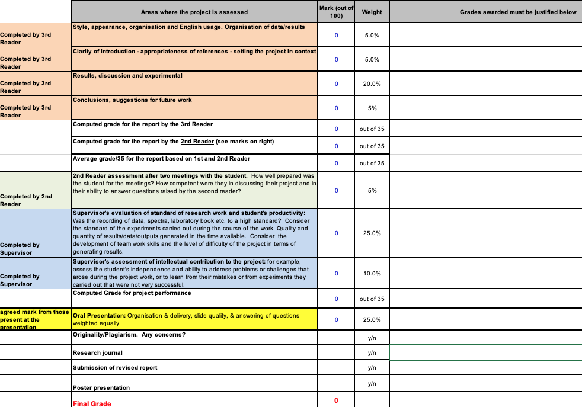

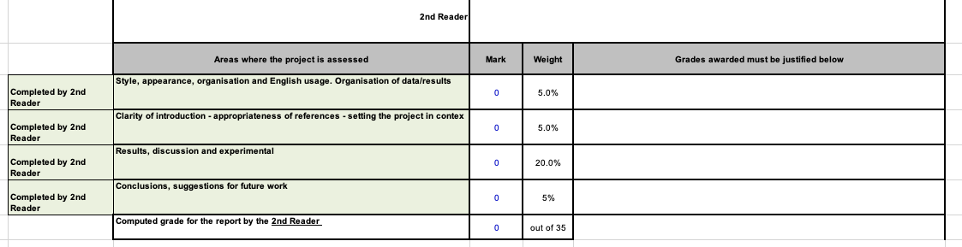

PLAGIARISM
Plagiarism is the act of copying, including, or, directly quoting from the work of another, without adequate acknowledgement, in order to obtain benefit, credit or gain. Plagiarism can apply to many materials, such as words, ideas, images, information, data, approaches or methods. Sources of plagiarism can include books, journals, reports, websites, essay mills, another student, or another person.
Self-plagiarism, or auto-plagiarism, is where a person re-uses work previously submitted to another course within the University or in another Institution or even a journal. Plagiarism can also involve overly relying on a source – even if it is referenced correctly.
All work submitted by students is accepted on the understanding that it is their own work and contains their own original contribution, except where explicitly referenced using the accepted norms and formats of the appropriate academic discipline. Students are required to sign an affidavit to confirm the above for all submissions in fourth year chemistry.
University of Galway applies a penalty grid to plagiarised submissions. All relevant information can be found at: https://www.universityofgalway.ie/media/studentservices/files/Code-of-Practice-for-Dealing-with-Plagiarism.pdf and https://www.universityofgalway.ie/media/registrar/docs/QA220-Academic-Integrity-Policy-Final.pdf. This penalty grid is University policy and no exceptions will be made.

Supervisor responsibilities
Supervisors will encourage students to avoid plagiarism during all meetings where preparation of project reports etc. are being discussed.

Plagiarism advisor responsibilities
The plagiarism advisor will check all submissions using Turnitin. In cases of plagiarised work, the plagiarism advisor will determine if there is a case to be made. If the decision is positive, the fourth year examiners including the supervisor and second reader will be contacted and appropriate action taken. The plagiarism advisor will write a confidential report, recording the decision and any penalty.

Student responsibilities
All students will be given access to their own Turnitin report. In cases of plagiarised submission, students will be obliged to formally meet with their project supervisor to discuss the plagiarised submission. The final project report will be submitted electronically through Canvas and Turnitin. In cases of plagiarised submissions the plagiarism advisor and the 4th year committee will be contacted and they will decide if appropriate action will be necessary according to University policy (https://www.universityofgalway.ie/media/registrar/docs/QA220-Academic-Integrity-Policy-Final.pdf)

Plagiarism adviser
Plagiarism adviser is Dr. Pau Farras.

AFFIDAVIT

Student Declaration on Plagiarism, Collusion or Copying
This declaration is to be completed and signed by the student. It must be included in the essay, first and final draft of the project reports.

I declare that this material, which I now submit for assessment, is my own work and that any assistance I received in its preparation is fully acknowledged and disclosed in the document. To the best of my knowledge and belief, all sources have been properly acknowledged, and the assessment task contains no plagiarism.
I understand that plagiarism, collusion, and/or copying are grave and serious offences and am aware that penalties could include a zero mark for this assessment, suspension or expulsion from University of Galway. I have read the University of Galway code of practice regarding plagiarism at https://www.universityofgalway.ie/media/registrar/docs/QA220-Academic-Integrity-Policy-Final.pdf
I acknowledge that this assessment submission may be transferred and stored in a database for the purposes of data-matching to help detect plagiarism. I declare that this document was prepared by me for the purpose of partial fulfilment of requirements for the programme for which I am registered with the AUA. I also declare that this assignment, or any part of it, has not been previously submitted by me or any other person for assessment on this or any other course of study or another college.

Student Name

___________________________
Student Signature Date

IMPORTANT:

Please sign and return to School Office (Karen.kelly@nuigalway.ie) by Wednesday 6th September 2023

Treatment of Personal Data*

I am aware that if I submit a medical certificate/letter regarding absences and/or any other personal information, this information may be shared with staff of the University and examiners for purposes related to assessing and maximizing my academic performance.
Signature

* If you have issues which you would prefer to remain confidential to the recipient it must be clearly stated. Be aware this will limit the School’s ability to react to or consider such information when assessing performance.

