**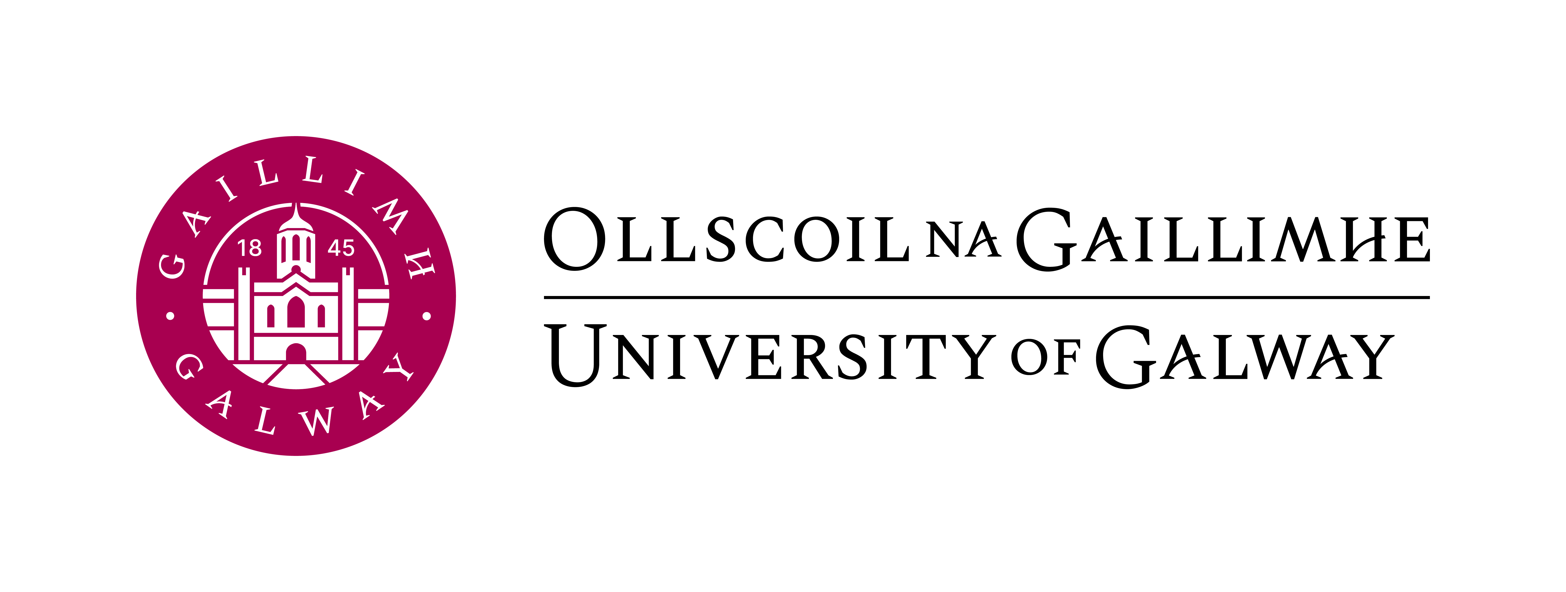**

**Arts in Action events in Academic Year 2022/23**

See all upcoming and previous Arts in Action events at: <https://www.eventbrite.ie/o/university-of-galway-arts-in-action-27310793629>

Arts in Action is University of Galway’s landmark programme of free cultural events to engage our students, staff and the public in arts and culture.

[[](https://www.eventbrite.ie/e/bel-canto-tickets-551448706927?aff=ebdsoporgprofile)](https://www.eventbrite.ie/e/bel-canto-tickets-551448706927?aff=ebdsoporgprofile" \t "_blank)

**Bel Canto**

Mon, 24 Apr, 13:00

**Free**

[[](https://www.eventbrite.ie/e/ceol-agus-craic-with-the-writers-of-tir-na-nog-a-new-irish-musical-tickets-550904589457?aff=ebdsoporgprofile)](https://www.eventbrite.ie/e/ceol-agus-craic-with-the-writers-of-tir-na-nog-a-new-irish-musical-tickets-550904589457?aff=ebdsoporgprofile" \t "_blank)

**Ceol agus Craic with the Writers of Tír na nÓg, a New Irish Musical**

Wed, 22 Mar, 13:00

**Free**

[[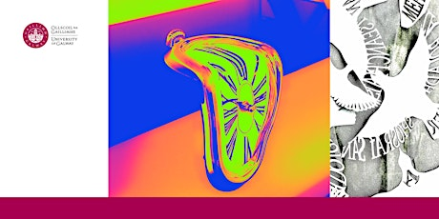](https://www.eventbrite.ie/e/none-the-wiser-the-bald-soprano-tickets-541124667447?aff=ebdsoporgprofile)](https://www.eventbrite.ie/e/none-the-wiser-the-bald-soprano-tickets-541124667447?aff=ebdsoporgprofile" \t "_blank)

**None the Wiser: The Bald Soprano**

Wed, 15 Mar, 13:00

**Free**

[[](https://www.eventbrite.ie/e/none-the-wiser-two-plays-by-gertrude-stein-tickets-541017777737?aff=ebdsoporgprofile)](https://www.eventbrite.ie/e/none-the-wiser-two-plays-by-gertrude-stein-tickets-541017777737?aff=ebdsoporgprofile" \t "_blank)

**None the Wiser: Two Plays by Gertrude Stein**

Mon, 13 Mar, 13:00

**Free**

[[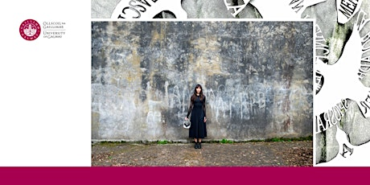](https://www.eventbrite.ie/e/olagon-meet-co-creators-james-riordan-bru-theatre-and-julianna-bloodgood-tickets-540970245567?aff=ebdsoporgprofile)](https://www.eventbrite.ie/e/olagon-meet-co-creators-james-riordan-bru-theatre-and-julianna-bloodgood-tickets-540970245567?aff=ebdsoporgprofile" \t "_blank)

**Olagón: meet co-creators James Riordan (Brú Theatre) and Julianna Bloodgood**

Fri, 3 Mar, 13:00

**Free**

[[](https://www.eventbrite.ie/e/gendered-experiences-of-the-irish-music-industry-tickets-540900466857?aff=ebdsoporgprofile)](https://www.eventbrite.ie/e/gendered-experiences-of-the-irish-music-industry-tickets-540900466857?aff=ebdsoporgprofile" \t "_blank)

**Gendered Experiences of the Irish Music Industry**

Fri, 24 Feb, 13:00

**Free**

[[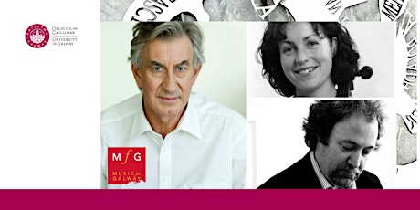](https://www.eventbrite.ie/e/music-for-galway-tennysons-enoch-arden-tickets-538681580107?aff=ebdsoporgprofile)](https://www.eventbrite.ie/e/music-for-galway-tennysons-enoch-arden-tickets-538681580107?aff=ebdsoporgprofile" \t "_blank)

**Music for Galway: Tennyson's Enoch Arden**

Wed, 22 Feb, 13:00

**Free**

[[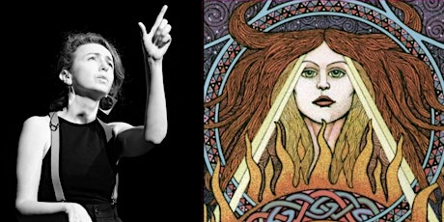](https://www.eventbrite.ie/e/brigid-other-badass-goddesses-tickets-526344660047?aff=ebdsoporgprofile)](https://www.eventbrite.ie/e/brigid-other-badass-goddesses-tickets-526344660047?aff=ebdsoporgprofile" \t "_blank)

**Brigid & Other Badass Goddesses**

Fri, 3 Feb, 13:00

**Free**

[[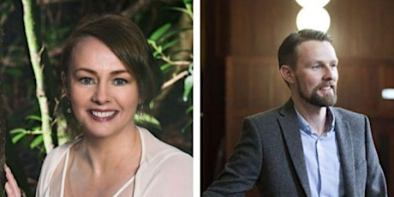](https://www.eventbrite.ie/e/muintir-ui-cheannabhain-the-o-ceannabhain-family-tickets-429203849267?aff=ebdsoporgprofile)](https://www.eventbrite.ie/e/muintir-ui-cheannabhain-the-o-ceannabhain-family-tickets-429203849267?aff=ebdsoporgprofile" \t "_blank)

**Muintir Uí Cheannabháin/ The Ó Ceannabháin Family**

Wed, 7 Dec, 13:00

**Free**

[[](https://www.eventbrite.ie/e/literary-futures-workshop-imagining-possible-futures-tickets-429198473187?aff=ebdsoporgprofile)](https://www.eventbrite.ie/e/literary-futures-workshop-imagining-possible-futures-tickets-429198473187?aff=ebdsoporgprofile" \t "_blank)

**Literary Futures Workshop: Imagining Possible Futures**

Wed, 30 Nov, 13:00

**Free**

[[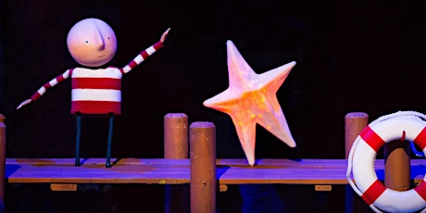](https://www.eventbrite.ie/e/how-to-catch-a-star-tickets-429191412067?aff=ebdsoporgprofile)](https://www.eventbrite.ie/e/how-to-catch-a-star-tickets-429191412067?aff=ebdsoporgprofile" \t "_blank)

**How to Catch a Star**

Fri, 25 Nov, 13:00

**Free**

[[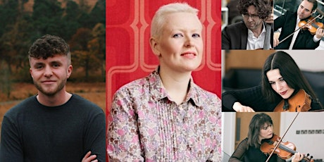](https://www.eventbrite.ie/e/galway-music-residency-reflections-on-loss-poetry-music-and-performance-tickets-429187038987?aff=ebdsoporgprofile)](https://www.eventbrite.ie/e/galway-music-residency-reflections-on-loss-poetry-music-and-performance-tickets-429187038987?aff=ebdsoporgprofile" \t "_blank)

**Galway Music Residency: Reflections on Loss: Poetry, Music and Performance**

Mon, 21 Nov, 13:00

**Free**

[[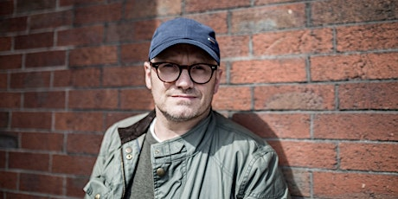](https://www.eventbrite.ie/e/postponed-lenny-abrahamson-in-conversation-with-conn-holohan-tickets-429179285797?aff=ebdsoporgprofile)](https://www.eventbrite.ie/e/postponed-lenny-abrahamson-in-conversation-with-conn-holohan-tickets-429179285797?aff=ebdsoporgprofile" \t "_blank)

**\*POSTPONED\* Lenny Abrahamson in conversation with Conn Holohan**

Wed, 16 Nov, 13:00

**Free**

[[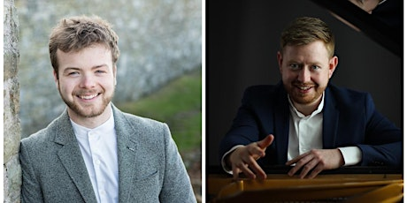](https://www.eventbrite.ie/e/music-for-galway-brendan-garde-and-gary-beecher-tickets-428410646777?aff=ebdsoporgprofile)](https://www.eventbrite.ie/e/music-for-galway-brendan-garde-and-gary-beecher-tickets-428410646777?aff=ebdsoporgprofile" \t "_blank)

**Music for Galway - Brendan Garde and Gary Beecher**

Wed, 5 Oct, 13:00

**Free**

[[](https://www.eventbrite.ie/e/night-shift-tickets-425111569147?aff=ebdsoporgprofile)](https://www.eventbrite.ie/e/night-shift-tickets-425111569147?aff=ebdsoporgprofile" \t "_blank)

**Night Shift**

Thu, 29 Sept, 13:00

**Free**

[[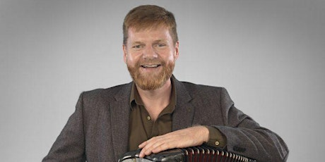](https://www.eventbrite.ie/e/danny-omahony-tickets-425013034427?aff=ebdsoporgprofile)](https://www.eventbrite.ie/e/danny-omahony-tickets-425013034427?aff=ebdsoporgprofile" \t "_blank)

**Danny O'Mahony**

Wed, 28 Sept, 13:00

**Free**