Reading and research skills
Top tips for note-making (6 pages)
Creating good quality notes on a topic can really ‘cement’ your learning. Transferring what you learn in class or through further reading and research into your own words, with your own examples, helps you identify what you know and what you don’t understand.
Your notes can be paper-based, electronic, or a combination of both. Check out note-making software such as Microsoft OneNote (which you have free access to as a University of Galway student) or Evernote. Some students like to create audio notes to listen back to in the gym or when travelling, for example.
Here are some tips for creating useful notes:
Select one topic at a time: Each module (or subject) that you take will cover a number of topics. Aim to create a really good set of notes for each topic. When you have chosen a topic to work on, gather all your materials related to this topic together. This is likely to include lecture notes/slides, your own notes taken in lectures and tutorials, handouts, assignments, and so on.

Scan your materials: Take note of key words, key theorists and key concepts. This is a good opportunity to review your general understanding of a particular topic. You may need to gather a few more materials, such as key readings, or relevant exam papers, before moving onto the next step.

Rewrite and arrange: Organise your notes in a way that brings everything together in a coherent, concise manner. Pay attention to assignments or exam questions on the topic you are studying when doing this. Remember, you are trying to create a set of notes that will help you to demonstrate your understanding of a topic when the time comes for you to do so.

Review: Look over your notes on a regular basis, addressing gaps, adding new information or knowledge, and evaluating your progress. This slow-and-steady activity will greatly reduce anxiety around exam time.
One-page summaries: One-pagers can be very helpful for revision purposes. Use any of the techniques described below to distil a topic down to a single page.
Beware of plagiarism: Be very careful about copying and pasting material that you find online – you run the risk of plagiarism (intentional or otherwise) when you do this. If you feel you must copy and paste, highlight any text that you have copied word-for-word and make sure to include the relevant bibliographic (referencing) information, so that you’ll have this to hand as needed.
Note-making strategies
Note-making strategies will vary from person to person, and sometimes from module to module. Try experimenting with some of these techniques to see what works best for you.

Linear notes: Basic linear note-making or outlining takes a form such as this:

- First item
      - Sub item
- Second item
      - Sub item
      - Sub-sub item
      - Sub-sub item
- Third item
      - Sub item

… and so on. You can use colours, stickers, and doodles to add interest to these list-type notes if you like.

Nuclear note-making: In this method, ideas, examples, or concepts are listed around a central theme. Some students find this more visually appealing and memorable than a linear approach. Again, you can use colour or other techniques or to add interest if you like. Figure 1 overleaf is an example of nuclear notes.

Figure 1: Nuclear notes example

Mind or concept maps: These are diagrams in which ideas, concepts, facts, theories, and so on are also arranged around a central key word or concept. Colour, font size, lines or arrows, images, or other techniques can be used to denote the importance of various concepts and their relationships to the central topic and to each other (see example in Figure 2 below). These type of notes are sometimes known as pattern notes. There are lots of mind-mapping applications available, such as MindGenius, Coggle, or FreeMind.
Figure 2: Mind map example
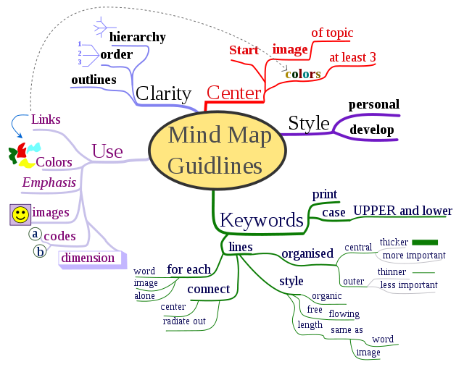
Source: http://en.wikipedia.org/wiki/File:MindMapGuidlines.svg

Cornell notes: A very well-known note-making technique is the Cornell method. Check out this video for short demonstration of this method.
Question/answer notes: In this variation of the Cornell method, you divide a page into two columns. On the left-hand side, write a question (or questions) relating to the topic at hand. On the right-hand side, write brief answers. This can be a good method for science or law students, for example, where you may want to note how particular experiments or legal cases relate to a topic. You can also adapt this method as a way to record or review the different experiments or cases that you have studied (see example below).
Table 1: Question/answer notes example

EU Law topic: Definition of a good/charges with equivalent effect
Case | Relevance
R. v Thompson [1978] | Money does not constitute a good. However, Kruggerands (pure gold bars) were considered as goods for the purposes of the rules on the Common Market, as they were not an everyday means of exchange.
Commission v Belgium [1992] (Belgian Waste Case)  Belgian government argued that only recyclable waste could be considered a good, in the sense that it had a value. | European Court of Justice held that all waste – including non-recyclable waste – was a good. Non-recyclable waste had a negative, rather than a positive value – i.e. the costs of its disposal – but could still be the subject of commercial transactions.
Commission v Luxembourg and Belgium [1962] (Gingerbread Case)  Luxembourg and Belgium placed an import charge on gingerbread, to be paid when import licenses were granted. Commission believed the charge was in breach of Article 25 and took an action. | Definition of a “charge with equivalent effect to a customs duty”:  - unilaterally imposed  - at time of entry or later  - applied on a product imported from a Member State  and not on a similar domestic product  - altering the price of the imported good (i.e. making it more expensive)  - has the same effect on the free movement of goods as a customs duty

Time-lines: These can be useful for students of subjects such as history, geography, archaeology, science, philosophy, classics, sociology and politics, and many more. A visual map of dates and events, using a simple line drawn across a page, can help you to see and remember how things evolved over time far more effectively than a written list can.
Figure 3: Timeline example
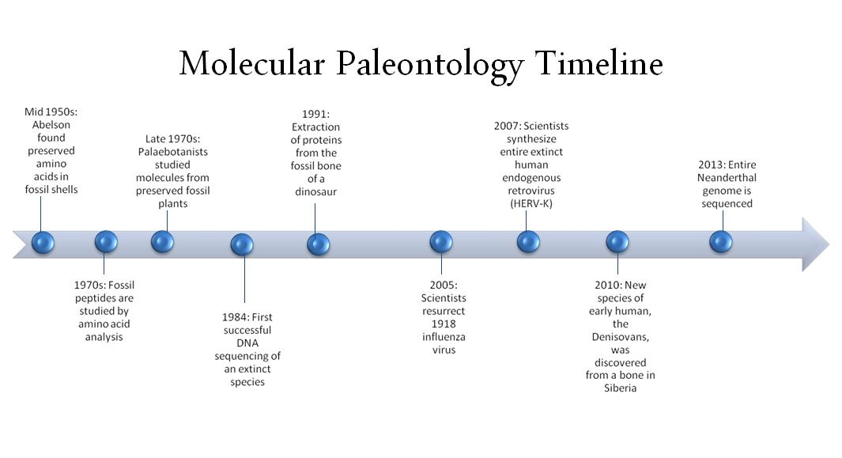Source: https://en.wikipedia.org/wiki/File:Molecular_Paleontology_Timeline.jpg

Fish-bone diagrams: These can be helpful for visually summarising cause-and-effect scenarios. For example, if you’re studying the causes of the First World War, you could create something like this:

Figure 4: Fish-bone diagram example

Alliances Nationalism/imperialism Militarism/arms race

World War I

Morrocan Bosnia Eastern Assassination of Archduke
crises question Franz Ferdinand

Formula sheets: These can be useful if you are taking modules that require you to memorise a lot of formulas, for example in some maths, science, or business modules (do check whether formulas will be provided with your exam paper – sometimes they are and sometimes not). An example of a formula sheet for Economics is provided below:

- Midpoint method: (Q2 – Q1) / [(Q2 + Q1)/2]
(P2 – P1) / [(P2 + P1)/2]

- Marginal product of labour: ∆TP/∆L, where TP = total product or quantity of output and L = number of workers

- GDP: Y = C + I + G + NX, where Y = total expenditure on the economy’s output of goods and services, C = consumption, I = investment, G = government purchases and NX = net exports, or exports minus imports

- Nominal GDP: (P x Q) + … + (P x Q), where P = current price and Q = current quantity
_ _ _
- Real GDP: (P x Q) + … + (P x Q), where P = price in the base period and Q = current quantity

- National saving, S: Y – C – G = I, where I = investment

- Money multiplier, M: 1/r, where r = reserve ratio, where r is expressed as a fraction or a decimal

Finally, remember that note-making is a very different activity to note-taking in lectures or tutorials. The former requires more time and effort, but your results should make it worth your while.

Supported by the Student Project Fund

