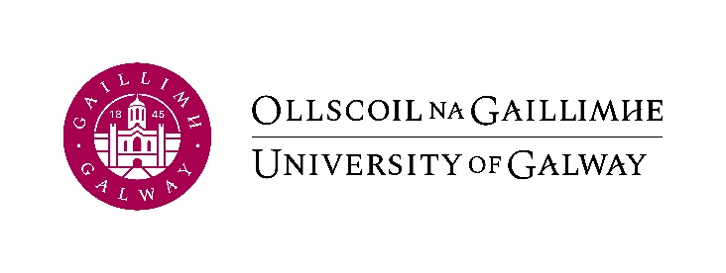

Erasmus+
Certificate of Arrival

(To be completed by the International Office of the Host University at the start of the study period abroad)

I hereby confirm that
_________________________________ (Name of Student)

has arrived at
_________________________________ (Name of Host University)
and will be enrolled as an Erasmus student between the following dates
____ / ____ / 20___
IMPORTANT: this can be the date of your Orientation Programme or a university-run language course, if the student attends these, but it should not be an earlier date. In other words, please write in the start date of the student’s official attendance at your university; do not include early arrival in the destination city.
and
____ / ____ / 20___ (the anticipated finish date, i.e. end of exams).

Signed on behalf of the host university: ______________________________
Name and function: _____________________________________________
Date of signature: _________________

Stamp of Host University:

In order to claim their Erasmus grant, students must return this form to the International Office, University of Galway. Please email it to Jodi Blumenfeld at outgoingerasmus@universityofgalway.ie.

