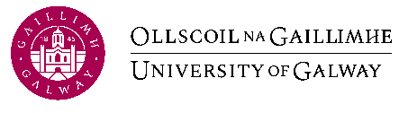**University of Galway Study Abroad + Exchange Factsheet 24/25**

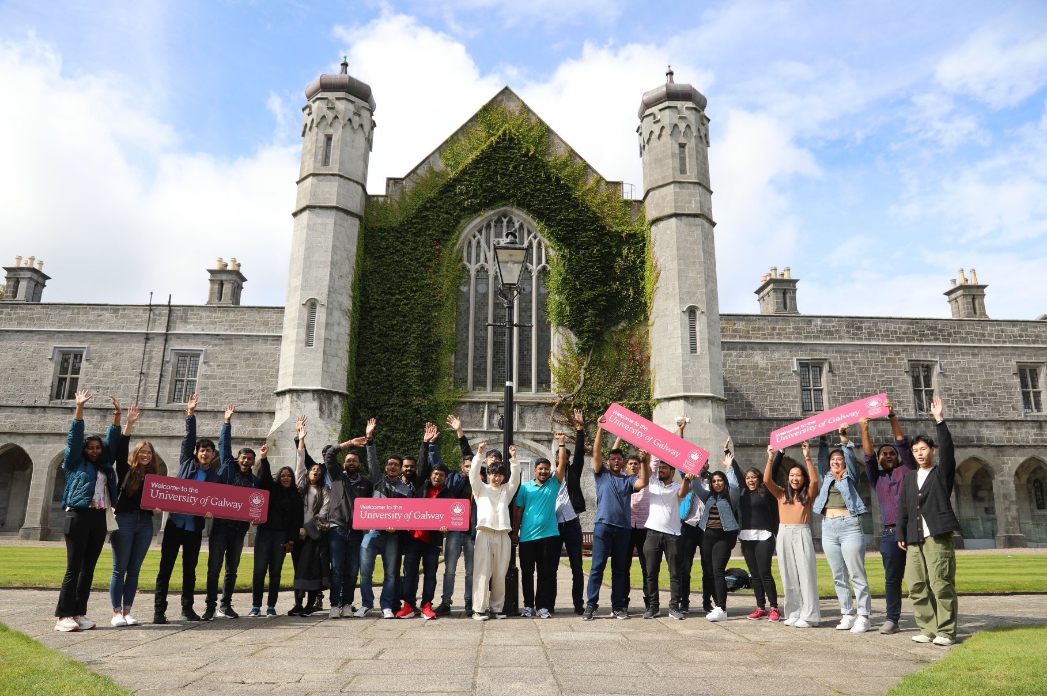**Our University**

Established in 1845, **University of Galway** is one of Ireland’s oldest and most prestigious universities, with a distinguished record in teaching and research. As a **research intensive institution** it boasts more of the world’s most influential scientific minds than anywhere else in Ireland and it has the highest success rate in Ireland for prestigious European Union research funding. Its talent has been bolstered by a recent €400m capital campaign which has provided the University with the most modern state-of-the-art facilities.

University of Galway has a rich and varied student life offering a wealth of experience outside the classroom. With over **110 societies and over 50 clubs** you can share your passion for your favourite sports, hobbies, and interests with other students. Joining a Society will help you make friends, learn new skills, pursue your interests, broaden your horizons, and go on great trips.

**Galway City**

Galway is an exciting place to be a student. It is big enough to have everything; shopping facilities, theatres, restaurants, music venues, and sports facilities – while small enough to feel intimate and welcoming. **Set between Connemara and the Burren, on the broad sweep of Galway Bay, our location is as distinctive as it is beautiful.** Galway casually combines the energy of a young and diverse population, with the authenticity of a place steeped in history and tradition.

We are renowned as a place where arts and theatre are celebrated. The city is a cultural hub, attracting thousands to its many festivals throughout the year. Galway is Ireland’s third largest city, and it’s easy to get around. Once you get to know our city, we’re sure you’ll grow to love it.

|  |  |
| --- | --- |
| **University of Galway** | |
| **Address** | University Road, Galway, Ireland |
| **Website** | [www.universityofgalway.ie](http://www.universityofgalway.ie) |
| **Study Abroad Office** | International Office, 42/43 Lower Newcastle, Galway, Ireland. |
| **Study Abroad Website** | [universityofgalway.ie/international-students/studyabroad](https://www.universityofgalway.ie/international-students/studyabroad.html) |
| **Contacts** | **General Enquiries**  Dr Cyril Reddington // Study Abroad Coordinator  [studyabroad@universityofgalway.ie](mailto:studyabroad@universityofgalway.ie)  **Renewals and New Agreements**  JB Terrins // Head of Global Galway  [jb.terrins@universityofgalway.ie](https://www.universityofgalway.ie/international-students/studyabroad.html)  **Reciprocity and Balances**  Suzanne Bradish // Global Experience Coordinator  [suzanne.bradish@universityofgalway.ie](mailto:suzanne.bradish@universityofgalway.ie) |

|  |  |
| --- | --- |
| **Application Procedure** | |
| **Application Requirements** | Minimum GPA of 3.0 on a 4.0 scale (or equivalent)  Students applying for **Science and Engineering courses** will have their applications assessed by the relevant disciplines to ensure they meet the appropriate academic prerequisites.  [English Language Requirements](https://www.universityofgalway.ie/international-students/studyinireland/entryrequirements/) |
| **Application Timelines** | * Full Year / Semester 1 **1st February - 30th April** * Semester 2 **1st August - 31st October**   Nominations for exchanges can be submitted to [studyabroad@universityofgalway.ie](mailto:studyabroad@universityofgalway.ie) during these dates |
| **How to apply** | 1. Apply online via the appropriate Application Form on the [study abroad website](https://www.universityofgalway.ie/international-students/inboundstudyabroad/howtoapply/) 2. Students must also submit the following via email to [studyabroad@universityofgalway.ie](mailto:studyabroad@universityofgalway.ie)  * Up-to-date college transcript * Copy of passport or birth certificate * A passport size photograph |

|  |  |
| --- | --- |
| **Academic Information** | |
| **Course Catalogue** | All courses offered to visiting students are listed in our handbooks located on our [website](https://www.universityofgalway.ie/international-students/inboundstudyabroad/ourprogramme/) |
| **How many modules/credits can be taken in each semester?** | Each class is weighted at 5 or 10 ECTS credits. You can take up to 30 ECTS credits per semester, which is a normal course load for University of Galway students. |
| **Where can I find timetables?** | Timetables are available on discipline websites. These are linked in the relevant discipline area of the student handbook. |
| **When will academic transcripts be sent?** | Within 6 weeks of the end of the examination period, transcripts will be sent to the international offices of partner institutions. |

|  |  |  |
| --- | --- | --- |
| **Academic Calendar 2024/2025** | | |
|  | Semester 1 | Semester 2 |
| **Orientation** | Thursday September 5th - Friday September 6th | Thursday January 9th - Friday January 10th |
| Start of Teaching | Monday September 9th | Monday January 13th |
| End of Teaching | Friday November 29th | Friday April 4th |
| Exams Start | Monday December 9th | Tuesday April 22nd |
| Exams End | Friday December 20th | Friday May 9th |
| **Public Holidays** | **Monday October 28th** | **Monday February 3rd**  **Monday March 17th**  **Friday April 18th**  **Monday April 21st**  **Monday June 2nd** |
| A complete list of Academic Terms dates is available [online](https://www.universityofgalway.ie/registry/academic-term-dates/). | | |

|  |  |
| --- | --- |
| **Accommodation** | |
| On-Campus | Off-Campus |
| University of Galway offers some accommodation on-campus in our student residences – Corrib Village, Goldcrest Village, and Dunlin Village.  Please visit [Campus Living Website](https://www.campusaccommodation.ie/) for the most up-to-date booking information. | University of Galway’s [Accommodation Advisory Service](https://www.universityofgalway.ie/student-life/accommodation/) offers advice and assistance.  University of Galway has a purpose-built portal for off-campus accommodation called [Studentpad](https://www.uniofgalwaystudentpad.ie/Accommodation). |
| **Please note:** Accommodation demand is always high, and we highly recommend starting  students start their accommodation search as soon as possible. Students should also be  on high alert for Accommodation scams. | |

|  |
| --- |
| **Facts and Figures** |
|  |

|  |
| --- |
| **Useful Links** |

University of Galway offers a wide range of services for students. Click on the icons below to find out more.

|  |  |  |  |
| --- | --- | --- | --- |
| [House with solid fill](https://www.universityofgalway.ie/student-life/accommodation/)  Accommodation | [Books with solid fill](http://library.nuigalway.ie/)  Library | [Medical with solid fill](https://www.universityofgalway.ie/health_unit/)  Student Health Services | [Email with solid fill](https://www.universityofgalway.ie/information-solutions-services/)  IT Support |
| [Mental Health outline](https://www.universityofgalway.ie/counsellors/)  Student Counselling Service | [Person in wheelchair with solid fill](https://www.universityofgalway.ie/disability/)  Disability Support Service | [Table setting with solid fill](https://www.universityofgalway.ie/catering-services/restaurantscafes/)  Restaurant Facilities | [Sport balls with solid fill](https://www.universityofgalway.ie/societies/)  Social Activities |