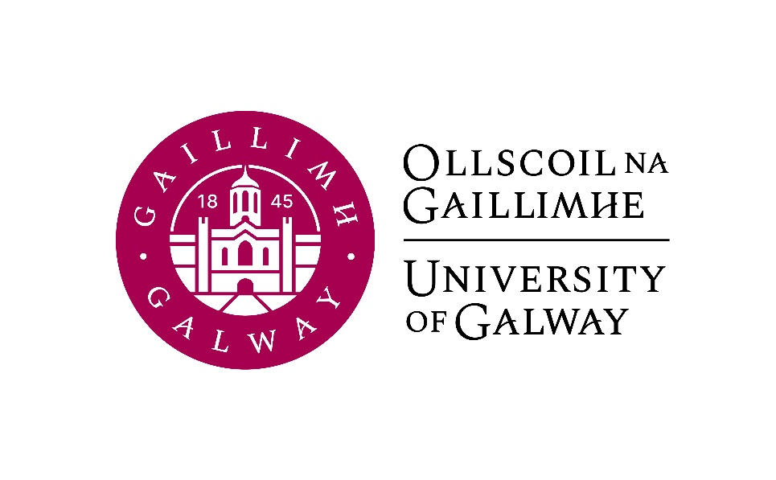

First Year German
Course Booklet

(Post-Leaving Certificate German)

2025-2026

First Year Co-ordinator: To be confirmed
Email: jeannine.jud@universityofgalway.ie
Head of Discipline: Dr. Deirdre Byrnes, Room AMB-2003
Email: deirdre.byrnes@universityofgalway.ie
Discipline Administrator: Natalie Nevin, Room AMB-2006
Email: natalierebecca.nevin@universityofgalway.ie

Discipline of German website: https://www.universityofgalway.ie/german/

 | Academic Year 2025-2026
2025 (Semester 1)
Start of teaching – 1st years | Monday 8th September
End of teaching all years | Friday 28th November
Study Week | Monday 1st December - Friday 5th December
Semester 1 Exams | Monday 8th December – Friday 19th December
Christmas Holidays | Start Saturday 20th December
2026 (Semester 2)
Start of Teaching | Monday 12th January
End of Teaching | Thursday 2nd April
Easter | Good Friday 3rd April to Easter Monday 6th April
Field Trips | Tuesday 7th April to Friday 10th April
Study Week | Monday 13th April to Friday 17th April
Semester 2 Exams | Tuesday 21st April – Friday 8th May
Autumn Repeat Exams | Tuesday 4th August to Friday 14th August
Holidays | Easter: Good Friday 3rd April to Easter Monday 6th April
 | Bank Holidays: Monday 27th October 2025/ Tuesday, 17th March 2026/ Monday 4th May 2026/ Monday 1st June 2026 / Monday 3rd August 2026

Students must register for GR1100 and for GR1102.
GR1100  German Language and Culture  15 ECTS | Semester 1 and Semester 2
GR1102  Skills for Studying German  5 ECTS | Semester 1 and Semester 2

Important notice for visiting students:
Visiting students wishing to take the module GR1100 German Language and Culture should register for GR142.

Important information about in-house assessments:
Both GR1100 and GR1102 contain graded in-class tests. A medical certificate or the approval of an Extenuating Circumstance is required for a student to be able to sit the in-class test at a later date. More information regarding the Extenuating Circumstance Scheme can be found here: https://www.universityofgalway.ie/colleges-and-schools/arts-social-sciences-and-celtic-studies/student-information/studentformsandlinks/

GR1100 German Language and Culture (5 hours per week)

Lecturers: Nura Alwani
Languages of instruction: German and English
Course description:
This course aims to expand your knowledge of the German language and of German culture and traditions. Classes focus on improving your confidence in the use of German in everyday situations. A communicative approach and a variety of oral and written exercises are employed, in conjunction with listening comprehension exercises. You will read and discuss a broad variety of texts which will expand your vocabulary. Grammatical ability will also be strengthened.
Course content and grammatical progression comply with the requirements of level A2 (Semester 1) and B1 (Semester 2) of the Common European Framework of Reference for Languages.
Teaching and learning methods: A variety of stimulating oral, written and listening exercises is employed. The course programme includes a systematic revision of German grammar. All students have access to the Virtual Learning Environment Canvas where they can find announcements, assignments, lecture notes, websites, videos and audio material.
Core texts:
Menschen A2.2: Kursbuch and Menschen A2.2: Arbeitsbuch for Semester 1
Menschen B1.1: Kursbuch and Menschen B1.1: Arbeitsbuch for Semester 2
These texts are available for purchase in the campus bookshop.

Assessment (Semester 1):
Written examination (GR1100-1) at the end of Semester 1: 50%
Oral assignment: 15%
Continuous assessment: 35%

Assessment (Semester 2):
Written examination (GR1100-2) at the end of Semester 2: 50%
Oral examination: 20%
Continuous assessment: 30%

GR1102 Skills for Studying German (1 hour per week)

Lecturer: Tina-Karen Pusse
Language of instruction: English
Course description:
The course explores the basis for effective ways of studying in general and studying a foreign language and culture specifically.
In Semester 1, the focus is on individual learning techniques and self-motivational skills, group learning, efficient exam preparation, memory and retention, tools for reading, speaking, writing and listening comprehension, and the basics of German grammar terminology and phonetics.
In Semester 2, the focus is on enabling and encouraging students to interpret literature or other cultural products. It introduces relevant literary terms, reading strategies, narratology and genre theory. The final course segment introduces students to film analysis and aims to convey awareness regarding approach and terminology while discussing examples from German film history.
In both semesters, continuous engagement with course materials through an online learning journal is essential and will help to prepare for the in-class exam at the end of term.
Assessment (Semester 1):
Learning journal: 40%
In-class exam: 60%

Assessment (Semester 2):
Learning journal: 40%
In-class exam: 60%

Learning materials: handouts, videos, online articles
Learning outcomes:
If you engage continuously with this class, you will find out which learning strategies come easier to you and the areas where you will have to put in more work. You will develop professional study methods as well as strategies to approach literary texts and films.

Essay Guidelines: All essays which form part of the assessment of any module within the BA German programme must adhere to the format and the referencing system laid out in the discipline’s essay guidelines, available on the Discipline of German website (Section: Undergraduate Programmes).

