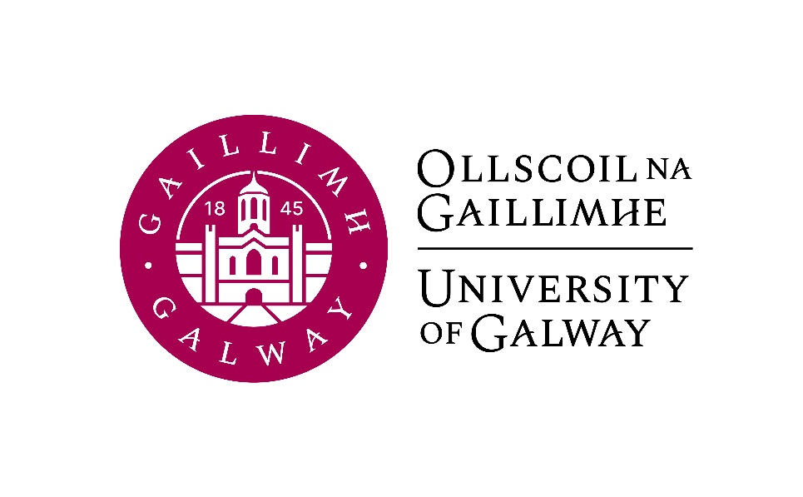

Final Year Arts
German
Course Booklet

2024-2025

Final Year Co-ordinator (Semester 1): Professor Hans-Walter Schmidt-Hannisa, Room AMB-2007
Email: h.schmidthannisa@universityofgalway.ie
Head of Discipline: Dr. Deirdre Byrnes, Room AMB-2003
Email: deirdre.byrnes@universityofgalway.ie
Discipline Administrator: Natalie Nevin, Room AMB-2006
Email: natalierebecca.nevin@universityofgalway.ie

Discipline of German website: https://www.universityofgalway.ie/german/

 | Academic Year 2024 -2025
2024 (Semester 1)
Start of teaching | Monday 9th September
End of teaching all years | Friday 29th November
Study Week | Monday 2nd December - Friday 6th December
Semester 1 Exams | Monday 9th December – Friday 20th December
Christmas Holidays | Start Saturday 21st December
2025 (Semester 2)
Start of Teaching | Monday 13th January
End of Teaching | Friday 4th April
Field Trips | Monday 7th April to Thursday 10th April
Study Week | Friday 11th April to Thursday 17th April
Easter | Good Friday 18th April to Easter Monday 21st April
Semester 2 Exams | Tuesday 22nd April – Friday 9th May
Autumn Repeat Exams | Tuesday, 5th August to Friday 15th August
Holidays | St. Brigid’s Day: Monday 5th February 2024
 | Easter: Good Friday 18th April to Easter Monday 21st April
 | Bank Holidays: Monday 28th October 2024 /Monday 3rd February 2025/ Monday, 17th March 2025/ Monday 5th May 2025/ Monday 2nd June 2025 / Monday 4th August 2025

SEMESTER 1
All modules have the value of 5 ECTS.

Module | Component(s)
GR341 German Language I
GR337 German Studies I  Students must choose Novella plus one of the optional components. | The Novella in German Literature 50%  AND  Post-migrant Podcasts 50%  OR  Introduction to Sociolinguistics 50%
GR338 German Studies II | Masterpieces of German Cinema 100%
SEMESTER 2
All modules have the value of 5 ECTS.

Module | Component(s)
GR342 German Language II
GR339 German Studies III | German Theatre Production 100%  OR  Christa Wolf: Kindheitsmuster 100%
GR340 German Studies IV | Memory in Contemporary German Writing 100%

Important information about in-house assessments:
A medical certificate or the approval of an extenuating circumstance is required for a student to be able to sit the in-class test at a later date. More information regarding the Extenuating Circumstance Scheme can be found here: https://www.universityofgalway.ie/colleges-and-schools/arts-social-sciences-and-celtic-studies/student-information/studentformsandlinks/

Important information about end-of-year oral exams for GR342:
Although the written examinations conclude on Friday, May 9th, the oral examinations for GR342 do not take place until the external examiner is on campus. These are in-person examinations and usually take place later in May. Please do not make arrangements to travel overseas until the oral examinations are over. Exact dates for the oral examinations will be provided in early February 2025.

SEMESTER 1
GR341 | German Language I (4 hours per week)

Lecturers: Tom Wilks (Grammar, Reading, Listening, Writing), Lisa Tismenezky (Speaking)
Course description:
This course will further develop the language skills acquired in second year and refine your
understanding of German vocabulary, communication and sentence structures. The aim is
to advance your ability to speak and write correctly, fluently and accurately in typical
communication situations, while also enhancing your reading and listening skills. Core aims
for this course are to ensure that all participants are engaging in high-level language learning
activities, such as group discussions, individual Stellungnahmen in speech and writing, grammar exercises, reading and listening comprehension, as well as accurate vocabulary and memory work and writing to the norms of different text types.

Prerequisites: Successful completion of Second Arts German, or equivalent.

Assessment:
Written examination: 50%
Oral examination: 30%
Continuous assessment: 20%

Core text: Erkundungen C1 (Third Edition/Dritte Auflage, 2023: Schubert, ISBN 978-3-96915-075-7; available to purchase in the campus bookshop.) Please ensure that you acquire this new edition rather than an older or ‘Kompakt’ edition.

Please note that you are expected to attend FOUR taught sessions per week: all three sessions (Grammatik, Lesen und Hören, Schreiben) with Tom Wilks and one of the Sprechen hours with Lisa Tismenezky. Attendance will be monitored.

GR337 | German Studies I (2 hours per week)  The Novella in German Literature (obligatory) 50%  AND  Postmigrant Podcasts 50%  OR  Introduction to Sociolinguistics 50%

GR337 The Novella in German Literature (1 hour per week)
Lecturer: Deirdre Byrnes
Course description:
„Was ist eine Novelle anders als eine sich ereignete, unerhörte Begebenheit?“, Johann Wolfgang von Goethe famously asked in 1827. A novella recounts a striking and unexpected event that brings about a sudden and dramatic change (Wendepunkt); it explores the effect of this event on the lives of the characters. Novellas often contain a concrete symbol around which the narrative unfolds. This seminar develops close reading skills as we focus on two German novellas that caused a sensation when they were published: Heinrich von Kleist’s Das Erdbeben in Chili, published in the first decade of the nineteenth century, and Gerhart Hauptmann’s Bahnwärter Thiel, published in 1888. We will consider the significance and symbolism of the earthquake in Kleist’s text and of the railway in Bahnwärter Thiel. The central role played by nature in both novellas will also be explored.
Assessment: Continuous assessment: 30%
In-house essay (week 12): 70%

Core Texts: The two core texts are available to purchase in the campus bookshop.
Heinrich von Kleist, Das Erdbeben in Chili (Reclam)
Gerhart Hauptmann, Bahnwärter Thiel (Reclam)
Study guides accompanying both novellas can be accessed on Canvas.

GR337 OPTION 1: Post-migrant Podcasts (1 hour per week)
Lecturer: Antonia Musolff

Course description:
This course will introduce students to a variety of current German podcasts. We will discuss Germany as a post-migrant society and discover its immigration history in the last centuries. The focus will be on podcasts made by young Germans whose parents migrated to Germany. Young Turkish Germans, Black Germans, Asian Germans and Jewish Germans talk about their everyday experience of life in Germany. By listening to these podcasts students will discover concepts like “Bio-German” and “Postmigrant” and gain a deeper understanding of immigration discourses as well as racism and empowerment in Germany. We will compare these podcasts to podcasts by to Irish migrants. We will also explore the life and poems of May Ayim, poet, scientist and founder of the organization Black Women in Germany. As we will work mostly with audio files, students will greatly improve their listening skills, learn new content-related vocabulary and practise their oral skills by preparing an end-of-term podcast.

Teaching and learning methods: Work with authentic cultural material. In-class discussions, podcast production in partner work or individual work.
Language of instruction: German and English
Assessment: Continuous Assessment: 35%
End-of-term podcast: 65%

Text and material: All podcasts and additional texts will be available on Canvas.
Azeret, Nathan und Vincent (Moderator_innen). (14.10.2018): Blöd gesagt... biodeutsch. (aus: Audio-Podcast: Two Blacks and a Jew).
Malcolm Ohanwe und Marcel Aburakia (Moderatoren). (4.10.2018): Fußballgucken als Kanacke. (aus: Audio-Podcast: Kanackische Welle).
Hasters, Alice, Was weiße Menschen nicht über Rassismus hören wollen, aber wissen sollten. Hanserblau. 2021
May, Ayim, Blues in Schwarz weiss. Nachtgesang. Gedichte. Unrast Verlag 2022
Plamper, Jan, Das neue Wir. Warum Migration dazugehört. Eine andere Geschichte der Deutschen.

GR337 OPTION 2: Introduction to Sociolinguistics (1 hour per week)
Lecturer: Verena Platzgummer
Course description:
In this course, students will be introduced to key concepts and methods of sociolinguistics, the field of linguistics that studies how language interacts with society. Students will learn how social contexts and identities affect how we use and perceive variation in language. In a hands-on approach, we will analyse examples from the students’ own experience and from (social) media with a focus on the German-speaking world. We will adopt an intersectional perspective and discuss language variation in relation to gender, class, race, age, place and other identities. We will also explore language ideological debates, such as controversies around the use of anglicisms in German, around the introduction of German-only policies during morning breaks at schools, or around the use of gender-sensitive language.
Languages of instruction: German and English
Teaching and learning methods: Lectures, in-class discussions, case studies
Assessment: Continuous assessment: 30%
In-house exam: 70%

GR338 German Studies II (2 hours per week)
Masterpieces of German Cinema
Lecturer: Hans-Walter Schmidt-Hannisa

Course description:
In this course, students will discuss selected German films produced between 1970 and the present day – films representing a broad range of genres such as comedy, drama, and documentary. The focus will be both on analysing the cinematic language and aesthetic aspects of the films and on exploring their cultural and historical significance. For example, films such as Volker Schlöndorff’s Die Blechtrommel or Rainer Werner Faßbinder’s Die Ehe der Maria Braun are epic commentaries on crucial episodes of German history, while Fatih Akin’s Gegen die Wand highlights the life of Turkish immigrants. All films provide insights into different aspects of German history, society and lifestyle.
Assessment: Presentation: 20%
Two short in-class-tests: 20% each
Essay: 40%
Core films:
Apart from the films mentioned above, the course programme will include Werner Herzog: Aguirre; Rainer Werner Fassbinder: Die Ehe der Maria Braun, Tom Tykwer: Lola rennt; Edgar Reitz: Die andere Heimat: Chronik einer Sehnsucht; Wolfgang Becker: Good Bye, Lenin!; Nicolette Krebitz: Wild; Nora Fingscheidt: Systemsprenger and others.

SEMESTER 2
GR342 | German Language II (4 hours per week)

Lecturers: Tom Wilks (Grammar, Reading, Listening, Writing), Lisa Tismenezky (Speaking)
Course description:
Continuing from GR341, this course builds up fluency and accuracy in the German language. The classes will involve language exercises and text production, including aural, oral, and written work on material at the C1 level of the Common European Framework
of Reference for Languages.

Assessment:
Written examination: 50%
Oral examination: 30%
Continuous assessment: 20%

Core text: Erkundungen C1 (Third Edition/Dritte Auflage, 2023: Schubert, ISBN 978-3-96915-075-7; available to purchase in the campus bookshop.) Please ensure that you acquire this new edition rather than an older or ‘Kompakt’ edition.

Please note that you are expected to attend FOUR taught sessions per week: all three sessions (Grammatik, Lesen und Hören, Schreiben) with Tom Wilks and one of the Sprechen hours with Lisa Tismenezky. Attendance will be monitored.

Important information about end-of-year oral exams for GR342:
Although the written examinations conclude on Friday, May 9th, the oral examinations for GR342 do not take place until the external examiner is on campus. These are in-person examinations and usually take place later in May. Please do not make arrangements to travel overseas until the oral examinations are over. Exact dates for the oral examinations will be provided in early February 2025.

GR339 German Studies III
German Theatre Production 100%
OR
Christa Wolf: Kindheitsmuster 100%

GR339 German Theatre Production (2 hours per week)
Lecturer: Antonia Musolff
Maximum number of students: 16
Course description:
The German Department has a long tradition of bringing a German play to the stage. The aim of this course is to prepare a German drama which will be performed in the Bank of Ireland Theatre on three evenings in March 2025. Students will contribute to the performances in various ways – as actors, stagehands, lighting technicians, prompters, make-up artists, programme editors, costume designers, surtitle technicians, etc. Participating in the performance of a play is an excellent way to improve rhetoric and language skills; it is also a valuable exercise in time management and organization. In addition, students will acquire a deeper understanding of a work of literature.

Teaching and learning methods:
The project requires regular and active student participation.
Please note that due to the practical nature of this course, a repeat option cannot be offered. Attendance and active participation are essential.

Language of instruction: German
Assessment: Contribution to the performance: 70%
Written reflection: 30%.

Core texts: to be confirmed

GR339 Christa Wolf: Kindheitsmuster (2 hours per week)
Lecturer: Jeannine Jud
Course description:
This module will focus on Christa Wolf's semi-autobiographical novel Kindheitsmuster. Born in 1929 in Landsberg an der Warthe (current-day Poland), Christa Wolf lived through three historical eras: the Nazi era, the GDR era and the reunified Germany. In Kindheitsmuster., published in 1976, Wolf reflects on her experiences as an Aryan German child in Nazi Germany and on her childhood/teenage years during the Second World War and post-war years. Kindheitsmuster explores concepts of childhood indoctrination, how much the Germans really knew about the atrocities that were happening, and the trauma of war. The novel reflects Wolf’s problematic relationship with authorities and her conflicted personal identity; it also provides insight into the difficulties of coping with memories of a traumatizing past. This course will focus on a close reading of this novel, which will be supported by an analysis of the socio-historical context.

Assessment:
Continuous Assessment: 50%
Essay: 50%
Core text: Christa Wolf, Kindheitsmuster (available to purchase in the campus bookshop).

GR340 German Cultural Studies IV (2 hours per week)
Memory in Contemporary German Writing

Lecturer: Deirdre Byrnes
Course description
This course focuses on two texts by novelist and essayist Monika Maron: Stille Zeile Sechs, published in 1991, and her family story Pawels Briefe, published in 1999. Stille Zeile Sechs charts a bitter and ultimately fatal struggle to write and, more significantly, to rewrite conflicting memories of life in the German Democratic Republic. In Pawels Briefe, Maron uses rediscovered family photographs and letters as she attempts to reconstruct her family biography so brutally ruptured by historical events; in so doing, she exposes generational memory gaps. Situating the texts within the framework of individual, collective and cultural memory theories, this course foregrounds the emergence of memory as a central theme in contemporary German literature.

Assessment:
Continuous Assessment: 50%
Essay: 50%

Core texts: Monika Maron, Stille Zeile Sechs (available to purchase in the campus bookshop)
Monika Maron, Pawels Briefe (available to purchase in the campus bookshop)

