Events - Venue Set Up Checklist
(to be completed with ref to the quick guide & policy > https://www.universityofgalway.ie/buildings/space-management/event-management/)

As per QA123 Event Management & Event Safety Policy, activities on campus are only considered “business as usual” if being held in venues purpose built for such event types and require no setup arrangements through Buildings and Estates.
If any furniture or other items are required, it is classified as an event and this form MUST be submitted to space@universityofgalway.ie in line with the timelines set out for submission (see link to quick guide and timelines above)

Event Details:
Date(s) of your event:
Title of your event
Event Controller (Must be a University Staff Member)
Contact Name,
Phone Number
Email

Venue(s) (Please complete the following indicating when set up/set down needs to be completed and event start/finish time)
Venue | Event Set up Date/Time | Event Start Date/Time | Event End Date/Time | Event Set Down Date/Time

Non – Catering Set up Requirements: Please state the number of each item required below and specify the location where these items are required:
Item Required | No | Venue | Location (and FAQ’s)
Trestle tables  (dimensions 1.8m x 0.75m)  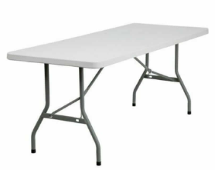 |  |  | (Do not use this section for tables required for catering)  Note: Foyer Area in AULA Lower will accommodate max 1 x Trestle Table for Registration.
Chairs  (Grey fold up chairs only)  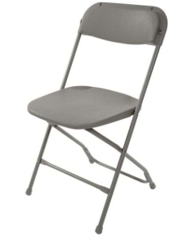  AULA Upper, AULA Lower and the Bailey Allen Hall have their own supply purple/red soft back/seat chairs. These are not available for use any other venues.  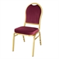 |  |  | (Note: B&E cannot provide armchairs or side/coffee tables outside of the Bailey Allen Hall. These should be ordered directly from an event supplier if required but delivery and collection times for additional furniture must be agreed with B&E in advance as we will not have space to store them)
Poster Boards |  |  | (Note: B&E hold a limited number of poster boards. we cannot guarantee we will have your preferred no of them available, particularly if you are requesting 10+)
Lectern  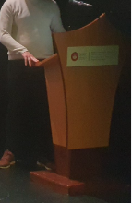 |  |  | (Note: Lecterns are for use internally in buildings only and must be pre-booked as we have a very limited number available.)
Stage - Bailey Allen Hall only  State size required  35 Sections of 2.0m x 1.0m avaiable |  |  | (Note: Max Stage size 5m x 13m)
Direction Signage/Stands  There are 3 external direction sign holders on campus and these are fixed in place. They are located at the entrances to the Quadrangle, the HBB and Engineering. |  |  | (Note signs must be printed in A3 Landscape orientation,  laminated and dropped to the mail room a min. of 24hrs before the event)
Conference Cloths  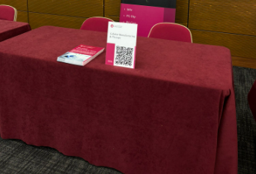 |  |  | (Note: buildings provide burgundy cloths for trestle tables only, we cannot provide these for use on banquet tables. White catering tablecloths or chair covers if required must be ordered from your caterer)
Electrical Requirements:  Please confirm if additional power is required giving details. |  |  | (Note: power for Food trucks, extension leads to exhibition tables etc.)

Catering Set Up Requirements: If catering is being provided for the event, please complete the following:
Catering Company
Contact name, telephone & email

Please confirm if the following are required for catering (White tables cloths must be ordered directly from your caterer):
Item Required | No | Venue | Location/Set up
Trestle tables (dimensions 1.8m x 0.75m)  In the AULA Lower a max of 3 no. catering tables will fit under Archway on the RHS.  B&E do not have any pod tables. These can be ordered from your caterer as required.  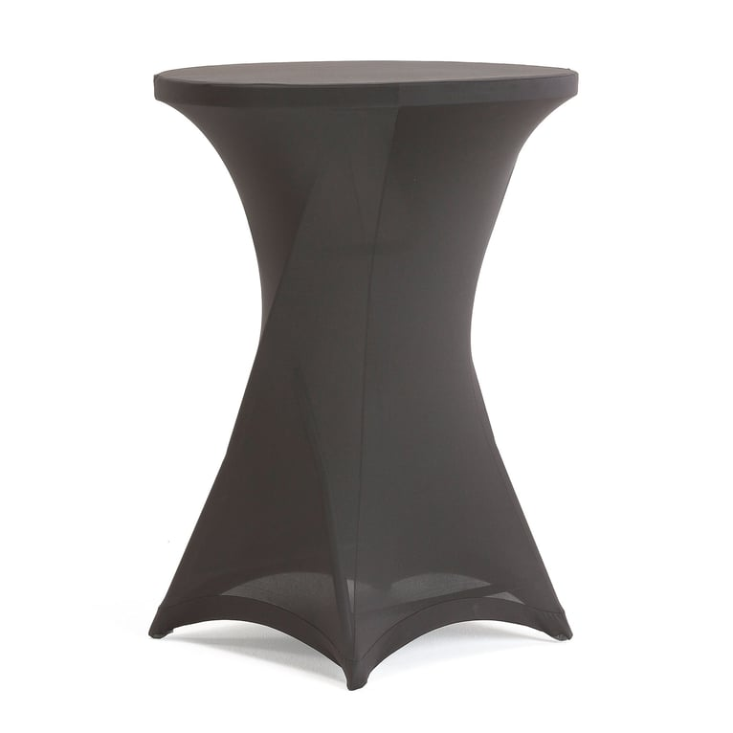 |  |  | (Note: B&E do not provide tablecloths for catering tables. These must be ordered from your caterer)
Bailey Allen & Emily Anderson Concert Hall ONLY  6 ft round banquet tables (Max no. depends on the event set up, inclusion of stage, catering etc.) |  |  | (Note: Max no. ppl per table – 8 comfortable, 10 tight fitting)
Lower Aula ONLY 4 ft round banquet tables (Max no. 12) |  |  | (Note: Max no. ppl per table – 6 comfortable, 8 tight fitting)
Chairs
(Grey fold up chairs only).
AULA Upper, AULA Lower and the Bailey Allen Hall have their own supply purple/red soft back/seat chairs. These are not available for use any other venues.

Other (please specify) |  |  | (Note: B&E do not have any pod tables. These can be ordered from your caterer as required)

It is the responsibility of the Event Controller (who must be a University of Galway staff member) to complete this form fully to comply with the University Event Management & Event Safety Policy.

All communications with Buildings & Estates in relation to your event including this venue set up checklist MUST come directly from the Event Controller.

Signed: _____________________________ Extension: _____________

