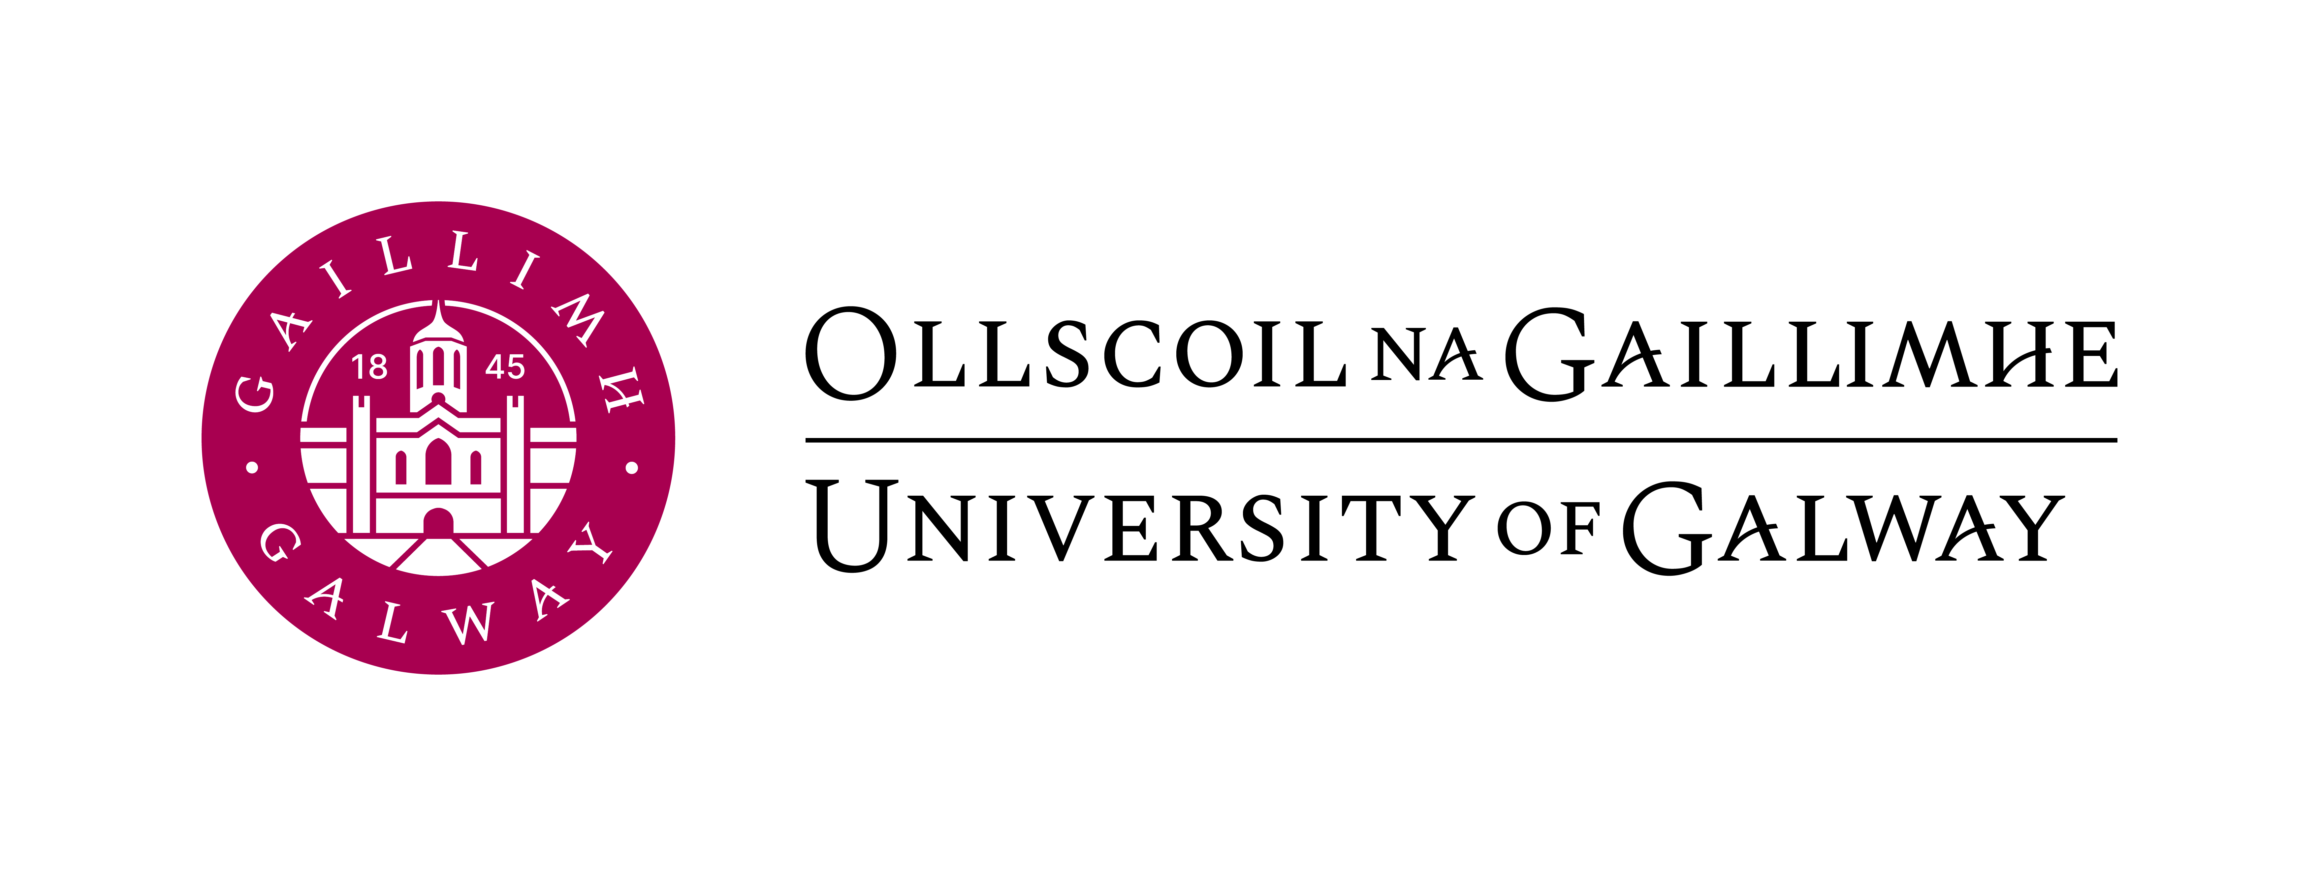
Centre for Adult Learning and Professional Development
FEES SCHOLARSHIP FORM 2024-2025
Closing Date for application is: 5pm – 12th September 2024. Applicants are encouraged to accept their offer as soon as possible to ensure a place is reserved for them on the course, particularly where class limits apply.
There are two steps in this Application Process:
- Complete the Application Form (page 1).
- Scan or post the Relevant Supporting Documentation (page 2) and email it (with the application form) to the appropriate Course Administrator (page 3).

To complete the application form using Microsoft Word click View on the top left-hand side and Edit Document.
Application Form (Please answer ALL questions)
1. | Surname (as per course application form):
2. | First Name(s)(as per course application form):
3. | Date of Birth: DD/MM/YYYY
4. | Student No. (if available):
5. | Address for Correspondence:
6. | Country of Birth:
7. | Nationality:
8. | PPS Number:
9. | Telephone (Mobile): | Telephone (Landline):
10. | Email Address:
11. | Are you currently in receipt of:  Please note the Start date: DD/MM/YYYY
12. | Have you applied for or are you in receipt of any other source of funding for this course?  Yes No  If YES Please give details:
Course of Application:
Please indicate which course you have applied for at University of Galway in 2024/2025.
Course Title:
Year of Course: Year (i.e. Year 1, 2)
Course Fees: euros
Details of Unemployment Status from Department of Social Protection
This scheme is designed for students who have recently become unemployed or are on reduced working hours, and wish to update their skills and knowledge by participating in a part-time adult education course under the fees scholarship scheme. It is open to applicants who are normally resident in Ireland and meet the nationality and EU residency rules (i.e. ordinarily resident in an EU/EEA/UK/Swiss state for at least three of the five years preceding their entry to the course). An application can be submitted for one course per year; scholarship applications for multiple courses will not be approved. Scholarships will constitute a 30% contribution towards course fees for first time entrants.

How do I qualify?
- Students must initially meet the minimum entry requirements for their chosen course. Check with the course administrator for information on eligibility criteria.
- Students must be registered as unemployed and/or in-receipt of one of the following payments.
- Job-seekers Benefit
- Job-seekers Allowance
- One-parent family allowance
- Disability allowance
- Community Employment Scheme
- Carer’s Allowance
- or signing for social insurance contribution credits

Applicants must provide a statement from their local Social Welfare Office* confirming receipt of the above payments to justify financial support from the University for this scheme. Candidates not meeting the above criteria, but who have recently become unemployed, may also apply. Such candidates will be required to furnish evidence of their unemployment status and will be dealt with on a case-by-case basis.

*Proof of funding from the Department of Social Protection Office, confirming receipt of eligible payments, must be in date within the last 3 months at the time of application.

Applicants should note that all information received will be used for the purposes of selection of students for the Fees Scholarship Scheme only. Under no circumstances will it be disclosed to any other agency or body.

Please note:
- Candidates are advised to contact their local Department of Social Protection Office to establish whether receipt of this scholarship would impact upon their entitlements under the Supplementary Welfare Allowances Scheme (i.e. rent or mortgage supplement or medical card etc.)
- Applications must be made on an annual basis.
- Should an applicant’s circumstances of employment change during the course, their eligibility for the scheme will be reviewed.

The above Supporting Documentation is required to supplement your application form and should be scanned and emailed to the course administrator. Alternatively, you may post this information to the address provided.
POSTAL ADDRESS: Centre for Adult Learning and Professional Development, University of Galway, Nuns’ Island, Galway (Please mark your application for the attention of the course administrator listed below).
Please ensure the supporting documents are forwarded as soon as possible after submitting your application form. Please check that you have answered all questions. Best of luck with your application.
PLEASE SEE FULL LIST OF COURSE ADMINISTRATORS ON THE NEXT PAGE.

Course | Course Administrator
Automation and Control (Diploma) | sciencetech@universityofgalway.ie
Bees & Beekeeping - Apiculture (Diploma) | artspt@universityofgalway.ie
Business Studies Online (Higher Diploma) | ptbusiness@universityofgalway.ie
Commerce Online (Degree) | ptbusiness@universityofgalway.ie
Community, Youth and Family Studies (Diploma/Degree) | gail.cassidy@universityofgalway.ie
Corporate Environmental Planning (Specialist Diploma) | sciencetech@universityofgalway.ie
Critical Business Skills (Diploma) | ptbusiness@universityofgalway.ie
Earth & Ocean Science (Diploma) | artspt@universityofgalway.ie
French (Diploma) | artspt@universityofgalway.ie
Gemmology (Diploma) | artspt@universityofgalway.ie
German (Diploma) | artspt@universityofgalway.ie
Irish Studies Online (Diploma) | artspt@universityofgalway.ie
Italian & Italian Online (Diploma) | artspt@universityofgalway.ie
Lean and Quality Systems (Specialist Diploma) | sciencetech@universityofgalway.ie
Management (Diploma) | ptbusiness@universityofgalway.ie
Marketing (Diploma) | ptbusiness@universityofgalway.ie
Medical Device Science (Specialist Diploma) | sciencetech@universityofgalway.ie
Science and Technology Studies (Diploma/Degree) | sciencetech@universityofgalway.ie
Spanish (Diploma) | artspt@universityofgalway.ie

